Samantha Clark
George’s Marvelous Medicine (3rd Grade)
and The BFG (4th Grade)

by Roald Dahl

Realistic Fantasy

This unit focuses on two works written by Roald Dahl. The unit is divided into eight sections, varying from 30-45 pages each. Each section contains a word wizard role, a passage picker role, a discussion director role, character sketcher role, and one other role. The other roles used consist of the artful artist, the investigator, the connector, and the summarizer. This unit is to help advance student reading skills in comprehension as well as advance their reading level.

NCSCS Goals Met By This Lesson

1.04 Increase reading and writing vocabulary through:
- wide reading.
- word study.
- knowledge of homophones, synonyms, antonyms, homonyms.
- knowledge of multiple meanings of words.
- writing process elements.
- writing as a tool for learning.
- seminars.
- book clubs.
- discussions.
- examining the author’s craft.

1.05 Use word reference materials (e.g., glossary, dictionary, thesaurus) to identify and comprehend unknown words.

1.06 Read independently daily from self-selected materials (consistent with the student’s independent reading level) to:
- increase fluency.
- build background knowledge.
- expand vocabulary.
2.01 Use metacognitive strategies to comprehend text and to clarify meaning of vocabulary (e.g., reread the text, consult other sources, ask for help, paraphrase, question).

2.02 Interact with the text before, during, and after reading, listening, and viewing by:
- setting a purpose using prior knowledge and text information.
- making predictions.
- formulating questions.
- locating relevant information.
- making connections with previous experiences, information, and ideas.

2.03 Read a variety of texts, including:
- fiction (legends, novels, folklore, science fiction).
- nonfiction (autobiographies, informational books, diaries, journals).
- poetry (concrete, haiku).
- drama (skits, plays).
2.04 Identify and interpret elements of fiction and nonfiction and support by referencing the text to determine the:
- plot.
- theme.
- main idea and supporting details.
- author’s choice of words.
2.05 Make inferences, draw conclusions, make generalizations, and support by referencing the text.
2.06 Summarize major points from fiction and nonfiction text(s) to clarify and retain information and ideas.
2.07 Determine usefulness of information and ideas consistent with purpose.
2.08 Verify the meaning or accuracy of the author’s statement(s) by referencing the text or other resources.
2.09 Listen actively by:
- asking questions.
- paraphrasing what was said.
- interpreting speaker’s verbal and non-verbal messages.
- interpreting speaker’s purposes and/or intent.

3.01 Respond to fiction, nonfiction, poetry, and drama using interpretive, critical, and evaluative processes by:
- analyzing the impact of authors’ word choice and context.
- examining the reasons for characters’ actions.
- identifying and examining characters’ motives.
- considering a situation or problem from different characters’ points of view.
3.02 Analyze characters, events, and plots from different selections and cite supporting evidence.
3.03 Consider the ways language and visuals bring characters to life, enhance plot development, and produce a response.

3.05 Integrate information from two or more sources to expand understanding of text.
3.06 Conduct research for assigned projects or self-selected projects (with assistance) from a variety of sources through the use of technological and informal tools (e.g., print and non-print texts, artifacts, people, libraries, databases, computer networks).

4.01 Read aloud grade-appropriate text with fluency, comprehension, and expression demonstrating an awareness of volume and pace.
4.02 Use oral and written language to:
- present information and ideas in a clear, concise manner.
- discuss.
- interview.
- solve problems.
- make decisions.
4.03 Make oral and written presentations using visual aids with an awareness of purpose and audience.
4.04 Share self-selected texts from a variety of genres (e.g., poetry, letters, narratives, essays, presentations).
5.02 Demonstrate understanding in speaking and writing by appropriate usage of:
- pronouns.
- subject/verb agreement.
- verb tense consistency.
- subject consistency.
5.03 Elaborate information and ideas in writing and speaking by using:
- simple and compound sentences.
- regular and irregular verbs.
- adverbs.
- prepositions.
- coordinating conjunctions.

George’s Marvelous Medicine
Section 1, pages 1-40

Character Sketcher
Your job is to complete the role sheet for one of the following characters: George, Grandma.

Discussion Director
Your job is to ask 6 questions, write their answers and the page and paragraph where they are found in the text (if possible). Ask thinking questions in the following categories:
1 MCEOG
1 Surprising
1 Prediction
1 Fact/ Opinion
1 Problem/ Solution
1 Thinking question on your own

Passage Picker
Pick 4 passages that show the following:
2 figurative language
1 Surprising
1 On your own

Word Wizard
Your job is to complete the role sheet and word wizard card for the following words found in the text:
untidiness- p. 4, par. 6
tremble- p. 9, par. 4
paraffin- p. 18, par. 2
bulging- p. 21, par. 2
maggot- p. 29, par. 7
scrawny- p. 36, par. 7
Connector
Your job is to connect this section of the book to the outside world. Write a paragraph answering one of the following statements:
• Does this story remind you of any other story that you have read or heard? Explain.
• Would your friends like to read this book? Why or why not?

Discussion Director- Section 1

MCEOG
Each of the following is a characteristic of Grandma, except for which one:
- demanding
- miserable
- kind
- tiny
(Answer- c)

Surprising
What happened when George finally gave Grandma the medicine that he had made for her?
(Answer- Many extraordinary things began to happen. She became suspended in midair, and when she came back down to her chair her stomach was on fire. Once the fire was put out she began to grow and grow and grow, all the while becoming thinner as well. Pages 32-36)

Prediction
What did you expect was going to happen to Grandma once she took the medicine while George was concocting it?
(Answer- There were many possibilities. Grandma could have gotten sick from it, it could have made her turn into a nice Grandma, nothing could have happened, etc.)

Fact/ Opinion
On page 31, paragraph 1, it says, “Grandma sat hunched in her chair by the window. The wicked little eyes followed George closely as he crossed the room towards her.” Is this sentence a fact or an opinion? Explain.
(Answer- Fact. It tells exactly what Grandma is doing as George brings her the medicine. There aren’t any expressed ideas from either character or a narrator.)

Problem/ Solution
Why did George begin to make the medicine in the first place?
(Answer- Grandma had always been mean to George. The medicine that she was taking at the time was not working to make her any nicer. He wanted to give her something to cure her meanness and make her nice. Page 12, paragraph 2.)

Thinking Question
Did George have any idea what the medicine would do to Grandma?
(Answer- He did not know that it would make her grow taller and taller to the roof. He had just thought that each ingredient would make her better in a different way.)

Passage Picker- Section 1 (1)
- Pick out the passage you would like to share with your group and write down the page___39___ and paragraph___4___.
- Write down the first two words, _Crash! The__, and the last two words_were butter., of your passage.
- The passage you choose is a great example of a _simile_ type of passage.
- This passage is a _simile_ type of passage because_it uses ‘as’ as a comparison of two things that are usually not compared .
- Think of a good thinking question about the passage. Write it down along with the answer to this question.
Why would Grandma’s head be similar to butter?
Because it went through the ceiling with such ease as butter might.
- Answer one of these questions in a complete sentence(s): Why did the author include this passage in the story? What does this passage add to the story?
It was included in the story to explain how quickly and easily Grandma’s head went through the ceiling.

Passage Picker- Section 1 (2)
1. Pick out the passage you would like to share with your group and write down the page___36___ and paragraph___7___.
2. Write down the first two words, _It was__, and the last two words, _invisible hands, of your passage.
3. The passage you choose is a great example of a _simile_ type of passage.
4. This passage is a _simile_ type of passage because_it uses ‘as’ as a comparison of two things that are usually not compared .
5. Think of a good thinking question about the passage. Write it down along with the answer to this question.
What other things could Grandma be compared to while she is tall and thin?
She could be compared to a pencil, a string bean, a rope, a tree, a growing weed, etc.
6. Answer one of these questions in a complete sentence(s): Why did the author include this passage in the story? What does this passage add to the story?
This passage adds explanation for how fast and tall Grandma was growing. It makes the process more exciting also.

Passage Picker- Section 1 (3)
1. Pick out the passage you would like to share with your group and write down the page___36___ and paragraph___3___.
2. Write down the first two words, _Suddenly she__, and the last two words, _to grow, of your passage.
3. The passage you choose is a great example of a _surprising_ type of passage.
4. This passage is a _surprising_ type of passage because _no one would have expected Grandma to start growing from the medicine that George concocted .
5. Think of a good thinking question about the passage. Write it down along with the answer to this question.
How does the medicine actually make her grow?
Maybe the mixture of all the weird things caused a strange reaction and caused Grandma to grow.
6. Answer one of these questions in a complete sentence(s): Why did the author include this passage in the story? What does this passage add to the story?
I guess we will find out in later sections why this medicine caused Grandma to grow.

Passage Picker- Section 1 (4)
1. Pick out the passage you would like to share with your group and write down the page___18___ and paragraph___9___.
2. Write down the first two words, __George didn’t__, and the last two words, _old woman, of your passage.
3. The passage you choose is a great example of a _funny_ type of passage.
4. This passage is a _funny_ type of passage because _George could not decide if his Grandma was automatic or not, the way that cars are. He just knew that she was dirty.
5. Think of a good thinking question about the passage. Write it down along with the answer to this question.
What characteristics about Grandma are automatic?
She gives George orders, she is constantly rude, she is crabby, and her attitude automatically changes when George’s parents leave the house.
6. Answer one of these questions in a complete sentence(s): Why did the author include this passage in the story? What does this passage add to the story?
This passes adds to the humor of the story. It makes it more enjoyable to read.

Word Wizard- Section 1(1)
1. Write down the word untidiness , the page 4 , and the paragraph number 6 .
2. Copy the sentence from the book in which the word appears.
“’I gave up growing when I was extremely small, along with all the other nasty childish habits like laziness and disobedience and greed and sloppiness and untidiness and stupidity.’”
3. Re-read the sentence in which the word appears. Think about the word, the sentence, and the story. Write down what part of speech you think the word is noun . Now, write down what you think the word means very messy .
4. n. something that is not well ordered or cared for.
5. It adds to the story as part of Grandma’s explanation about how terrible children are, or so she thinks.
6. See word wizard card.

Word Wizard- Section 1(2)
1. Write down the word tremble, the page 4, and the paragraph number 4.
2. “George began to tremble.”
3. Re-read the sentence in which the word appears. Think about the word, the sentence, and the story. Write down what part of speech you think the word is verb . Now, write down what you think the word means shake in fear .
4. v. shake from fear or cold, move or sound as if shaken.
5. This shows how fearful George was when his Grandma spoke to him.
6. See word wizard card.

Word Wizard- Section 1(3)
1. Write down the word paraffin, the page 18, and the paragraph number 2.
2. “Liquid paraffin, the next one was called.”
3. Re-read the sentence in which the word appears. Think about the word, the sentence, and the story. Write down what part of speech you think the word is noun . Now, write down what you think the word means some liquid substance .
4. n. white waxy substance used especially for making candles and sealing foods.
5. This word adds to the story because it was something interesting and nasty to add to his Grandma’s medicine.
6. See word wizard card.

Word Wizard- Section 1(4)
1. Write down the word bulging, the page 21, and the paragraph number 2.
2. “The shelves were bulging with bottles and jars of every sort.”
3. Re-read the sentence in which the word appears. Think about the word, the sentence, and the story. Write down what part of speech you think the word is verb . Now, write down what you think the word means overflowing .
4. v. swell out
5. This word reiterates how many items were available for George to put in his concoction.
6. See word wizard card.

Word Wizard- Section 1(5)
1. Write down the word maggot, the page 29, and the paragraph number 7.
2. “You nasty little maggot.”
3. Re-read the sentence in which the word appears. Think about the word, the sentence, and the story. Write down what part of speech you think the word is noun . Now, write down what you think the word means gross rodent or animal .
4. n. wormlike fly larvae.
5. This word is important in the story because it shows how mean and belittling Grandma was to George.
6. See word wizard card.

Word Wizard- Section 1(6)
1. Write down the word scrawny, the page 36, and the paragraph number 7.
2. “It was a truly fantastic sight, this ancient scrawny old woman getting taller and taller, longer and longer, thinner and thinner, as though she were a piece of elastic being pulled upward by invisible hands.”
3. Re-read the sentence in which the word appears. Think about the word, the sentence, and the story. Write down what part of speech you think the word is adjective . Now, write down what you think the word means small, little, and old .
4. adj. very thin
5. This word adds to the story because it tells how small Grandma was before she began to grow.

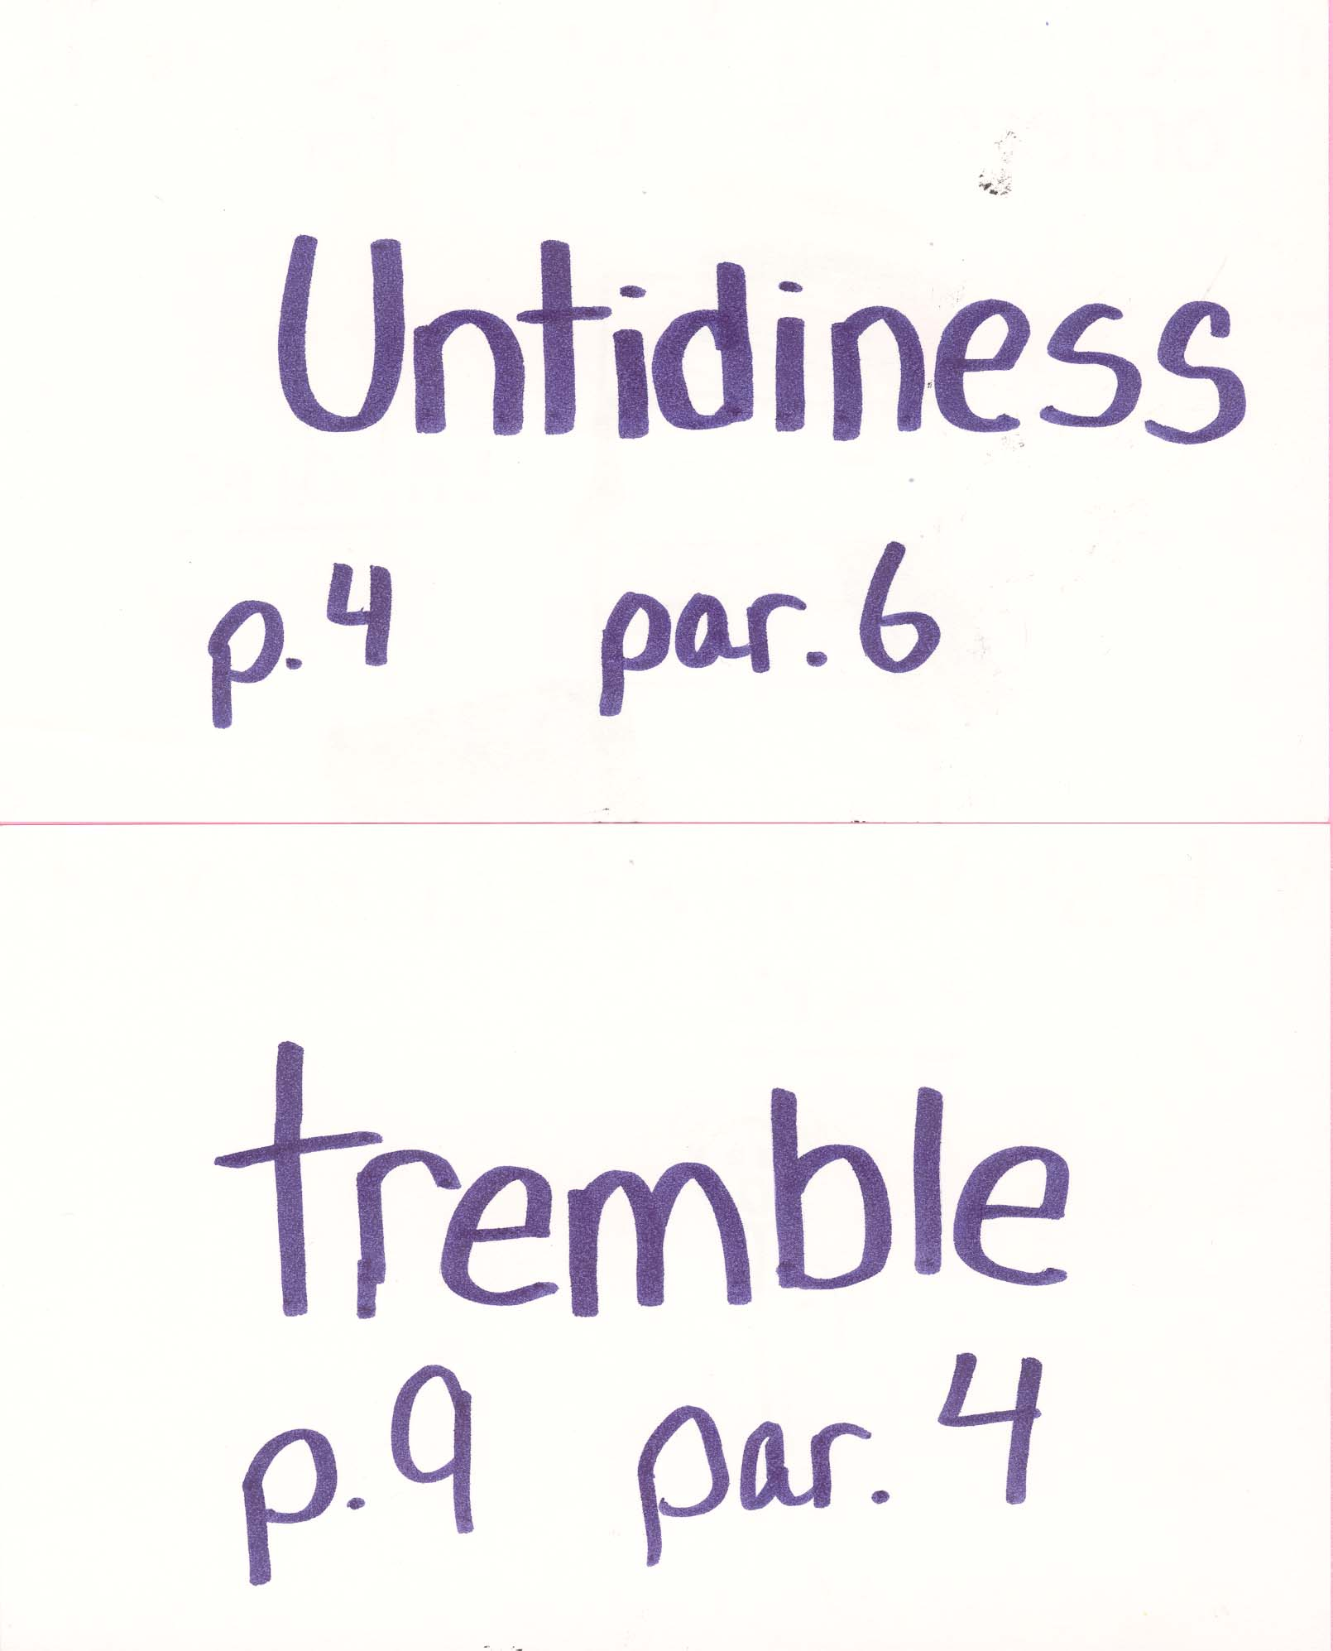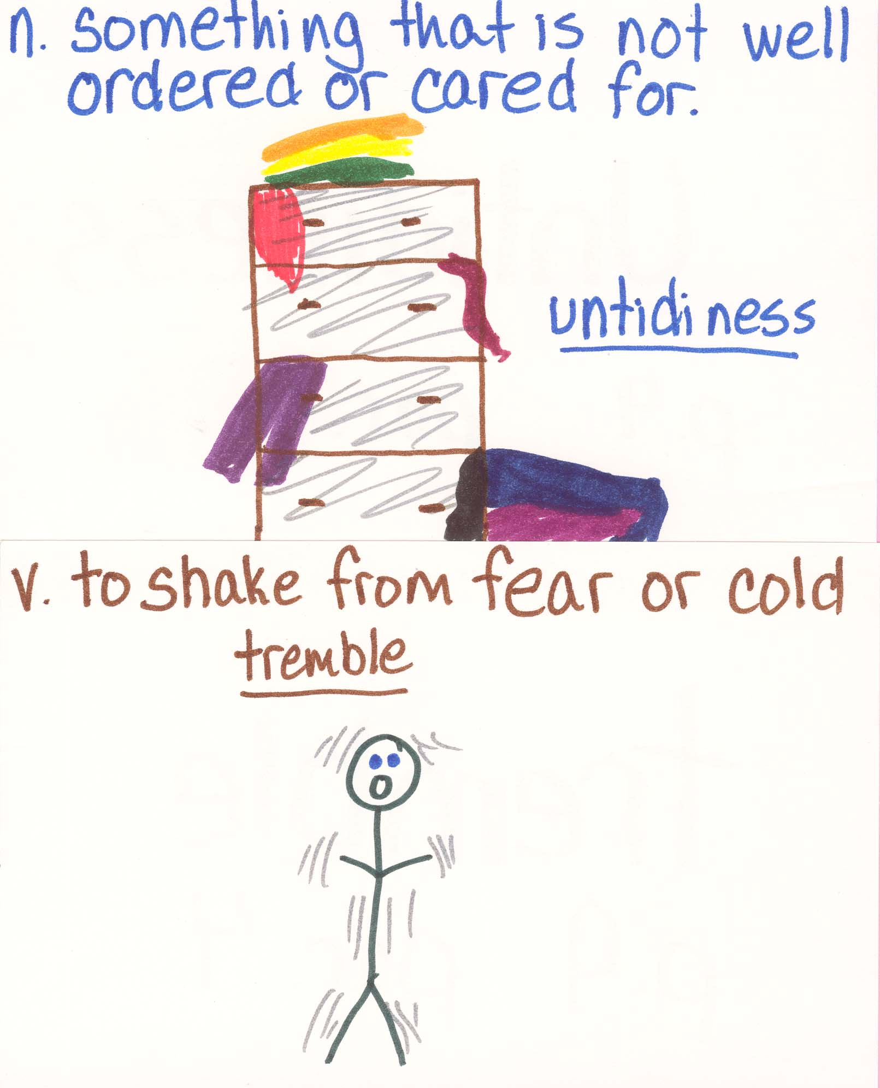

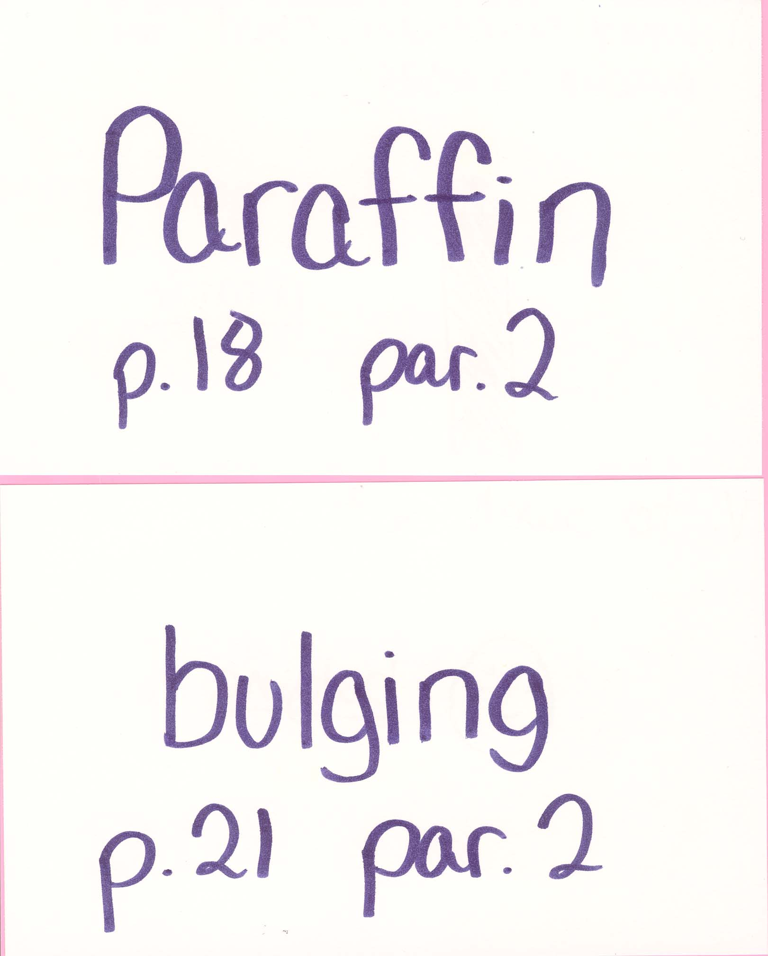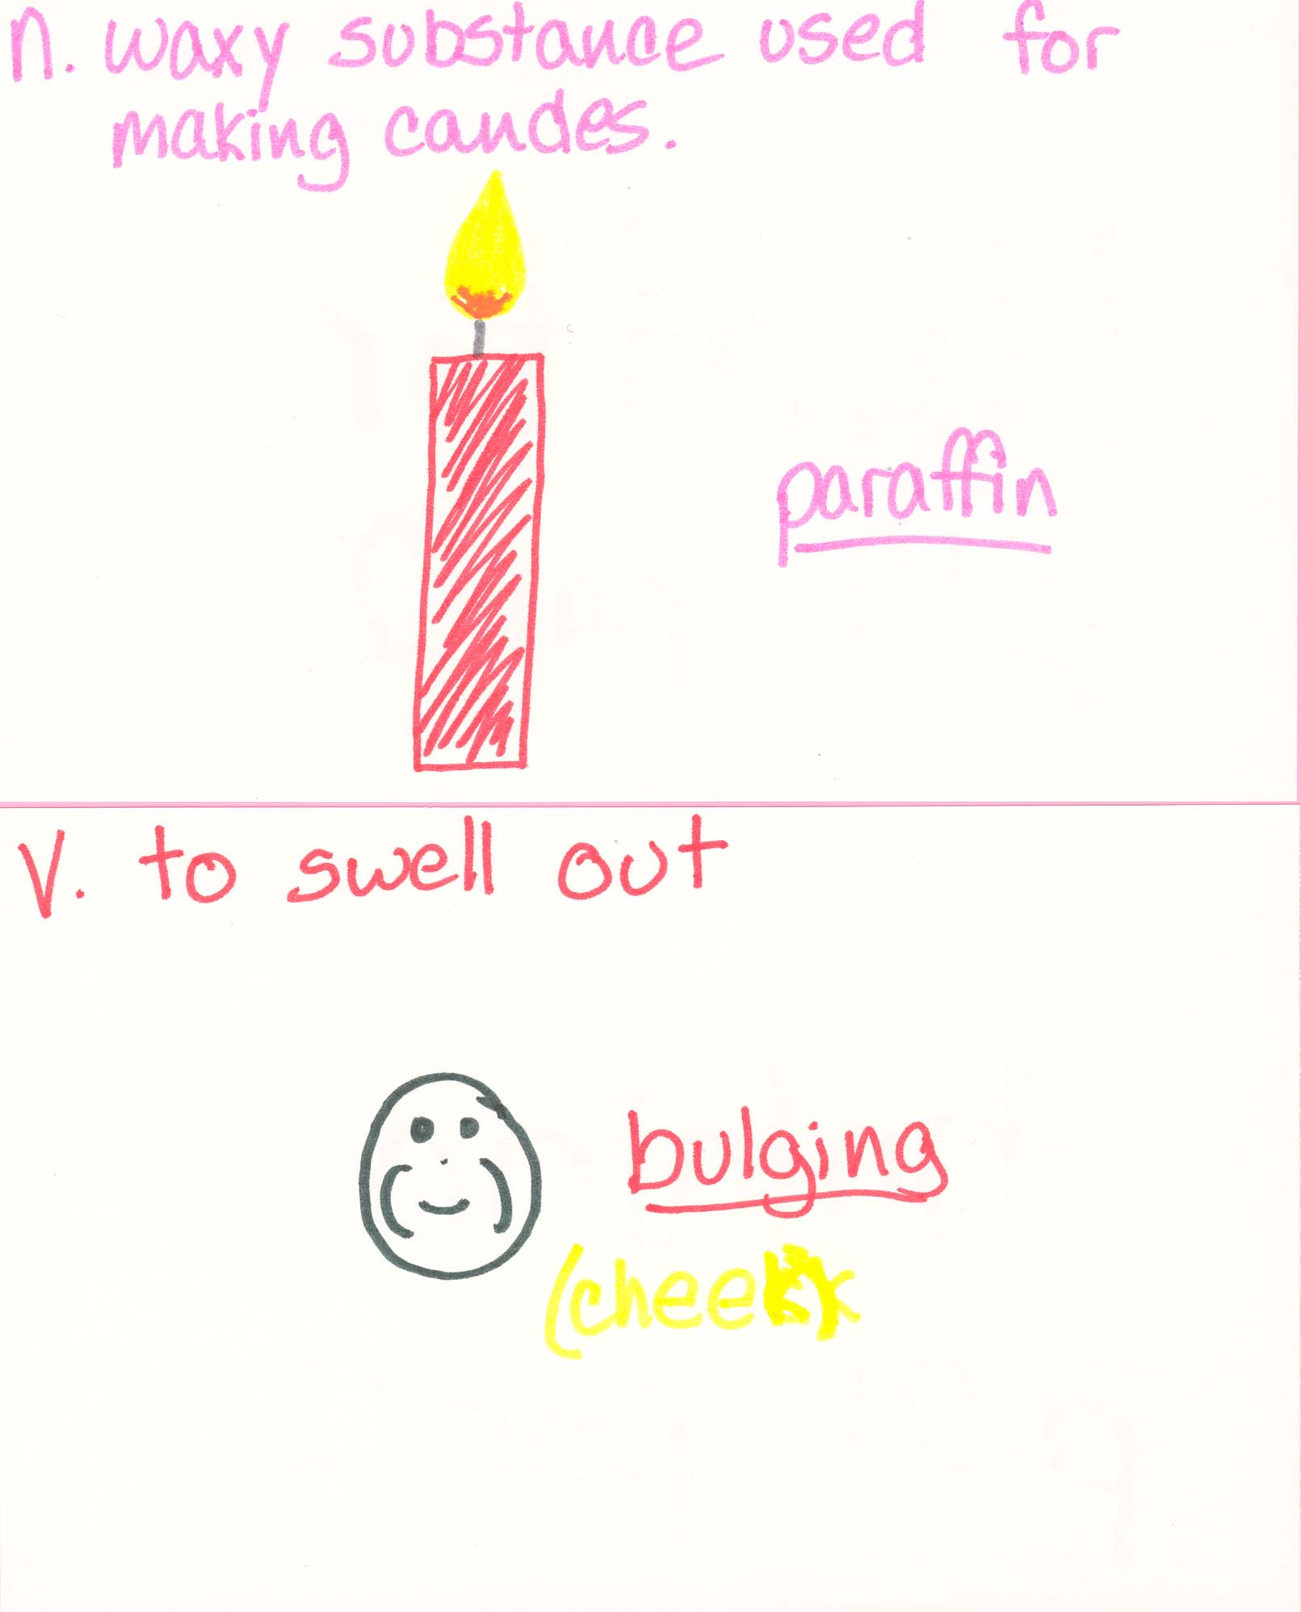

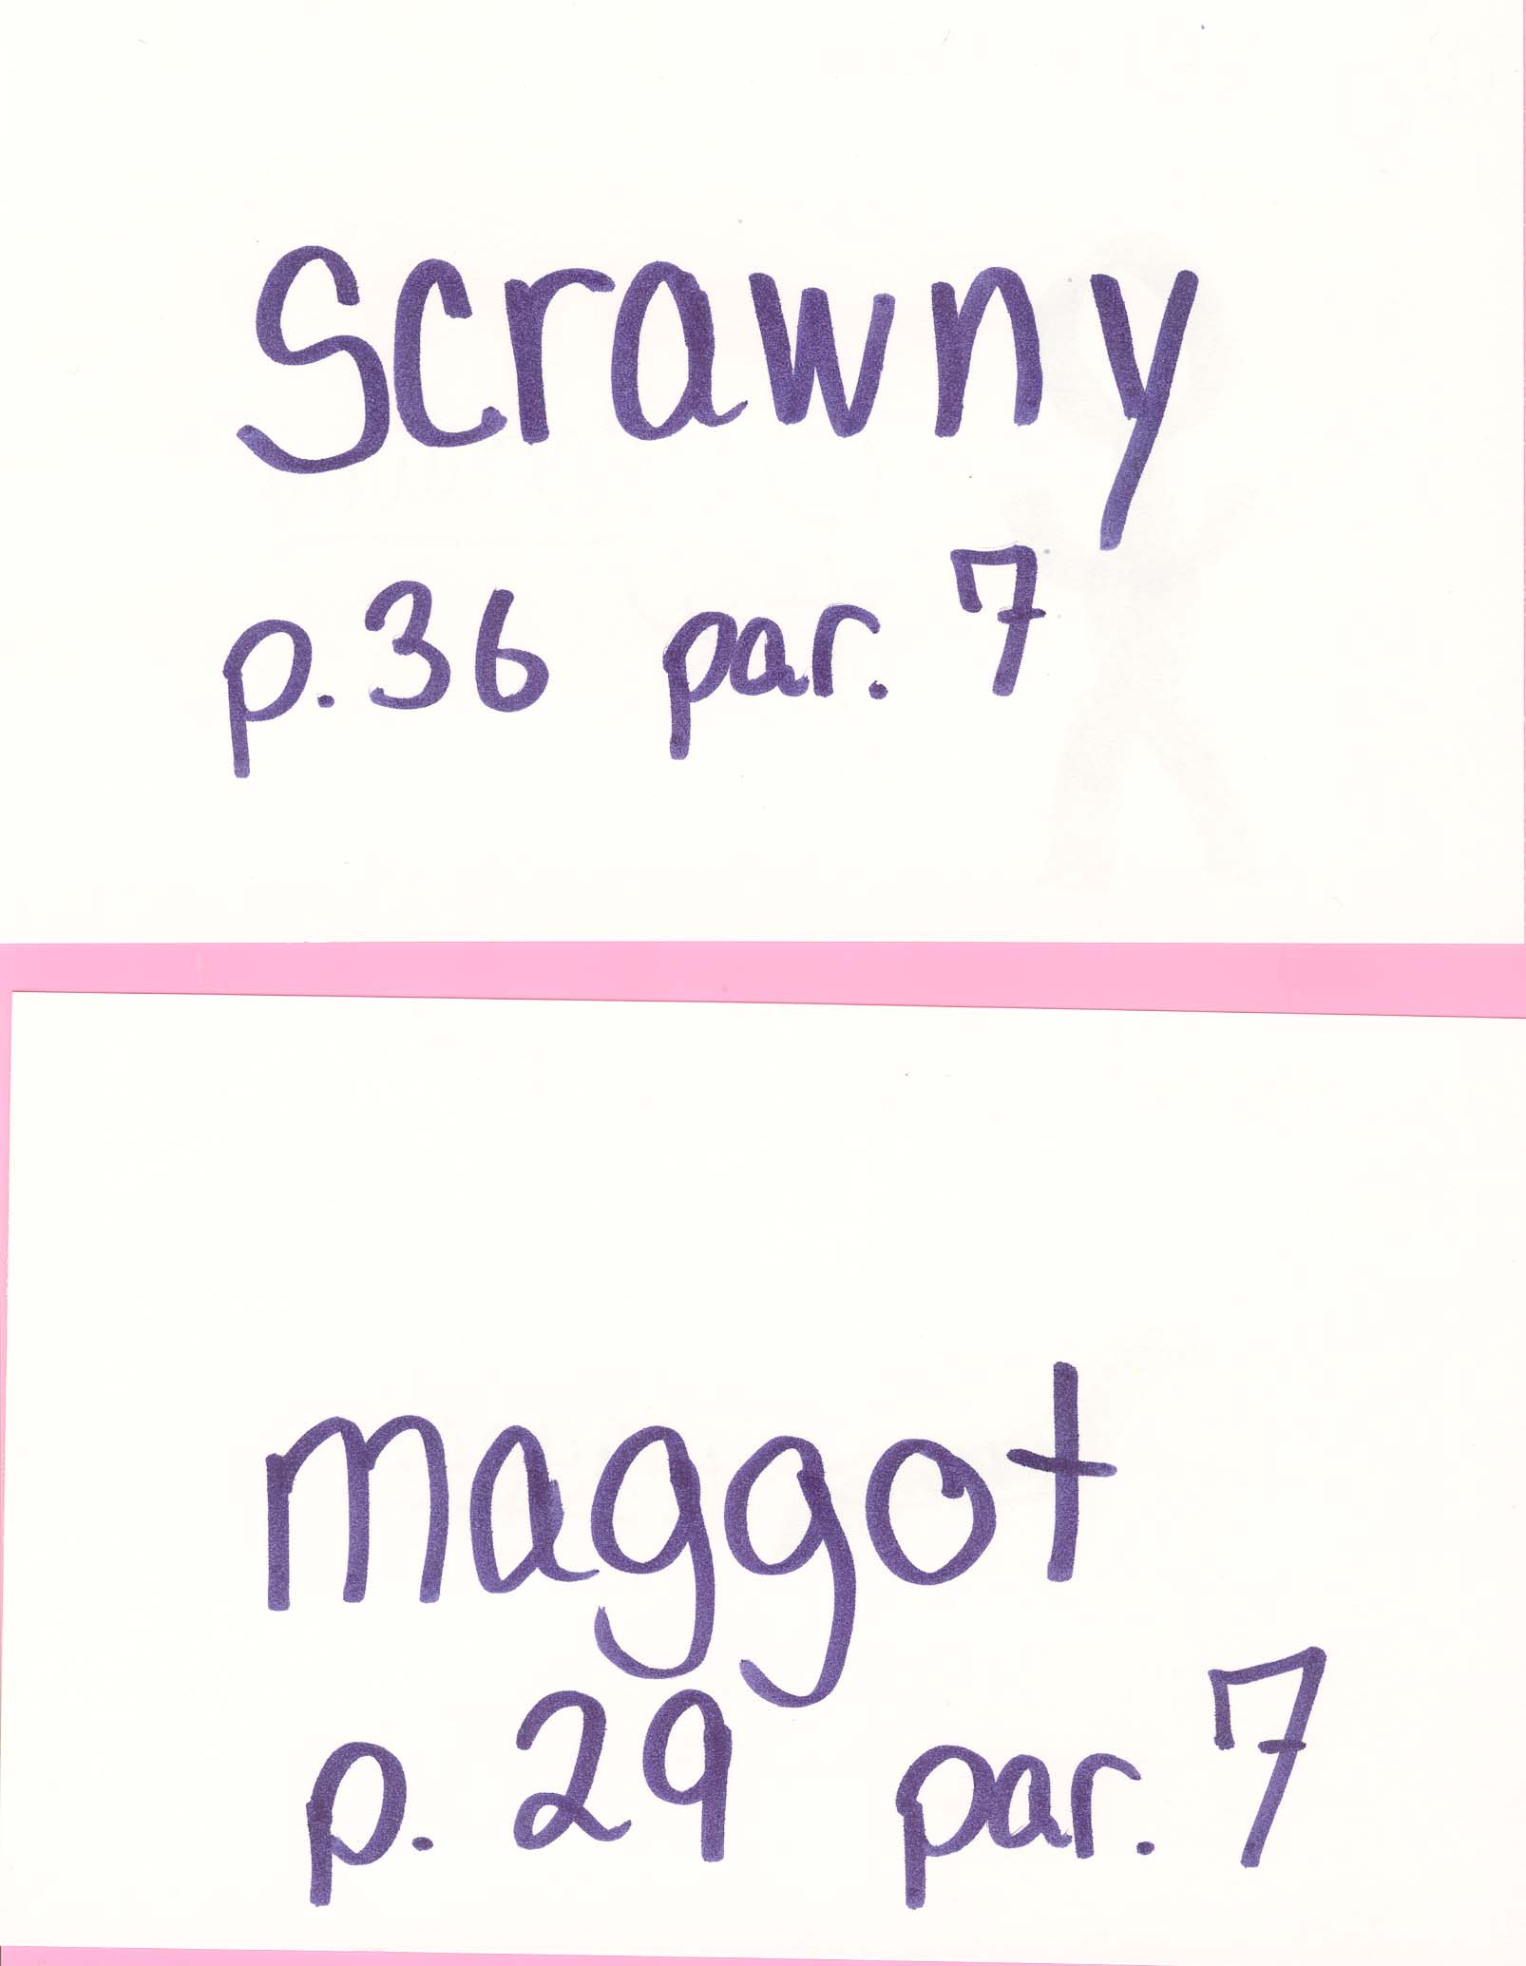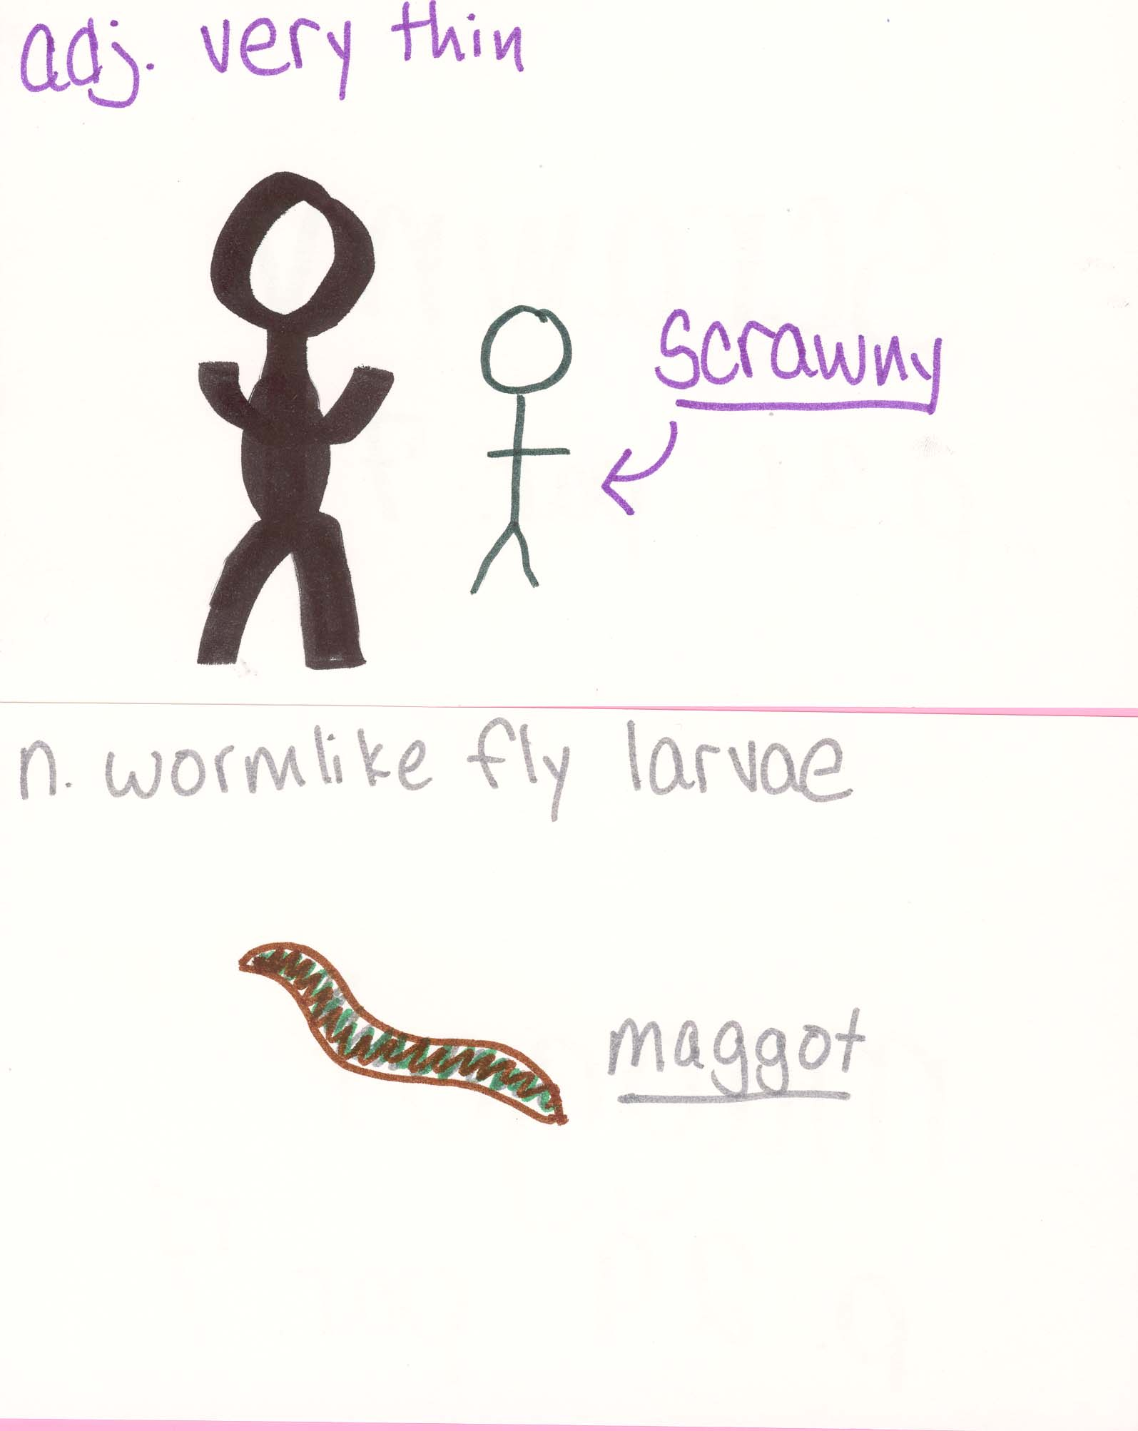

Connector- Section 1

▪ Does this story remind you of any other story you have read or heard? Explain.

Although the stories are completely different, parts of this section of George’s Marvelous Medicine remind me of Willie Wonka and the Chocolate Factory. There is much fantasy in Willy Wonka, as there is when George’s medicine makes Grandma begin to grow and grow. Such a concoction might not actually cause someone to react how Grandma did, just as there is no such soda that would cause one to rise to the ceiling like Charlie did in Willy Wonka. Charlie and the Chocolate Factory was written by Roald Dahl, and is much the same as Willy Wonka. Maybe the reason that these stories resemble each other is because they are written by the same author.

Character Sketch- Section 1
List three traits that describe your chosen character, the page and paragraph where it can be found, and a description of the trait using your own words. Also tell the character’s goal, problem, and possible solution. Draw a sketch of your character.

1. Bitter, p.2, par. 3
Grandma is old and always sees the bad side of things. She is always directly bitter towards George.
2. Two-sided, p.3, par. 7
When George’s parents are home, Grandma is fine. When they leave, she orders George around and is very rude.
3. Untruthful, p.4-5
Grandma lies to George about being a kid, eating chocolate and caterpillars, and telling George other fibs.

Goals: To make George miserable, order him around, and take her medicine every day.
Problem: George fed her the made up medicine and she keeps growing.
Possible Solution: Stop drinking the medicine that he gives her, or take a different one.

See next page for character sketch.

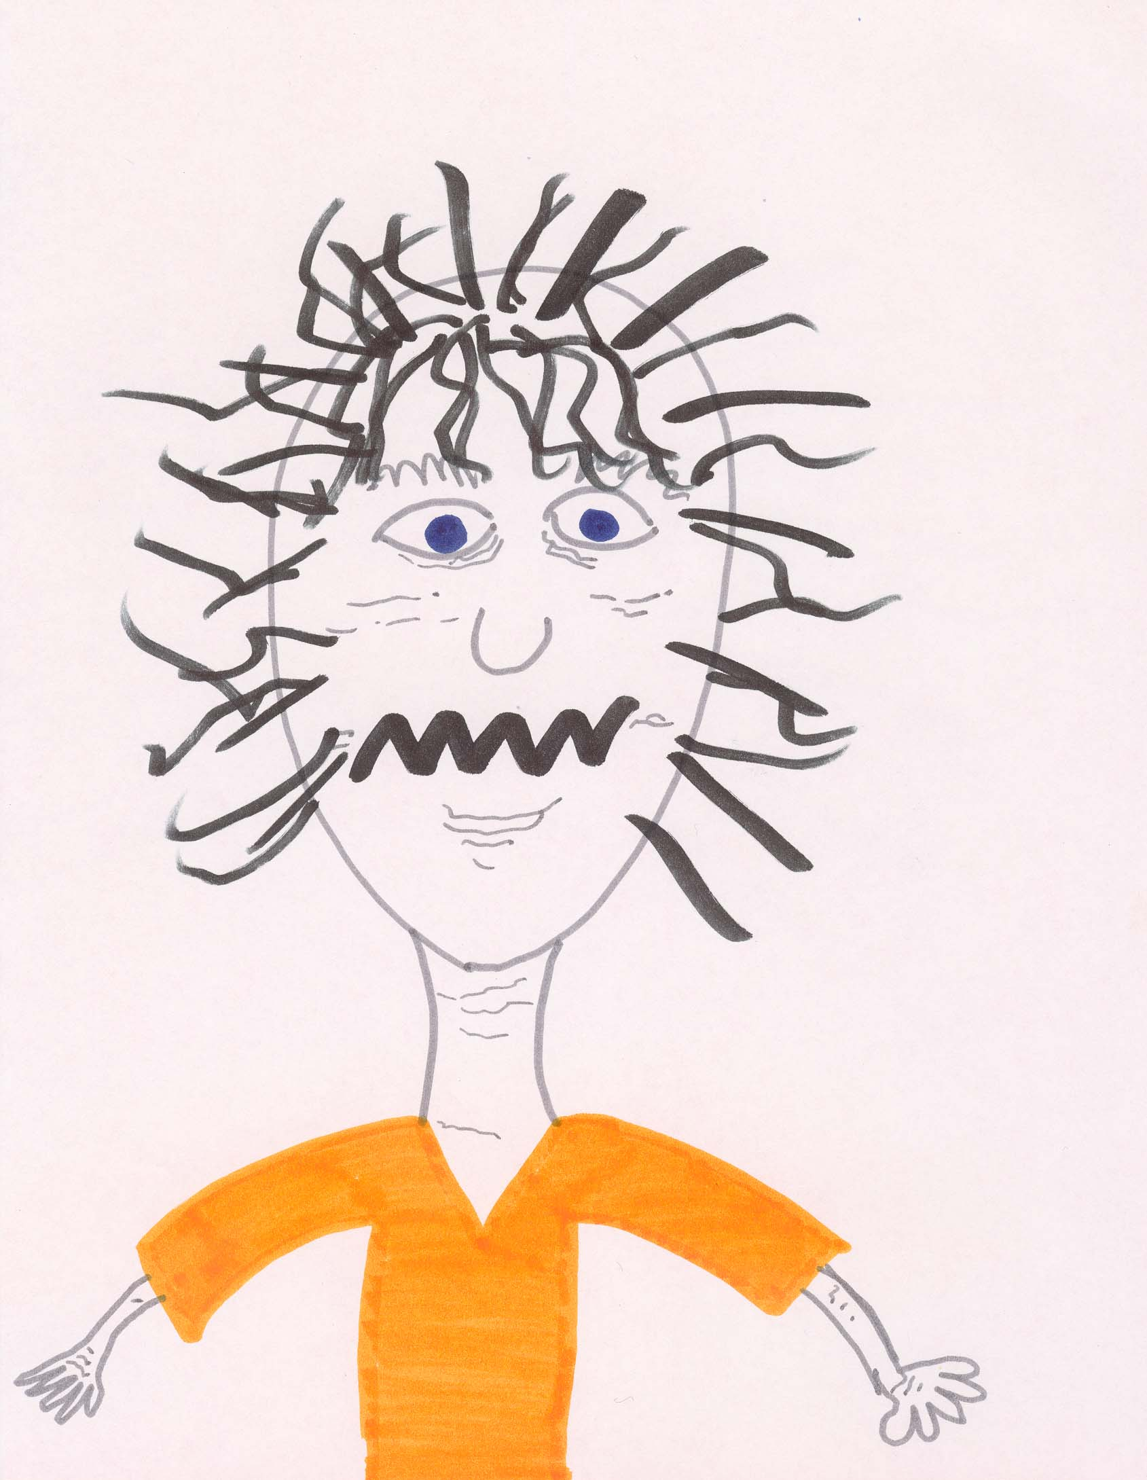

George’s Marvelous Medicine
Section 2, pages 41-89

Character Sketcher
Your job is to complete the role sheet for one of the following characters: George, Grandma, Mr. Killy Kranky

Discussion Director
Your job is to ask 6 questions, write their answers and the page and paragraph where they are found in the text (if possible). Ask thinking questions in the following categories:
1 MCEOG
1 Problem/ Solution
2 Prediction
1 Fact/ Opinion
1 Cause/ Effect

Passage Picker
Pick 4 passages that show the following:
1 Surprising
1 Funny
1 Descriptive
1 Figurative

Word Wizard
Your job is to complete the role sheet and word wizard card for the following words found in the text:
greedy- p. 43, par. 5
colossal- p. 50, par. 2
idle- p. 58, par. 2
hesitate- p. 68, par. 5
brute- p. 78, par. 8
nuisance- p. 89, line 2
Connector
Your job is to connect this section of the book to the outside world. Write a paragraph answering one of the following statements:
• Does this story remind you of any other story that you have read or heard? Explain.
• Would your friends like to read this book? Why or why not?

The BFG
Section 3, pages 9-37

Character Sketcher
Your job is to complete the role sheet for one of the following characters: Sofie, the BFG

Discussion Director
Your job is to ask 6 questions, write their answers and the page and paragraph where they are found in the text (if possible). Ask thinking questions in the following categories:
1 Characterization
1 Sequencing
1 MCEOG
1 Surprising
1 Compare/ Contrast
1 Setting

Passage Picker
Pick 4 passages that show the following:
1 Simile
1 Step by Step
1 Fantasy
1 Descriptive

Word Wizard
Your job is to complete the role sheet and word wizard card for the following words found in the text:
tingling-p. 15, par. 6
smothered- p. 17, par. 4
craggy- p. 22, par. 1
rasher- p. 23, par. 3
peculiar- p. 26, par. 7
tremendous- p. 33, par. 5
Summarizer
Your job is to give a brief summary of this section of the story. Include in your summary the beginning, middle, and end of this section. Examples are:
- Who the characters are
- Where the story takes place
- When the story takes place
- What the problem is

Summarizer (Section 3)

Your job is to give a brief summary of this section of the story. Include in your summary the beginning, middle, and end of this section. Examples are:
- Who the characters are
- Where the story takes place
- When the story takes place
- What the problem is

The characters introduced in this section are Sofie and the BFG, and the story takes place at the present time in Sofie’s neighborhood as well as the BFG’s cave.
Sofie couldn’t sleep one night, so she sneaked out of bed to look out of her bedroom window. She sees this huge person-like thing walking down the street. It sees that she has seen him and grabbed her out of her window, smothered in a blanket. The giant person ran and ran with Sofie in the blanket, and she thought that the giant was running away so he could eat her as soon as possible. When they finally get to the giants cave, he lets her out of the blanket. It turns out that he is not going to eat her, but rather is the Big Friendly Giant. There are other giants that live in the same area who would eat her in a second. But the BFG said that if she sticks with him she would be all right. The reason that he took her out of her bed was because she saw him. He could not let a child spread rumors that giants really do exist!

The BFG
Section 4, pages 38-69

Character Sketcher
Your job is to complete the role sheet for one of the following characters: Sofie, the BFG, Mrs. Clonkers, The Bloodbottler

Discussion Director
Your job is to ask 6 questions, write their answers and the page and paragraph where they are found in the text (if possible). Ask thinking questions in the following categories:
1 Compare/ Contrast
1 Funny
1 MCEOG
1 Problem/ Solution
1 Genre
1 Thinking Question on Your Own

Passage Picker
Pick 4 passages that show the following:
1 Sad
1 Surprising
1 Scary
1 On Your Own

Word Wizard
Your job is to complete the role sheet and word wizard card for the following words found in the text:
grandly p. 49, par. 2
perambulator p. 49, par. 3
forlorn p. 50, par. 3
winsome p. 52, par. 4
stammered p. 57, par. 1
reverberated p. 68, par. 2
Artful Artist
Your job is to draw a picture that illustrates what you like best about this section of the story. After finishing your picture, write about your drawing.
- Who or what my picture is about
- Where my picture takes place
- When it is happening
- Why I drew it

Artful Artist (section 4)
Your job is to draw a picture that illustrates what you like best about this section of the story. After finishing your picture, write about your drawing.
- Who or what my picture is about
- Where my picture takes place
- When it is happening
- Why I drew it

I drew a picture of the frobscottle drink. This is the drink that the BFG shares with Sofie when she is thirsty. The two of them share the drink inside the BFG’s cave. It happens right after the Bloodbottler leaves the cave.
I chose to draw this bottle because I think that it is a really funny and strange type of refreshment. Apparently it taste’s very good, but it is so different from any drink that we have ever heard of. It is so strange that the bubbles fizz down the drink instead of up. It is also very funny that this drink makes the giants pass gas, which is something good to them.

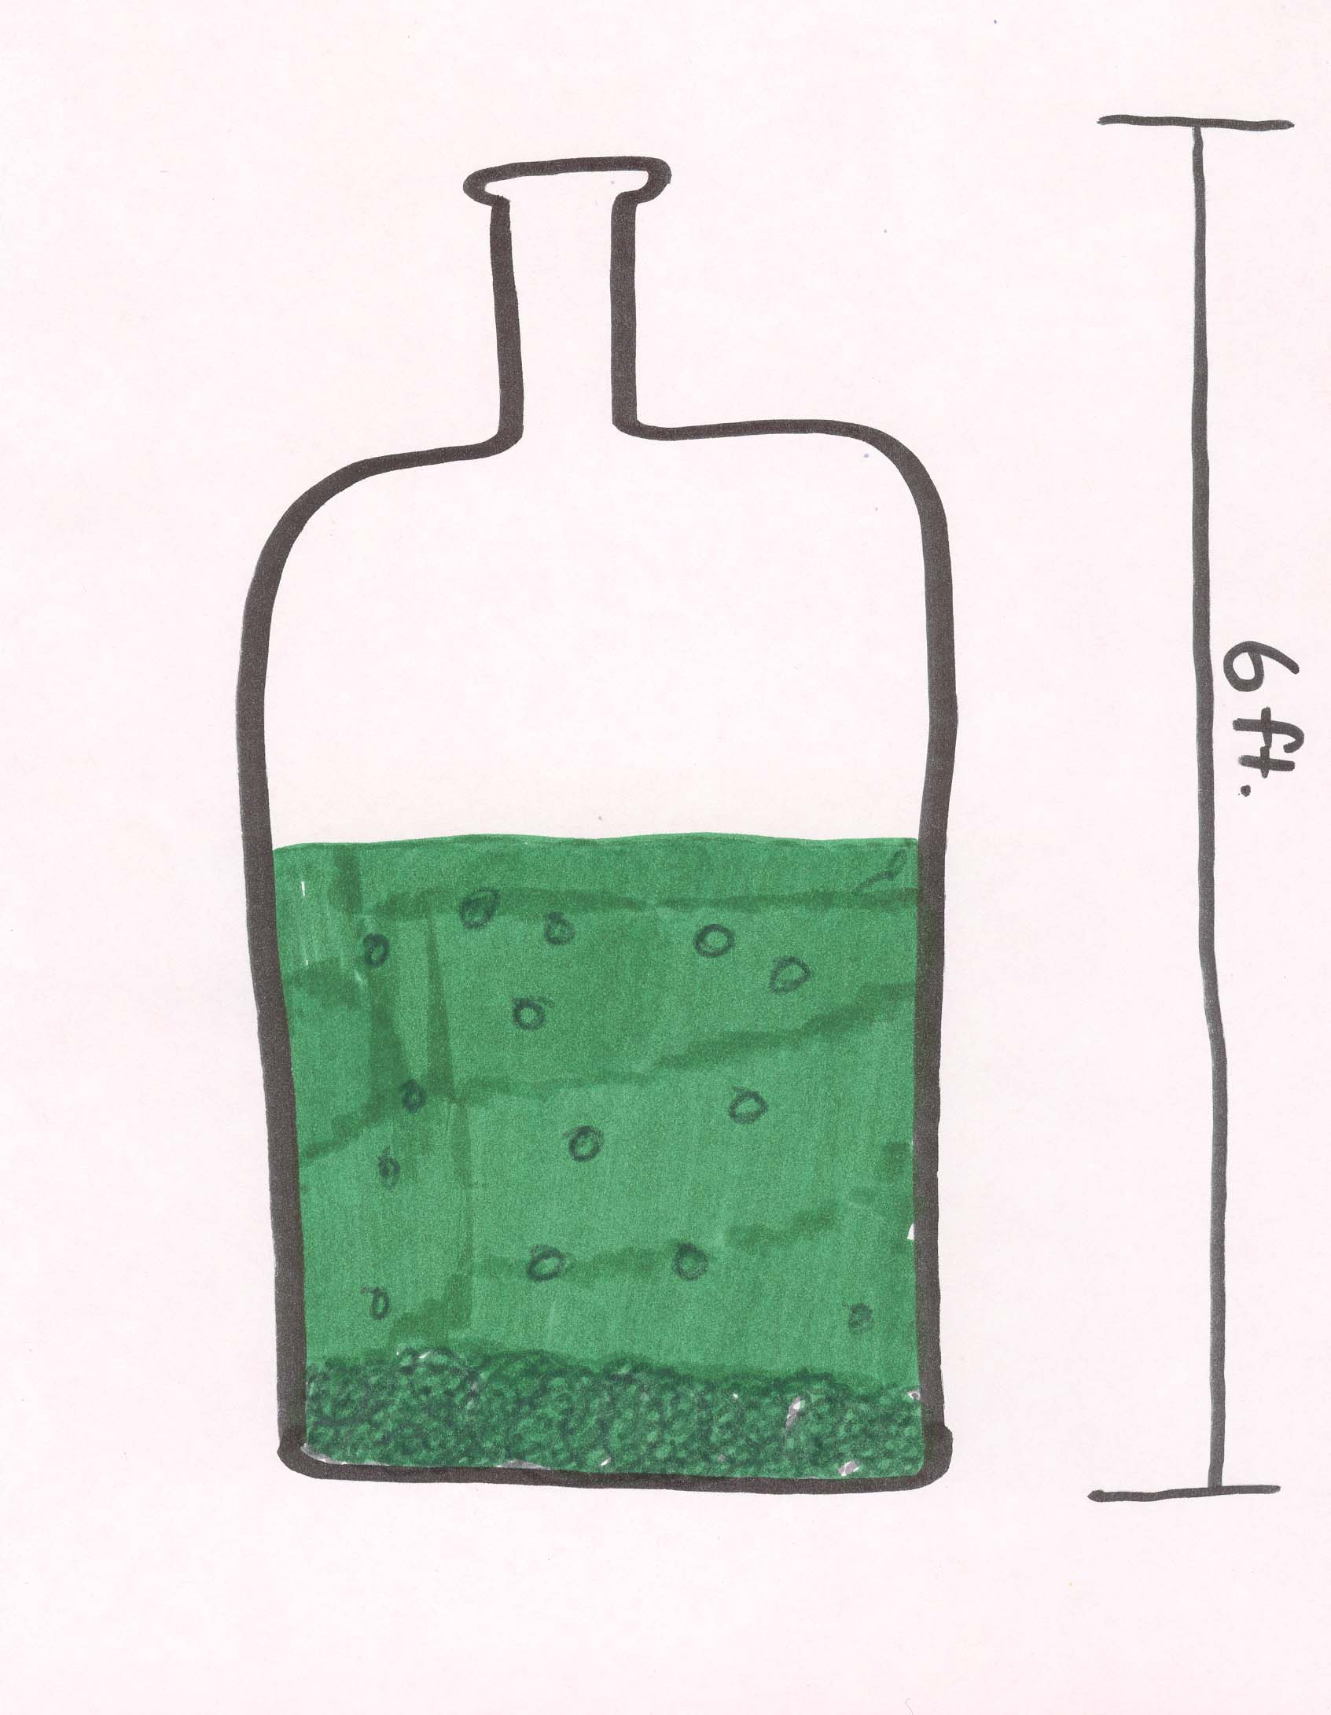

The BFG
Section 5, pages 70-114

Character Sketcher
Your job is to complete the role sheet for one of the following characters: Sofie, the BFG, The Fleshlumpeater

Discussion Director
Your job is to ask 6 questions, write their answers and the page and paragraph where they are found in the text (if possible). Ask thinking questions in the following categories:
1 Fact/ Opinion
1 Characterization
1 Problem Solution
1 MCEOG
1 Compare/ Contrast
1 Thinking Question on Your Own

Passage Picker
Pick 4 passages that show the following:
1 Descriptive
1 Interesting
1 Figurative
1 Cause/ Effect

Word Wizard
Your job is to complete the role sheet and word wizard card for the following words found in the text:
intercept p.72, par. 5
phenomenal p. 79, par. 10
ashy p.80, par. 3
thrashing p. 85, par. 5
regarded p. 99, par. 4
horizon p. 114, par. 5

Summarizer
Your job is to give a brief summary of this section of the story. Include in your summary the beginning, middle, and end of this section. Examples are:
- Who the characters are
- Where the story takes place
- When the story takes place
- What the problem is

The BFG
Section 6, pages 115-146

Character Sketcher
Your job is to complete the role sheet for one of the following characters: Sofie, The BFG

Discussion Director
Your job is to ask 6 questions, write their answers and the page and paragraph where they are found in the text (if possible). Ask thinking questions in the following categories:
2 MCEOG
1 Cause/ Effect
1 Sequence
1 Hero/ Heroine
1 Thinking question on your own

Passage Picker
Pick 4 passages that show the following:
1 Simile
1 Descriptive
1 Thematic
1 Passage on you own

Word Wizard
Your job is to complete the role sheet and word wizard card for the following words found in the text:
famished p. 124, par. 14
curtsey p.131, par. 1
desolate p. 133, par. 2
blurred p. 134, line3
crouching p. 136, par. 9
vast p.142, par. 8
Artful Artist
Your job is to draw a picture that illustrates what you like best about this section of the story. After finishing your picture, write about your drawing.
- Who or what my picture is about
- Where my picture takes place
- When it is happening
- Why I drew it

The BFG
Section 7, pages 147-175

Character Sketcher
Your job is to complete the role sheet for one of the following characters: Sofie, The BFG, The Queen, Mr. Tibbs

Discussion Director
Your job is to ask 6 questions, write their answers and the page and paragraph where they are found in the text (if possible). Ask thinking questions in the following categories:
1 Interesting
1 Factual
1 Problem/ Solution
1 Main Idea
1 Setting
1 MCEOG

Passage Picker
Pick 4 passages that show the following:
1 Problem/ Solution
1 Math
1 Informative
1 Descriptive

Word Wizard
Your job is to complete the role sheet and word wizard card for the following words found in the text:
distressed p.149, par. 5
punctuated p. 150, par. 12
absurdity p. 155, par. 2
frantic p. 162, par. 1
disdainful p.166, par.4
appalled p.172, par. 7

Author Investigator
Your job is to investigate the life and accomplishments of the author of The BFG, Roald Dahl. Prepare a very brief synopsis ( a paragraph or two) of his accomplishments and possibly some interesting or fun facts about Dahl. You may use any respectable source that you wish. Following are some websites that will be particularly helpful in your search:
www.roalddahlfans.com
www.kirjasto.sci.fi/rdahl.htm
www.surfnetkids.com/dahl.htm
www.roaldahl.com

Author Investigator
Your job is to investigate the life and accomplishments of the author of The BFG, Roald Dahl. Prepare a very brief synopsis (a paragraph or two) of his accomplishments and possibly some interesting or fun facts about Dahl. You may use any reputable source that you wish.

Roald Dahl is one of the world’s most beloved children’s authors. He was born in 1916 in Llandaff, South Whales. Before he began writing books he had a few other jobs. He worked for Shell Oil in East Africa before joining the Royal Air Force. He flew a fighter plane in Kenya and was then stationed in Greece. He finally published his first full-length book in 1943. It was titled The Gremlins. Since then he has continued to write multitudes of wonderful books, winning prestigious awards for so many of them.
There is a museum exhibit dedicated to Dahl at the Buckinghamshire County museum. You can discover Willy Wonka’s inventions, go inside the Giant Peach, and much more! Dahl has many interested fans, which is extremely apparent in all of the sites and articles dedicated to him.

The BFG
Section 8, pages 176-208

Character Sketcher
Your job is to complete the role sheet for one of the following characters: Sofie, The BFG, The Queen

Discussion Director
Your job is to ask 6 questions, write their answers and the page and paragraph where they are found in the text (if possible). Ask thinking questions in the following categories:
1 Point of View
1 Theme/ Moral
1 Main Idea
1 Interesting
1 Point of View
1 Thinking questions on your own

Passage Picker
Pick 4 passages that show the following:
1 Important
1 Thematic
1 Cause/ Effect
1 Point of View

Word Wizard
Your job is to complete the role sheet and word wizard card for the following words found in the text:
ninepins p. 177, par. 7
grudgingly p. 179, par. 1
broadly p. 186, par. 5
grotesque p. 188, line 1
hovering p. 196, par. 2
contrivance p. 199, par. 1
Connector
Your job is to connect this section of the book to the outside world. Write a paragraph answering two of the following statements/questions:
- Does this part of the story remind you of any other story that you have read or heard? Explain.
- Does this part of the story remind you of anything that has happened to you? Explain.
- Would your friends like to read this book? Why or why not?

