4th Grade
Literature Circle Unit
The Long Winter
By
Laura Ingalls Wilder

By Liz Brown
11-7-02

The Long Winter by Laura Ingalls Wilder is a 4th Grade book about an extremely difficult winter the Ingalls family faced. Laura Ingalls and her family live on the Praire but when Pa has a feeling that the winter is going to be a difficult one, he moves his family into town. Pa’s intuition was correct and it was the worst winter anyone had seen in a long time. The Ingalls family handles the winter well until supplies begin to run short and the trains can not travel down the tracks because the snow is so deep. When supplies in the town get really low, Almanzo and Cap go to look for wheat based on a rumor they heard that a man 20 miles outside of town had some. Almanzo and Cap are able to buy 60 bushels of wheat and return to town to divide the wheat up among families right before another blizzard strikes and the families are able to get by until spring. The following literature circle unit is designed to do with a fourth grade class. By doing a literature circle with a book you provide a great way to integrate other subject into language arts. You also quickly meet many of the North Carolina Competency goals.

Competency Goals the Literature Circle meets:

English and Language Arts:
Competency Goal 1: The learner will apply enabling strategies and skills to read and write.

1.01 Use word identification strategies appropriately and automatically when encountering unknown words (graphophonic, syntactic, semantic).
1.02 Infer word meanings from taught roots, prefixes, and suffixes to decode words in text to assist comprehension.
1.03 Identify key words and discover their meanings and relationships through a variety of strategies.
1.04 Increase reading and writing vocabulary through:
- wide reading.
- word study.
- knowledge of homophones, synonyms, antonyms, homonyms.
- knowledge of multiple meanings of words.
- writing process elements.
- writing as a tool for learning.
- seminars.
- book clubs.
- discussions.
- examining the author’s craft.
1.05 Use word reference materials (e.g., glossary, dictionary, thesaurus) to identify and comprehend unknown words.
1.06 Read independently daily from self-selected materials (consistent with the student’s independent reading level) to:
- increase fluency.
- build background knowledge.
- expand vocabulary.
Competency Goal 2: The learner will apply strategies and skills to comprehend text that is read, heard, and viewed.

2.01 Use metacognitive strategies to comprehend text and to clarify meaning of vocabulary (e.g., reread the text, consult other sources, ask for help, paraphrase, question).
2.02 Interact with the text before, during, and after reading, listening, and viewing by:
- setting a purpose using prior knowledge and text information.
- making predictions.
- formulating questions.
- locating relevant information.
- making connections with previous experiences, information, and ideas.
2.03 Read a variety of texts, including:
- fiction (legends, novels, folklore, science fiction).
- nonfiction (autobiographies, informational books, diaries, journals).
- poetry (concrete, haiku).
- drama (skits, plays).
2.04 Identify and interpret elements of fiction and nonfiction and support by referencing the text to determine the:
- plot.
- theme.
- main idea and supporting details.
- author’s choice of words.
2.05 Make inferences, draw conclusions, make generalizations, and support by referencing the text.
2.06 Summarize major points from fiction and nonfiction text(s) to clarify and retain information and ideas.
2.07 Determine usefulness of information and ideas consistent with purpose.
2.08 Verify the meaning or accuracy of the author’s statement(s) by referencing the text or other resources.
2.09 Listen actively by:
- asking questions.
- paraphrasing what was said.
- interpreting speaker’s verbal and non-verbal messages.
- interpreting speaker’s purposes and/or intent
Competency Goal 3: The learner will make connections with text through the use of oral language, written language, and media and technology.

3.01 Respond to fiction, nonfiction, poetry, and drama using interpretive, critical, and evaluative processes by:
- analyzing the impact of authors’ word choice and context.
- examining the reasons for characters’ actions.
- identifying and examining characters’ motives.
- considering a situation or problem from different characters’ points of view.
3.02 Analyze characters, events, and plots from different selections and cite supporting evidence.
3.03 Consider the ways language and visuals bring characters to life, enhance plot development, and produce a response.
3.04 Make informed judgments about television and film/video productions.
3.05 Integrate information from two or more sources to expand understanding of text.
3.06 Conduct research for assigned projects or self-selected projects (with assistance) from a variety of sources through the use of technological and informal tools (e.g., print and non-print texts, artifacts, people, libraries, databases, computer networks).
Competency Goal 4: The learner will apply strategies and skills to create oral, written, and visual texts.

4.01 Read aloud grade-appropriate text with fluency, comprehension, and expression demonstrating an awareness of volume and pace.
4.02 Use oral and written language to:
- present information and ideas in a clear, concise manner.
- discuss.
- interview.
- solve problems.
- make decisions.
4.03 Make oral and written presentations using visual aids with an awareness of purpose and audience.
4.04 Share self-selected texts from a variety of genres (e.g., poetry, letters, narratives, essays, presentations).
4.05 Use planning strategies to generate topics and organize ideas (e.g., brainstorming, mapping, webbing, reading, discussion).
4.06 Compose a draft that conveys major ideas and maintains focus on the topic with specific, relevant, supporting details by using preliminary plans.
4.07 Compose fiction, nonfiction, poetry, and drama using self-selected and assigned topics and forms (e.g., personal and imaginative narratives, research reports, diaries, journals, logs, rules, instructions).
4.08 Focus revision on a specific element such as:
- word choice.
- sequence of events and ideas.
- transitional words.
- sentence patterns.
4.09 Produce work that follows the conventions of particular genres (e.g., personal and imaginative narrative, research reports, learning logs, letters of request, letters of complaint).
4.10 Use technology as a tool to gather, organize, and present information.

The Long Winter by Laura Ingalls Wilder
Section 1: Pages 1-37

Character Sketcher:
Your job as character sketcher is to follow the role sheet and identify one of the following characters: (Laura, Ma, or Pa)

Discussion Director:
Your job is to ask 5 questions. If the answers to the questions are found in the section you must cite the page and paragraph. Remember to ask good thinking questions!

1 MCEOG question
1 cause and effect
1 setting question
1 prediction question
1 on your own

Passage Picker:
Complete the role sheet for the following 4 passages. Remember to cite page numbers and paragraphs.

1 descriptive
1 cause and effect
2 figurative language

Word Wizard:
Complete the role sheet for the following words:

Slough (pg. 1 par. 2)
Trampling (pg. 6 par. 1)
Muskrat (pg. 12 par. 4)
Equinoctial (pg. 27 par. 2)
Muslin (pg 33. par 1)

Summarizer:
Give a brief summary of today’s section. Be sure to include all the major events and characters in the section.

Character Sketcher

Your job as Character Sketcher is to identify a character’s actions (traits) and explain or prove these traits, identify their goal, identify the problem and solution in the reading, and also draw the character based on descriptive passages provided in the reading.
The actions of your character may or may not be directly stated in the reading. If they are not directly stated you must choose implied traits you become aware of as you read.
In some sections, both the problem and solution are not provided. If this is the case provide a possible solution to the problem or predict what problem you think the character may encounter.

Pa (Charles Ingalls)

Character Traits (3)
- Pa is a hard worker. (pg 1 par 2, page 2 par 3, pg 5 par 1)
Pa is a hard worker because he is doing all of the labor in the heat of the day, stopping only for a drink of water and continuing until all of the work is completed.

- Pa is grateful. (pg 9 par 1)
Pa is grateful to have Laura’s help with the chores. Without her help, it would have taken him all day to stack the hay, but now he can spend the afternoon mowing.

- Pa is nervous. (pg. 12 par 2-4)
Pa is nervous that they are going to have a hard winter because the muskrat walls are so thick.

Character Goal:
Pa’s main goal in this section is to get as much accomplished on their farm as possible. He gets the field mowed, harvests some corn, and attempts to hunt for some food.

Problem:
There really isn’t a main problem yet but the section alludes to the fact that the winter is going to be harsh and the reader begins to wonder how Pa is going to take care of the family and the farm if a blizzard does occur.

Solution:
A possible solution to a hard winter would be methods which Pa takes to make sure his family is properly cared for.

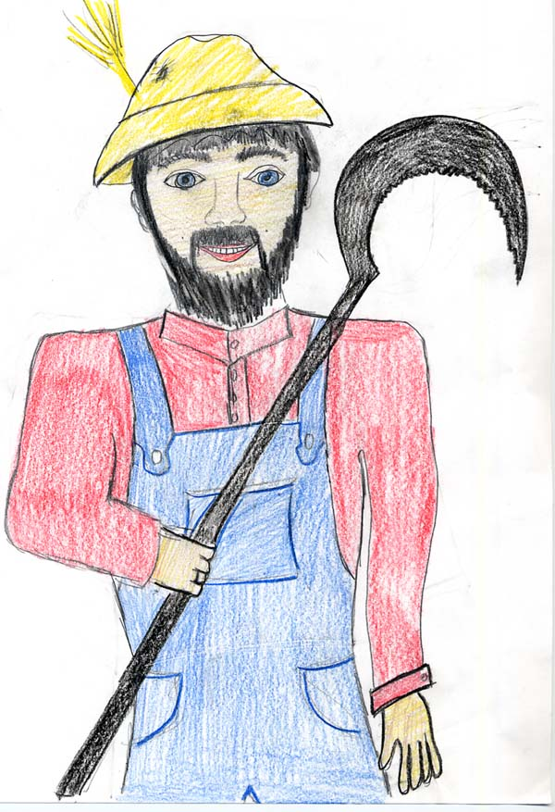

Discussion Director

The job of the discussion director is to ask questions which will initiate discussion. The discussion director will provide citations wherever possible.

- All of the following words describe Laura except which one?
  - caring
  - helpful
  - brave
  - mischievous

- What causes Pa to think that the winter is going to be harsh?

Answer: Pa notices that the muskrats have built their walls thicker than he has ever seen in the past. Pa also goes hunting and comes back empty-handed because there is not an animal in sight. All of the birds were flying as high as they could in the sky to get as far away as they could. (pg 12 and 34)

- Describe the setting of the story?

Answer: The Long Winter is set on a prairie in the Dakota Territory. Laura and her family live together in a house on a field. They live a few miles from town but traveling into town for supplies can be done by walking (pg 17). There is an area of slough which is not too far from their house which Laura and Carrie temporarily get lost in (pg 21).

- Based on the thickness of the muskrat walls and Pa’s nervousness about the upcoming winter, what do you think will happen?

Answer: I think that the Wilder family will experience a very harsh winter which they will never forget.

- When were the two times in the story that Laura has shown bravery?

Answer:
Laura was brave when she went to town to buy the mowing-machine part for Pa. Laura dislikes going to town and dealing with strangers but she didn’t want Carrie to know she was scared so she acted calm and collected. Laura was also brave when she and Carrie got lost in the Sloth. Laura never let Carrie know she was afraid that they wouldn’t find their way home (pg 22).

Passage Picker

The job of the passage picker is to pick out passages from the reading that worth discussing in the group. Be sure you write down the passage and call on one of your group members to read the passage out loud. After you have read the passage out loud tell what type of passage it is and why. Then think of a good thinking question to go along with your passage and finally include a reason why the author included the passage or what you think the passage adds to the story.

Descriptive:
“Under her feet the hay climbed higher, trampled down as solid as hay can be. Up and down, fast and hard, her legs kept going, the length of the hayrack and back, and across the middle. The sunshine was hotter and the smell of the hay rose up sweet and strong. Under their feet it bounced and over the edges of the hayrack it kept coming.” (pg 5 par 3)

This passage is descriptive because it describes how the hay was trampled down and the temperature it was outside.

How would this passage be different if Wilder had chosen not to use descriptive words? If Wilder had not chosen the descriptive words for the passage, it would not have created such a mental picture in my head as to how hard Laura was working to help Pa.

I believe Wilder included this passage to show how hard the work was that Laura, a girl, was doing to help her family.

Cause and Effect:
“She’s as stout as a little French horse. She’s been a great help, said Pa. “It would have taken me all day to stack that hay alone, and now I have the whole afternoon for mowing.” (pg. 9 par 1)

This is a cause and effect passage because tells the reader how Pa’s work was decreased since Laura helped him.

Within this passage is an example of a simile can you find it? She’s as stout as a little French horse is the simile because Laura is being compared to a horse using the word as.

I believe Wilder included this passage in the book because it demonstrates to the reader how much Pa appreciates all of the work that Laura is helping him do.

2 Figurative Language:
“The heat there smelled as good as an oven when bread is baking.” (pg 2).

This passage is a simile because it compares the heat to an oven.

How would this passage be different if the heat smelled like an old shoe? The passage would then suggest that the heat smelled terrible, which is not what the author intended.

I believe Wilder chose to use a simile because it is a creative way to describe an object.

“The mowing machine was humming steadily” (pg 25 par 5).

This passage is an example of personification because it gives the mowing machine a human characteristic, humming.

How would this passage be different if it said “the mowing machine was steady?” The passage would have been changed because the reader would have thought that the mower moved at a steady rate and Wilder wanted the reader to get an idea as to how the mower sounded.

I believe Wilder included this passage in her book because personification is a great tool to use to spice up what you have written and make it more creative.

Word Wizard

Your job as word wizard is to write down the word citing the page and paragraph numbers. You must then copy the sentence from the book in which the word appears. Next, use context clues to determine the meaning and part of speech of the word. Fourth, look up the word in the dictionary and write down the definition. Fifth, explain how the word gives meaning to the story. When you have completed all of this, write the word down on the front of an index card citing the page number. On the back of the card include the part of speech that the word is and draw a picture to represent the word.

Slough
- Page 1 Paragraph 2
- “Laura drew up a pailful of water from the well at the edge of the big slough.”
- I think this word is a noun and I think it is part of the prairie.
- Noun. A boggy, grass covered hill commonly found in the prairie terrain.
- This word adds meaning to the story because it helps to create the setting for the story.

Trampling
- Page 6 Paragraph 1
- “She went on trampling carefully.”
- I think this word is a verb because it shows action and ends in “ing”. I think it means stomping down hard.
- Verb. To flatten, crush, or walk in a stepping manner.
- Trampling adds emphasis to the story because shows a visual representation of Laura’s actions

Muskrat
- Page 11 Paragraph 4
- “After the sun had gone, the muskrats woke and went pattering down the smooth mud-floor of their hallway.
- I think this word is a noun. I believe it is a type of animal/rodent which sleeps through the winter.
- Noun. A large rodent of North America, related to the lemming and the vole and having a dense brown coat and musk glands under a broad tail.
- Muskrat adds meaning to the story because the build thicker walls than Pa has ever seen foreshadowing the hard winter which is to come.

Equinoctial
- Page 27 Paragraph 2
- “Well, we must expect it,” Ma said. “It’s the equinoctial storm.”
- I think this word is a adjective describing the harshness of the storm which has lasted for three days.
- This word is an adjective for the word equinox. Equinox means: Noun. A violent storm of wind and rain occurring at or near the time of the equinox.
- Equinoctial adds meaning to the story because it lets the reader know that the storm has been steady and severe.

Muslin
- Page 33 Paragraph 1
- “Laura was sewing two long breadths of muslin together to make a sheet.”
- I think Muslin is a noun and a type of cloth.
- Noun. Any of various sturdy cotton fabrics of plain weave which are used especially in sheets.
- Muslin adds meaning to the story because it informs to reader as to the materials the Ingalls family had you learn that they made things by sewing them together.

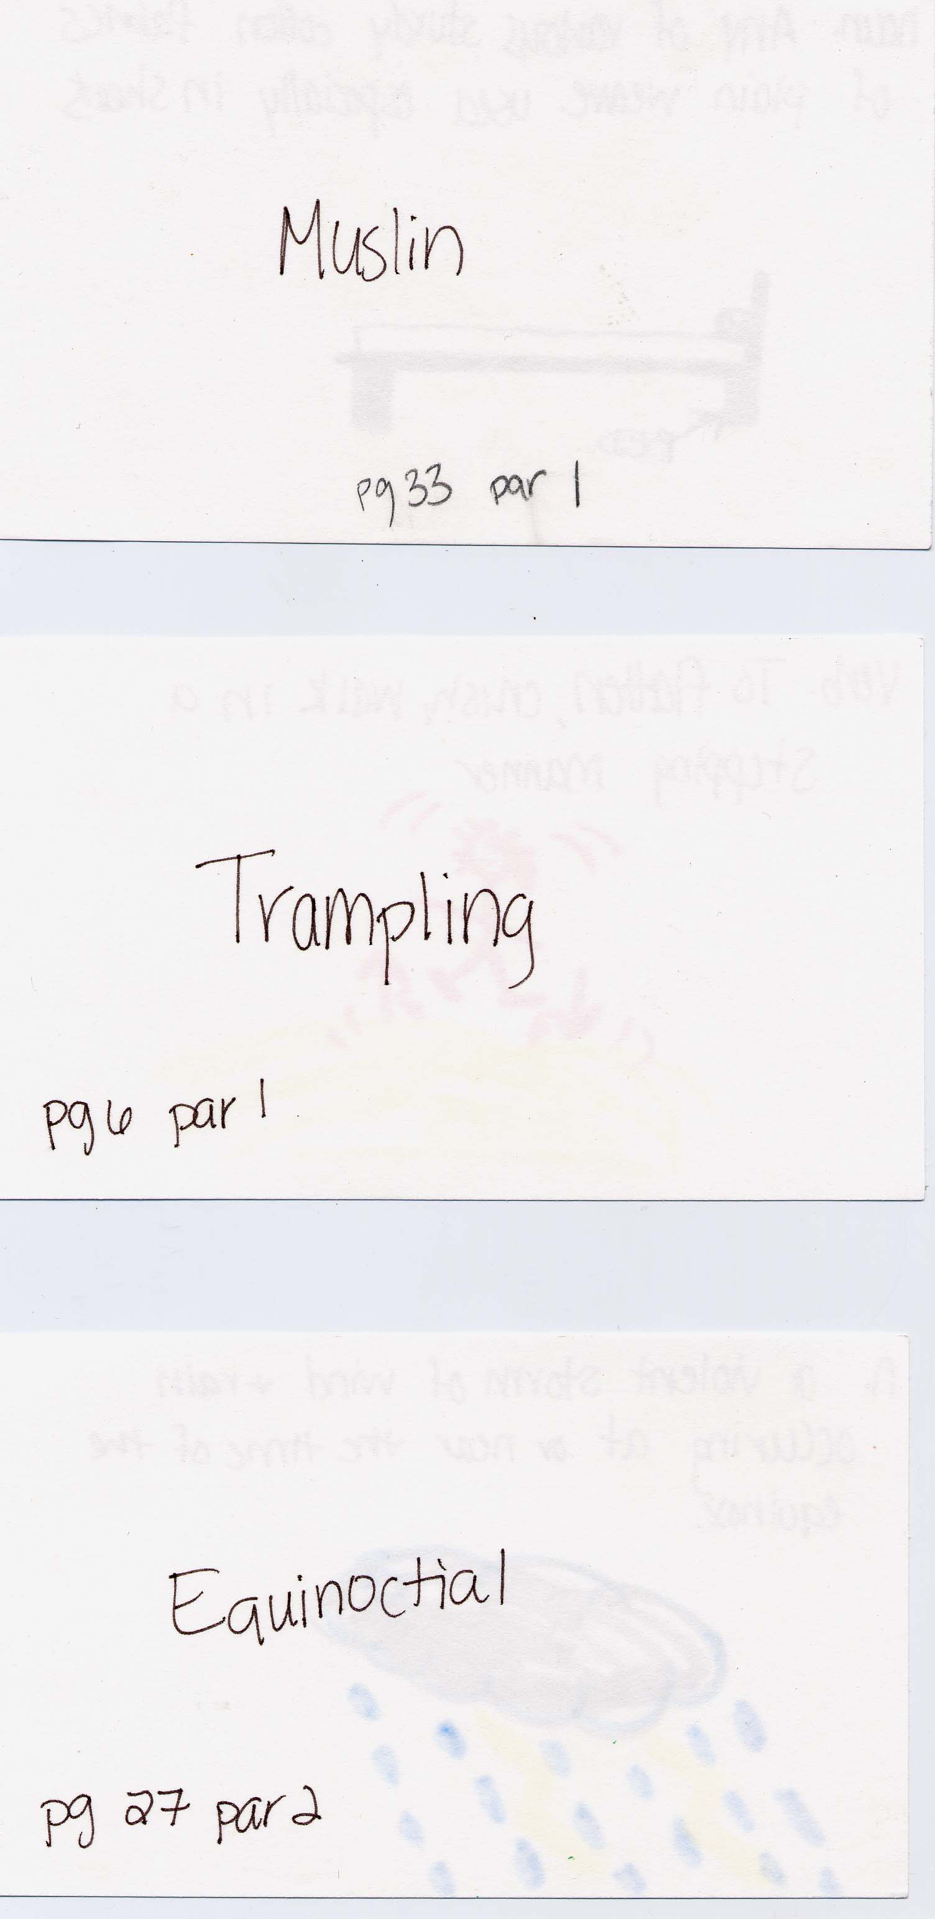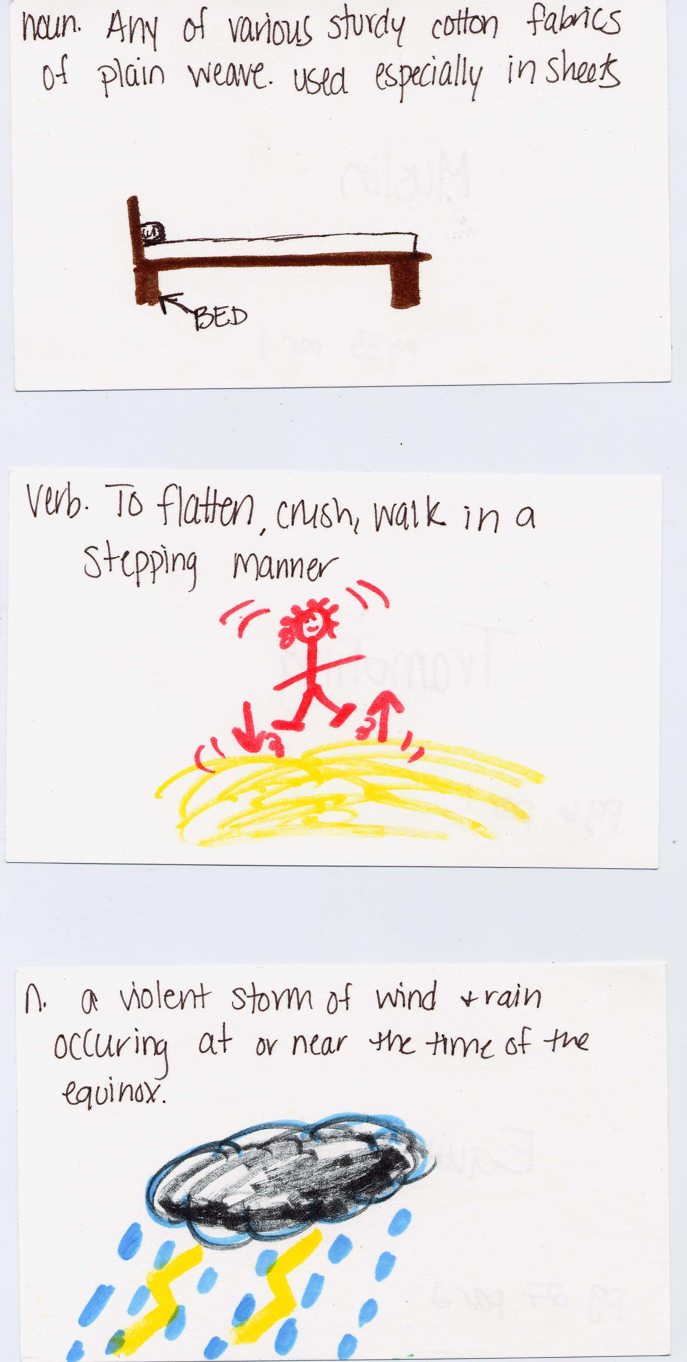
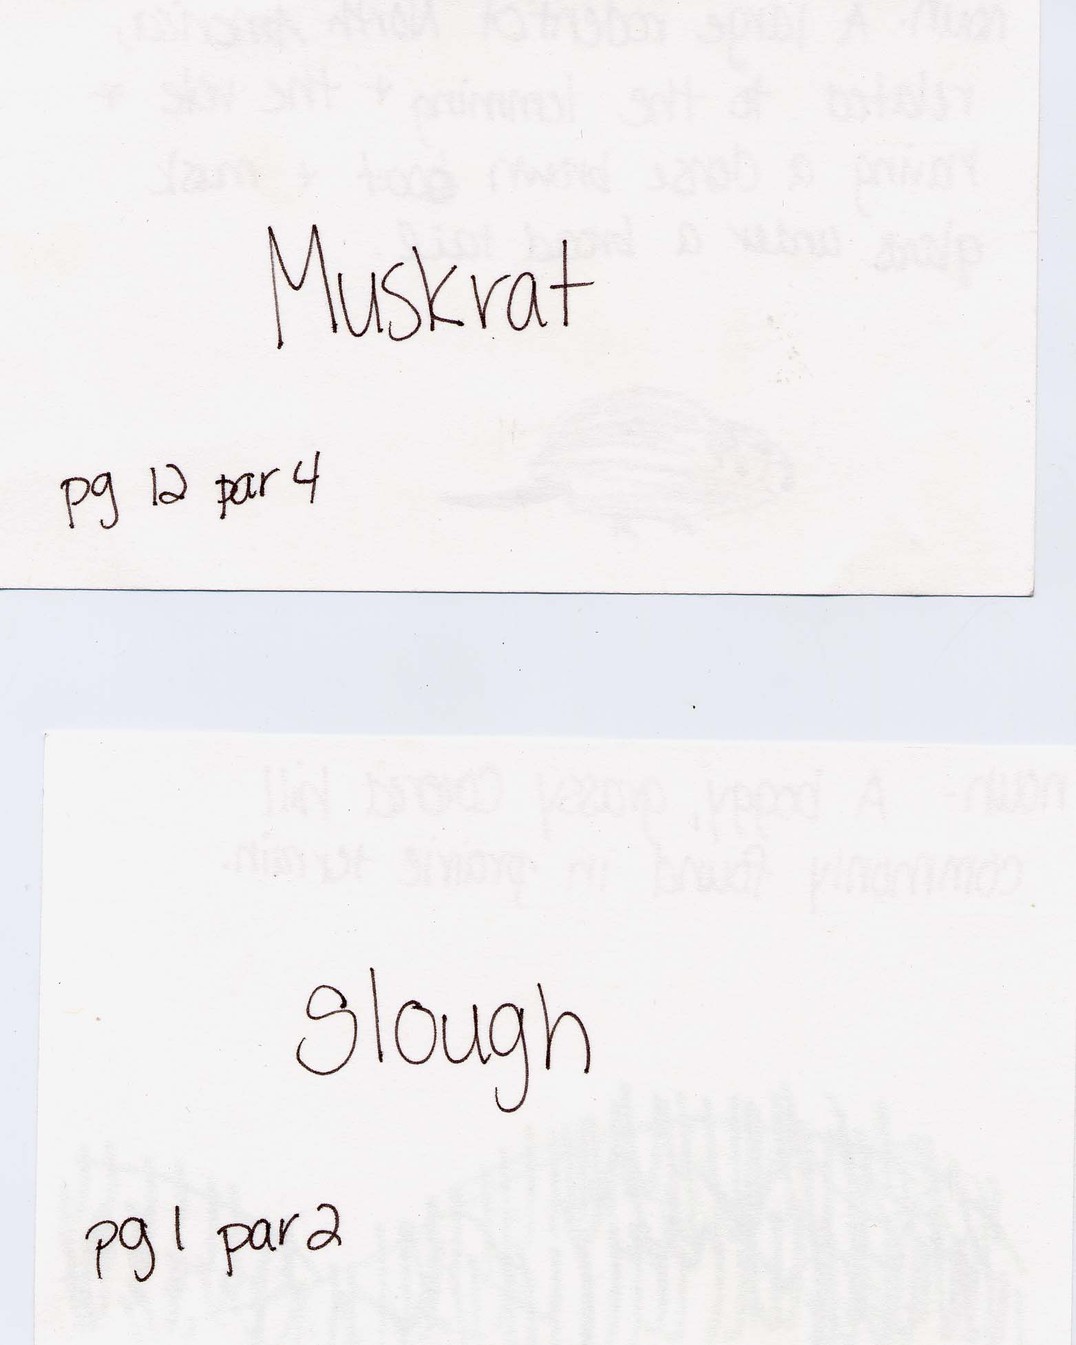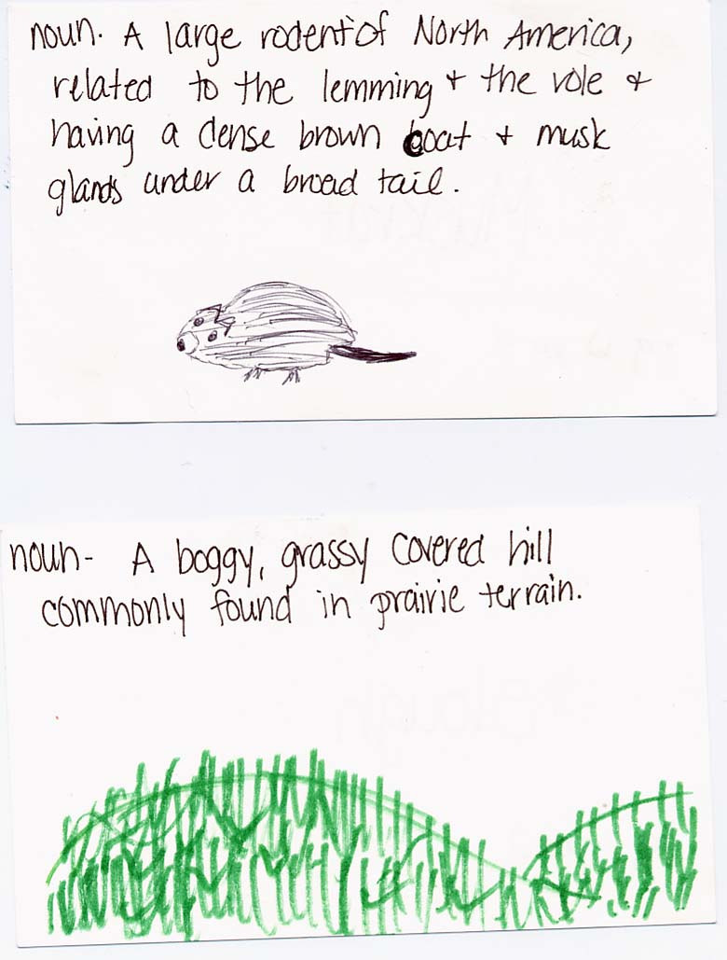

Summarizer

Your job is to prepare a summary of today’s reading. Be sure to include the key points and main events which happened in the reading in your summary.

Summary:
Laura Ingalls, her three sisters, and her parents live in a house on the prairie. Since the Ingalls family does not have much money, Laura begins to help her father with the chores around the farm. Laura is a very responsible girl who has a lot of responsibilities and also does a great deal to help her mother out with chores around the house. Laura’s sister’s, Carrie and Grace, can not help much because they are too small and her older sister, Mary, can not help much because she is blind. Laura’s dad becomes worried that they are going to have a harsh winter because the muskrats have built thick walls and there are not any birds left to hunt. Despite the “feeling” Pa has about a weather change which is about to occur, the family remains in high spirits and makes the best of each and every day.

The Long Winter by Laura Ingalls Wilder
Section 2: Pages 37-65

Character Sketcher:
Your job as character sketcher is to follow the role sheet and sketch the Indian.

Discussion Director:
Your job is to ask 5 questions. If the answers to the questions are found in the section you must cite the page and paragraph. Remember to ask good thinking questions!

1 MCEOG question
1 cause and effect
1 character
1 prediction question
1 on your own

Passage Picker:
Pick 5 passages that show the following. Remember to cite page numbers and paragraphs.

1 descriptive
1 cause and effect
2 figurative language
1 foreshadowing

Word Wizard:
Complete the role sheet for the following words:

Kindled (pg. 37 par 4)
Shanty (pg 38 par 5)
Desperately (pg 54 par 2)
Homestead (pg 59 par 2)

Summarizer:
Give a brief summary of today’s section. Be sure to include all the major events and characters in the section.

The Long Winter by Laura Ingalls Wilder
Section 3: Pages 66-95

Character Sketcher:
Your job as character sketcher is to follow the role sheet and sketch Cap Garland.

Discussion Director:
Your job is to ask 5 questions. If the answers to the questions are found in the section you must cite the page and paragraph. Remember to ask good thinking questions!

1 MCEOG question
1 cause and effect
1 setting question
1 compare/contrast
1 on your own

Passage Picker:
Pick 5 passages that show the following. Remember to cite page numbers and paragraphs.

1 descriptive
1 scary
1 figurative language
1 important
1 about feelings

Word Wizard:
Pick 5 of the following words and complete the role sheet for them.

Fluttering (pg 68 par 5)
Partition (pg 71 par 1)
Limply (pg 84 par 7)
Staggered (pg 93 par 2)
Weary (pg 94 par 2)
Posse (pg 94 par 7)

Illustrator:
Your job is to draw an image from the section and include a written paragraph about your picture explaining who or what your picture is about, where your picture takes place, when it is happening, and why you drew it.

Illustrator

Your job as illustrator is to draw an image which relates in someway to the section. The image can be a sketch, cartoon, diagram, flow chart, etc. You can draw a picture of something that’s discussed specifically in your book, something that the reading reminded you of, or a picture that shows any idea or feeling you got from the reading. When you are finished with your image, write a descriptive paragraph about your drawing. Include in the paragraph who or what your picture is about, where your picture takes place, when it is happening, and why you drew it.

I chose to draw a picture of what I envisioned part of the Ingall’s new house to look like when they first arrived in town. The book does a great job of describing the house as very empty and baron with only a few pieces of furniture. The house had few windows and was made of wood. I chose to draw this scene from the book because moving from one house to another is something which almost anyone can relate too. When I read how Laura felt as she walked into the empty and new house I could put myself into her shoes. I could remember how I felt when I moved to my house and I saw it for the first time when it was empty. I also chose to write about this passage because it goes into detail about how Ma and Laura try to get the new house looking as homey as possible with the materials they have brought with them. I felt this passage displayed to the reader how the Ingalls family always made the most out of what they were given. (Pg 67-68)

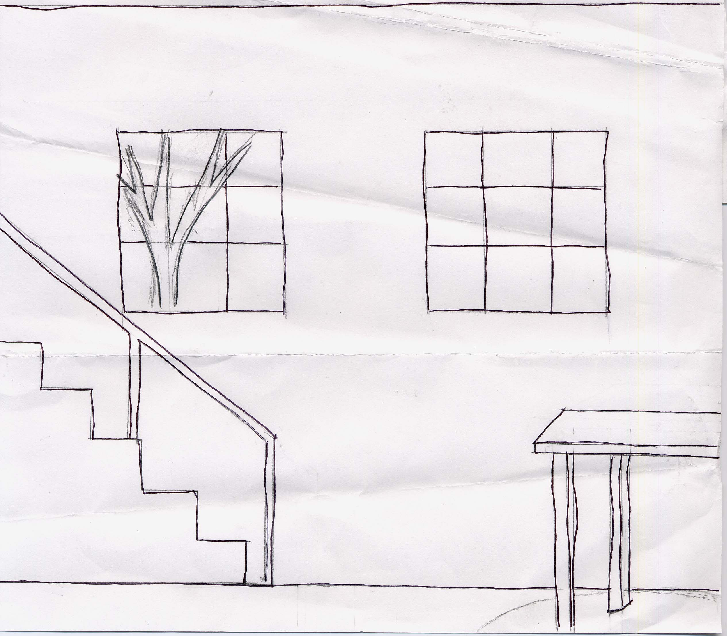

The Long Winter by Laura Ingalls Wilder
Section 4: Pages 96-130.

Character Sketcher:
Your job as character sketcher is to follow the role sheet and sketch Mr. Edwards.

Discussion Director:
Your job is to ask 5 questions. If the answers to the questions are found in the section you must cite the page and paragraph. Remember to ask good thinking questions!

1 MCEOG question
1 character
1 setting
1 problem/solution
1 on your own

Passage Picker:
Pick 5 passages that show the following. Remember to cite page numbers and paragraphs.

1 descriptive
1 informative
2 figurative language
1 important

Word Wizard:
Pick 5 of the following words and complete the role sheet for them.

Anxiously (pg. 96 par 2)
Petticoats (pg. 97 par 2)
Ridiculous (pg 102 par 1)
Persuade (pg 112 par 1)
Conscience (pg 126 par 2)

Meteorologist:
Your job is to complete the Meteorologist worksheet and use the knowledge your prediction skills to make a 7 day forecast for the upcoming week.

Meteorologist

Your job as meteorologist is to write a brief summary as to what the weather has been in the past few days. Be sure to include weather conditions, temperature, wind chill, etc. The passage may\may not give specific weather conditions but use logical thinking to come up with an educated guess. You then must plan a 7 day forecast based on what you think the weather will be like for the next week. Include an image for each day which will represent the weather, high and low temperatures, and wind chill. Use the chart below to help you plan your 7 day forecast.

A three day blizzard just ended long enough for Pa and some men to take the handcar from the depot to go meet a train in Volga. On Saturday, the sun was shining and the wind was not blowing too much and the sun was shinning but then all of the sudden another storm struck and Pa said it must be, “forty degrees below zero outside.” (page 129 par 7).

Sunday  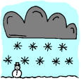  Blizzard conditions  Low: -40  High: -10  Wind-chill: -40 | Monday  Blizzard Conditions  Low: -40  High: 0  Wind-chill: -50 | Tuesday  Blizzard Conditions but becoming more sunny  Low: -20  High: 10  Wind-chill: 10 | Wednesday    Partly Sunny  Low: 0  High: 17  Wind-Chill: 17 | Thursday  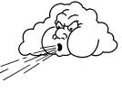  Looks like another blizzard is going to hit midday.  Low: -25  High: 10  Wind-Chill: -45 | Friday  Blizzard Conditions  Low: -32  High: 4  Wind-Chill: -37 | Saturday  Blizzard Conditions but not as windy.  Low: -26  High: 15  Wind Chill: -30

The Long Winter by Laura Ingalls Wilder
Section 5: Pages 131-160.

Character Sketcher:
Your job as character sketcher is to follow the role sheet and sketch Mary Power or Minnie Johnson.

Discussion Director:
Your job is to ask 5 questions. If the answers to the questions are found in the section you must cite the page and paragraph. Remember to ask good thinking questions!

1 MCEOG question
1 point of view
1 cause/effect
1 problem/solution
1 on your own

Passage Picker:
Pick 5 passages that show the following. Remember to cite page numbers and paragraphs.

1 descriptive
1 surprising
2 figurative language
1 important
1 on your own

Word Wizard:
Pick 4 of the following words and complete the role sheet for them.

Joyously (pg 137 par 6)
Sluggish (pg 139 par 2)
Kerosene (pg 141 par 6)
Stoutly (pg 143 par 5)
Reproachfully (pg 150 par 1)

Summarizer:
Give a brief summary of today’s section. Be sure to include all the major events and characters in the section.

The Long Winter by Laura Ingalls Wilder
Section 6: Pages 161-187.

Character Sketcher:
Your job as character sketcher is to follow the role sheet and sketch a character you have not yet done.

Discussion Director:
Your job is to ask 5 questions. If the answers to the questions are found in the section you must cite the page and paragraph. Remember to ask good thinking questions!

1 MCEOG question
1 cause/effect
1 problem/solution
1 compare/contrast
1 on your own

Passage Picker:
Pick 4 passages that show the following. Remember to cite page numbers and paragraphs.

1 descriptive
2 figurative language
1 important
1 on your own

Word Wizard:
Complete the role sheet for the following words.

Stout (pg 161 par 1)
Harness (pg 163 par 2)
Whittling (pg 167 par 4)
Impatient (pg 169 par 1)

Summarizer:
Give a brief summary of today’s section. Be sure to include all the major events and characters in the section.

The Long Winter by Laura Ingalls Wilder
Section 7: Pages 188-224.

Character Sketcher:
Your job as character sketcher is to follow the role sheet and sketch Almanzo.

Discussion Director:
Your job is to ask 5 questions. If the answers to the questions are found in the section you must cite the page and paragraph. Remember to ask good thinking questions!

1 MCEOG question
1 cause/effect
1 problem/solution
1 compare/contrast
1 on your own

Passage Picker:
Pick 4 passages that show the following. Remember to cite page numbers and paragraphs.

1 descriptive
2 figurative language
1 important
1 on your own

Word Wizard:
Complete the role sheet for the following words.

Fiercer (pg 188 par 1)
Antelope (pg 200 par 20
Gaily (pg 212 par 5)
Reluctantly (pg 213 par 9)
Contradicted (pg 219 par 3)

Meteorologist:
Your job is to complete the Meteorologist worksheet and use the knowledge your prediction skills to make a 7 day forecast for the upcoming week.

The Long Winter by Laura Ingalls Wilder
Section 8: Pages 225-259.

Illustrator:
Your job as illustrator is to draw some sort of sketch related to the reading and then write a paragraph related to your sketch. Use the Illustrator role sheet to guide you as you write your sketch.

Discussion Director:
Your job is to ask 5 questions. If the answers to the questions are found in the section you must cite the page and paragraph. Remember to ask good thinking questions!

1 MCEOG question
1 cause/effect
1 point of view
1 compare/contrast
1 on your own

Passage Picker:
Pick 4 passages that show the following. Remember to cite page numbers and paragraphs.

1 descriptive
1 figurative language
1 surprising
1 Funny/entertaining
1 on your own

Word Wizard:
Complete the role sheet for the following words.

Murmured (pg 231 par 6)
Drowsily (pg 231 par 6)
Scouring (pg 232 par 1)
Latchstring (pg 250 par 2)
Methodically (pg 256 par 6)

Connector:
Your job as connector is to connect the following passage to your life.

(Pg 243 Par 1) On this page Ma says, “Never complain of what you have. Always remember you are fortunate to have it.”

Connector

Your job as connector is to connect the story and selected passage with your real life. Answer the following questions to help you complete your role.

- What did you notice about the passage?
I noticed that this passage the optimism that Ma has about everything terrible that has been happening to the Ingalls family.

- How did the passage make you feel?
This passage made me feel guilty because it made me think about how sometimes I just take what I have for granted and I do not sit back and think about the fact that I should be lucky and thankful for what I have.

- What does the passage remind you of in your own life?
This passage reminded me of tidbits my mother always tells me. She is always telling me that everything will work out, treat others with respect, and what goes around comes around. When I read the following passage I immediately thought about my mother and how she is always using little phrases about life to try to get me to behave in appropriate ways.

- What would you tell your friend if they asked you about this book?
If a friend were to ask me about this book I would tell them to read another Laura Ingalls Wilder book before they read this one. This book is not one of her more interesting books and is rather dry at times. I would not discourage anyone from reading it but it is not my top choice of a book by Wilder to read.

- What character in the book are you most like or unlike? Explain.
I believe I am most like Laura because she is an independent person who likes to do things on her own. She is also very ambitious and willing to help out whenever needed. I am also very ambitious and willing to help out especially when it comes to family. Laura also strikes me as somewhat of a tom boy and I feel that I also have some tom boy characteristics in me.

- Does this passage or any part of the book remind you of any other story you have heard or read? Explain.
No, I really can’t think of any other stories which I have read that remind me of the book. Pretty much the book is just about how the Ingalls family gets through the tough winter, and I can not think of any other story which is solely devoted to one families techniques for surviving the winter.

The Long Winter by Laura Ingalls Wilder
Section 9: Pages 260-293.

Character Sketcher:
Your job as character sketcher is to follow the role sheet and sketch Cap Garland.

Discussion Director:
Your job is to ask 5 questions. If the answers to the questions are found in the section you must cite the page and paragraph. Remember to ask good thinking questions!

1 MCEOG question
1 cause/effect
1 problem/solution
1 compare/contrast
1 setting

Passage Picker:
Pick 4 passages that show the following. Remember to cite page numbers and paragraphs.

1 descriptive
1 personification
1 metaphor
1 important
1 confusing

Word Wizard:
Complete the role sheet for the following words.

Clamor (pg 262 par. 5)
Zenith (pg 271 par 5)
Treacherous (pg 281 par 1)
Savage (pg 285 par 5)

Summarizer:

Give a brief summary of today’s section. Be sure to include all the major events and characters in the section.

The Long Winter by Laura Ingalls Wilder
Section 10: Pages 294-334.

Character Sketcher:
The blizzard has been a very important role throughout the entire book. Your job as character sketcher is to follow the role sheet and sketch the Blizzard.

Discussion Director:
Your job is to ask 5 questions. If the answers to the questions are found in the section you must cite the page and paragraph. Remember to ask good thinking questions!

1 MCEOG question
1 thematic
1 problem/solution
1 main idea
1 on your own

Passage Picker:
Pick 4 passages that show the following. Remember to cite page numbers and paragraphs.

1 descriptive
1 simile
1 symbolic
1 important
1 surprising

Word Wizard:
Complete the role sheet for the following words.

Objected (pg 302 par 5)
Snarlingly (pg 303 par 12)
Acquainted (pg 314 par 3)
Rosined (pg 332 par 4)

Investigator:

Your job as investigator is to research ways to survive the winter and report your findings to the group.

Investigator

Your job as investigator is to research relevant and important information that deals with the book you are reading in your literature circle. Most of the time the teacher will give you the information to research along with certain questions for you to answer after you have researched the information. It is up to you do decide how you will share the information with your group. Have fun investigating and remember if you find out any more information than what was provided by your teacher share it with the group!

For your role as investigator you are to think back throughout the entire book and compile a top 10 list of ways the Ingalls family survived the winter. Then you are to look at the following web sites and compile a top 10 list of ways you would survive the winter today.

Top 10 Ways the Ingalls Family made it through the winter:
  - Twisted hay to burn when they ran out of coal
  - They ground wheat up to make bread
  - Made a button lamp when the ran out of Kerosene
  - Went to be early to conserve fuel
  - Ate small rations of potatoes and bread for every meal
  - Hung a close line from their house to where the horses were kept to guide them
  - Ma put a flat iron in Mary and Laura’s bed to keep them warm
  - When it stopped snowing they ran around outside to keep their muscles active
  - The moved a lot of the furniture into the kitchen
  - They kept themselves busy by doing chores, schoolwork, and singing to help pass the time by.

Use the following websites for the next top 10 list.
http://www.crh.noaa.gov/unr/edusafe/wwaw/surviving_a_winter_storm.htm
http://health.co.genesee.mi.us/A-Z/surviving_the_winter.htm
http://www.survivalplans.com/winterstorm.html
http://www.wbuf.noaa.gov/wntwx.htm
http://www.co.dane.wi.us/ems/winter/
http://www.woodtv.com/Global/story.asp?S=610384&nav=0RcfC6zv

Top 10 ways families today make it through the winter:

  - Keep blankets in your car
  - Keep a stock of nonperishable food in the pantry
  - Keep your car in good shape
  - Keep a flashlight and matches handy
  - Keep a full tank of gas in your car
  - Have a battery powered radio
  - Have first aid supplies handy
  - Have an emergency heating source available
  - Stay indoors
  - Be prepared

