Best Practice Synthesis and Analysis of Literacy Instruction in a Primary Classroom

Carrie Brown

RE 5710
April 21, 2011

Hmmm….What is best practice? If I was asked that question with my current school as my sole experience, I don’t believe I could properly answer that question. In my current role as an instructional coach, I have encouraged best practice in a variety of ways. I’ve offered professional development, I’ve modeled thorough lessons, I’ve had discussions about effective strategies and techniques, and I’ve collaborated with teachers to create interactive lesson plans that focus on differentiating skills. Unfortunately, I find myself in a situation where many of the teachers I work with are stagnant, and don’t retain or attempt to change their instruction for the betterment of their students.
Fortunately, I had an incredible experience when I taught 2nd grade in Chicago at Donoghue Charter School. That one experience has shaped my career. It taught me the importance of collaboration, professional development, reflection, inquiry based learning, creating rigorous and meaningful curriculum, and most importantly, how to teach kids to read and write effectively. That experience, paired with the opportunity to learn from professors at Appalachian State University, has allowed me to form a strong sense of what best practice education looks like. For this reason, I have chosen to describe what my classroom looked like as a 2nd grade teacher instead of as an instructional coach.
Instituting a strong literacy program is not an easy task. It takes time, preparation, management, and creativity, all factors of teaching I strived to do well. I learned the importance of having a strong classroom community where students felt safe and secure, so they would be open to learning new things. I recognized the magnitude of having a literate environment, where students were inundated with a great variety of materials that encouraged them read and write. I understood the significance of integrating technology and 21st century skills into literacy instruction. I modeled the value of reading a variety of texts, in different contexts, so students would be encouraged to do the same. I organized my literacy block so that it allowed for us to learn all of the important aspects of reading development. I integrated reading and writing into all subject areas. Finally, I assessed where students were so I knew where to take them next. The following is a critical reflection on what I did well, and what I would like to incorporate in the future, when I return to the classroom.

Materials, Media, and Technology:
As educators, we know that the environment influences learning and, in
particular, classroom environments influence literacy development
(Wolfersberger, Reutzel, Sudweeks, & Fawson, 2004). There are many materials that are essential to strong literacy instruction. I have worked in places that provided support in purchasing materials, and those that were unable. When the latter was the case, I wrote grants, and spent an inordinate amount of my own money on materials I thought were necessary for strong instruction. The most important part of a classroom is the classroom library. Mine was organized by genre and theme where I had over 45 book bins containing both fiction and non-fiction books.

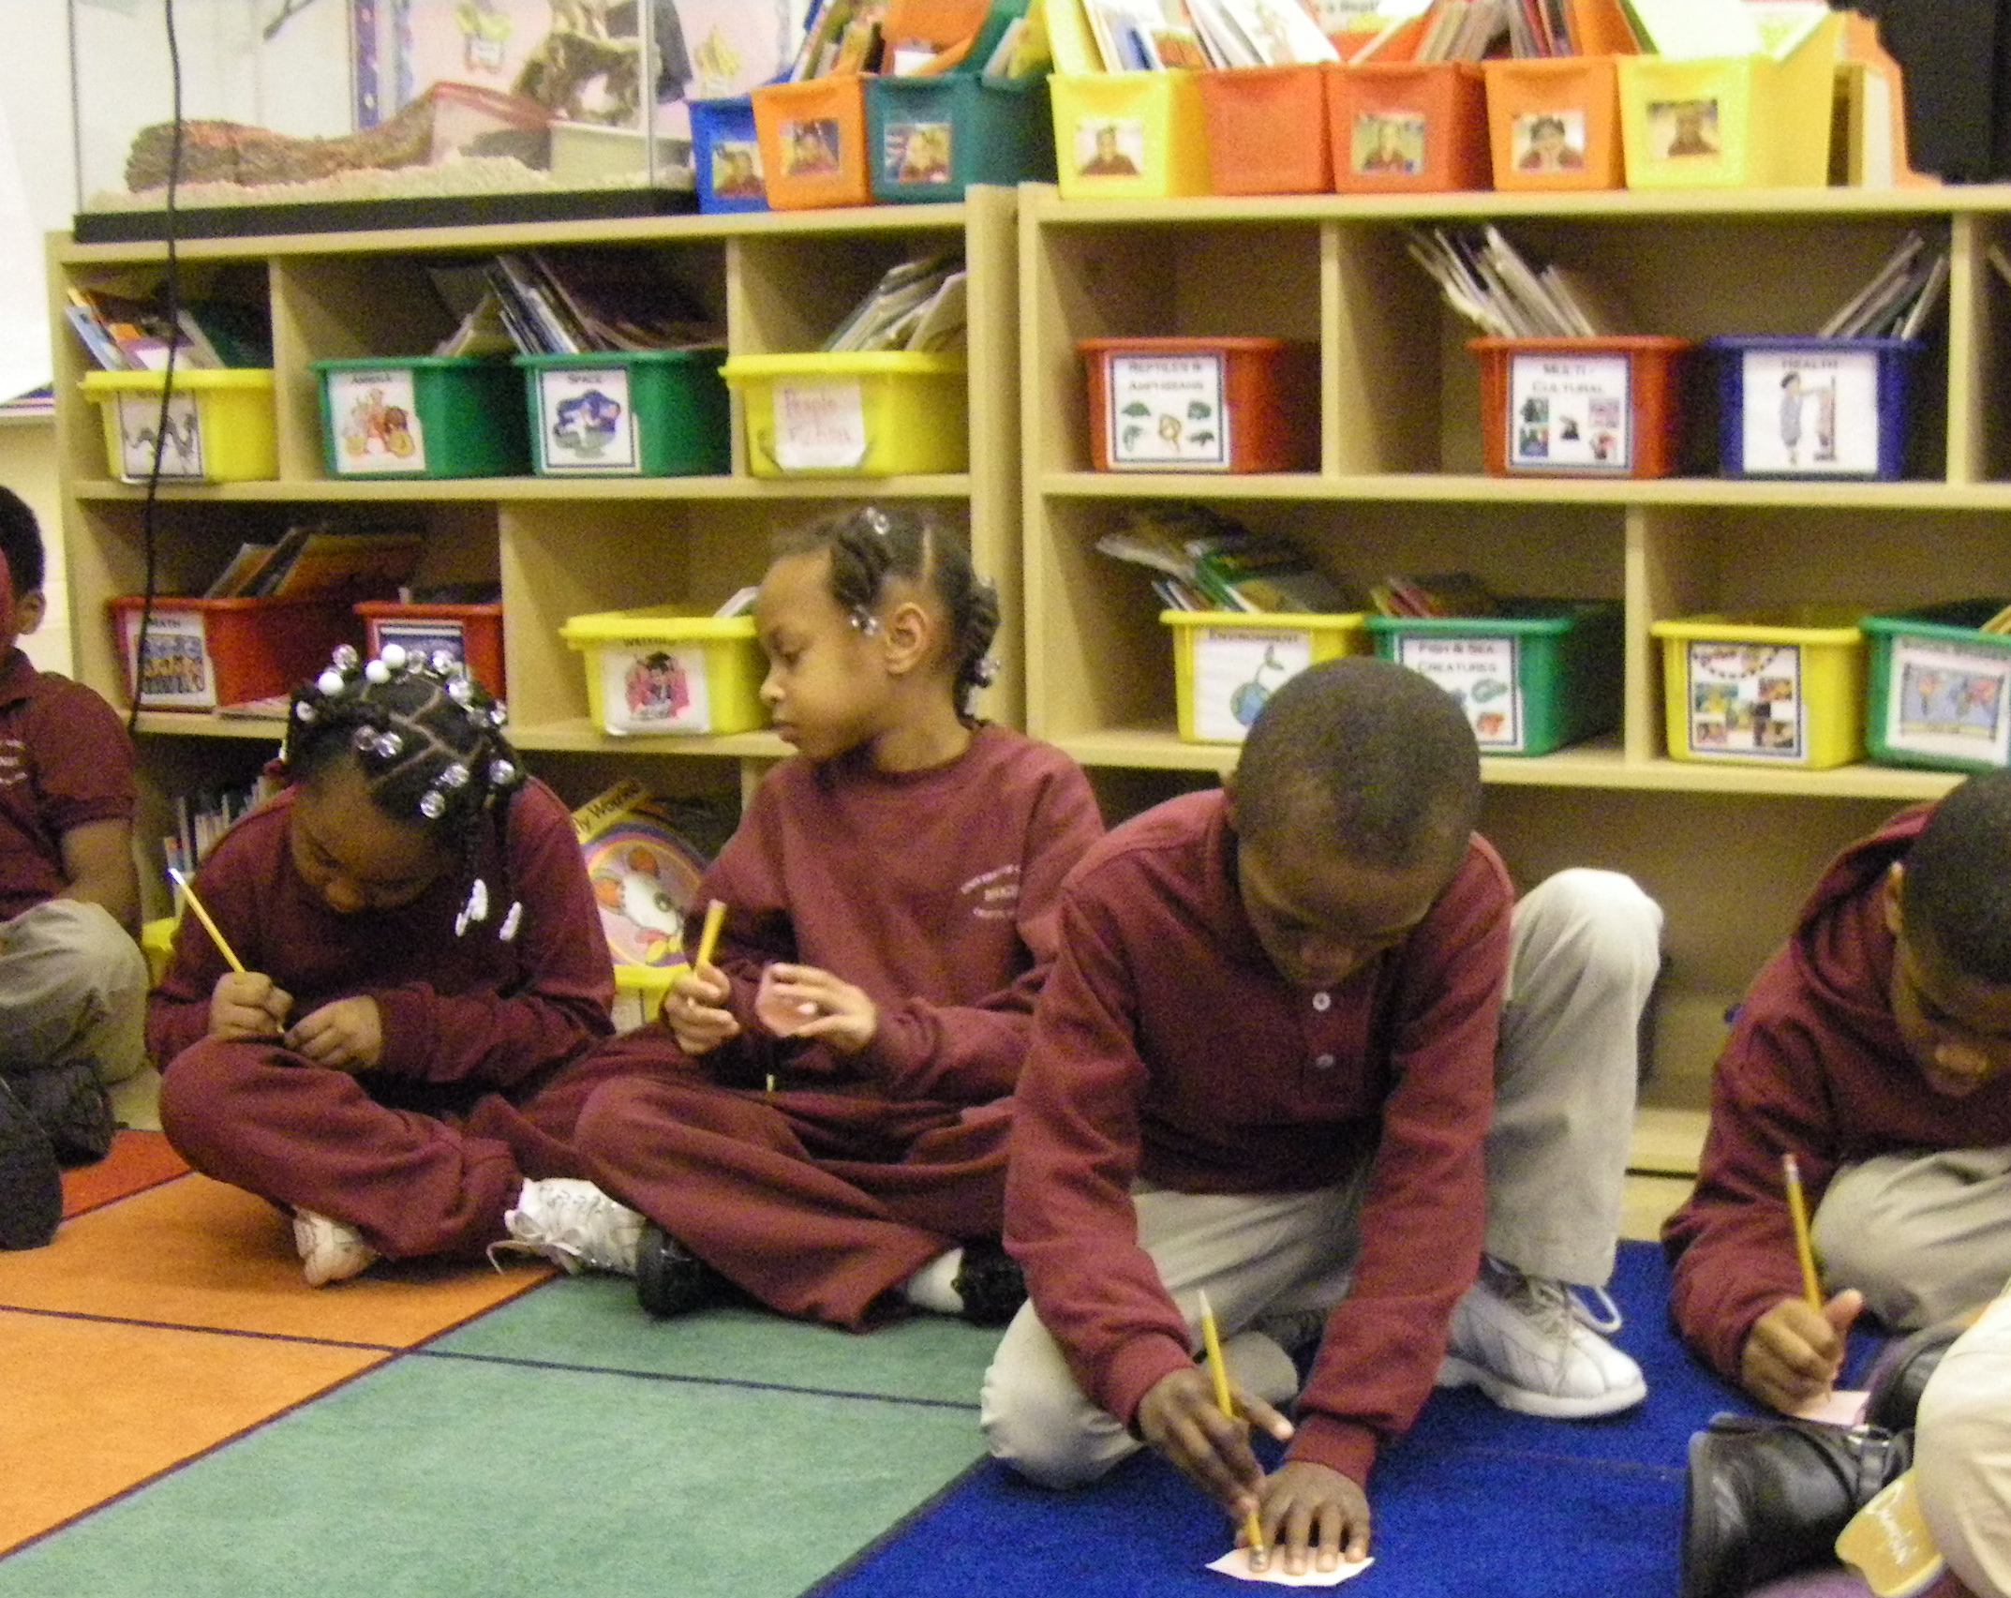
Each book bin had a label on the front and all of the books found in that book bin had a correlating label (Fractor & Woodruff, 1993). Gradually, as the year went on, the students learned how to determine which books went in what book bin by reading them and then sorting the books themselves, unknowingly strengthening their knowledge of theme and genre. This is important because research claims that children in classrooms with literature collections read 50% more books than children that do not (Fractor & Woodruff, 1993).
The students also had their own book bins labeled with their pictures. When they borrowed a book from the library, they would put it in their personal book bin so that while they were using it, it wouldn’t be disturbed until they were finished. They would use post it notes to write notes on the book, and oftentimes, they didn’t have the time to read a book in one sitting so this provided them the opportunity to return to it later. They also kept their guided reading books in their book bin.
Figure 1: Students working in the classroom library

This would be a book at their level that we had previously read and they could keep for a few weeks to reread in order to practice fluency (Samuels, 1976). Additionally, they kept their reading response journals (Martinez & Roser, 2008) in their book bin so that when they went to their seat with their book bin, they had easy access to their journals when responding to books.
Also found in the classroom library were a large amount of small stuffed animals referred to as our reading buddies. Students could be found reading to a reading buddy at silent reading or center time. I also had an assortment of reading pillows as well because I wanted to create a cozy, warm environment that promotes reading in a positive light (Fractor & Woodruff, 1993). As I modeled reading to students every day, it was important for me to find time for students to read on their own (Reutzel & Fawson, 2002).
The library was also our meeting place, where I did read alouds, small group instruction, or hosted whole group class meetings. I had an easel with chart paper that would allow me to model daily writing or reader’s workshop mini-lessons (Fountas and Pinnell, 2001). I would also use the chart paper for our morning meetings, where we would correct my daily letter to them (Schifferdanoff, 2001).
Next to my classroom library was a magnetic white board that I had transformed into a word wall (Green, 1993). I used this word wall for both sight words and vocabulary words, both of which I backed with a magnetic strip. I chose to use a magnetic board so that students could manipulate words during activities (ex. alphabetizing) or they could remove the words from the wall, take it to their seat to use for writing, and then return it to the wall easily. Since it was also a white board, I was able to use expo markers on the word wall to provide further instruction on certain words or highlight words during certain activities. I believe adding the interactive element to a word wall enhances the learning. It
holds instructional potential for enhancing vocabulary learning as students engage in activities centered around the word wall. This allows for activities in which students explore, evaluate, reflect, and apply word meanings in meaningful contexts (Harmon, Wood, Hedrick, Vintinner, & Willeford, 2009).
Since I taught daily Guided Reading groups, I had literacy centers (Falk-Ross, 2008) in my classroom and these were designated at different spots throughout the room. The computer center, housing 5 computers, provided students an opportunity to practice learned skills or publish their writing. The listening center would allow students the opportunity to listen to a book on tape and write a reflective response. The writing center housed a variety of different kinds of paper, pencils, pens, envelopes, glue, crayons, markers, and tape so students could create their own unique writing pieces. The reading center was located conveniently in the classroom library. Other centers such as the phonics center or the poetry center were mobile and in containers that the students could take to a table and work on.
I observed a classroom with a document camera one year and was really impressed with the opportunities it provided. I wrote a Donors Choose grant and was fortunate to receive one to use in my classroom. It was wonderful for sharing students’ writing with the class and modeling how to edit during writing workshop. It also provided me the opportunity to show students books or poetry to use in fluency instruction. What I would love to have in a future classroom is a smart board. It provides many interactive opportunities for students in all subject areas and adds to the excitement of the lesson at hand. I could use the smart board to write a story starter and then ask each child to come up and add to the story. I could have students sequence a story by manipulating pictures on the smart board. I could also print everything that we do on the smart board so the students could have the class notes from the day, which would be particularly helpful for absent students. It can assist with sight word learning and help students make observations visually rather than auditorily. (Mechling, Gast, Krupa, 2007.) I envision having a highly interactive class with the use of a smartboard.

Kinds of Reading Instruction:

Guided Reading:
If anyone asked one of my students how I felt about Guided Reading they would respond, “It’s sacred time because it’s Mrs. Brown’s special time with us.” I looked forward to that individualized time to work in a small group with kids who were reading at or about the same developmental level (Fountas & Pinnell, 1996). Carrying out successful guided reading groups is not an easy task. I found myself reading 6 different books (or chapters) every night to stay ahead of my students. Yet, this was the opportunity to read with students at a level that they were successful at, build their confidence and love for reading, and make progress in the areas of fluency and comprehension. Therefore, it was worth it! I organized my groups based on how they faired on the STEP assessment (Kerbow & Bryk, 2004). I presented each group with a new book every day or every few days depending on the size of the book or type of text. With each guided reading lesson (Fountas & Pinnel, 1996), we would make predictions before reading based on the cover and/or illustrations/photographs in the book and I would assess prior understanding. Then, I would give the group some questions to think about while they read. I would introduce them to new vocabulary that they might find difficult. We would read the book together or independently depending on the level of readers. After the reading, we would have a discussion about what we read. It was important to me to ask thought provoking questions beyond what was “right there” in the book. I wanted students to take in the text, interpret it, and make connections to their own lives. Depending on the type of book, we would do activities with it. For example, after reading Amelia Bedelia, we created our own book of idioms and when completed, the authors read it aloud to the rest of the class. In this respect, I combined a comprehension activity with an opportunity for reading practice, and an informal assessment (Spinelli, 2008).
After reading a book, the students took the book home and were required to read it to 3 different sources (this included family members AND stuffed animals). I felt that this practice helped them improve on their fluency (Samuels, 1976). With each book, I gave a homework sheet of comprehension questions related to the story. After each question, I would put in parenthesis whether it was a “right there” or “make an inference” question. This guided students and parents to be aware and understand the difference between different types of questioning. The next day, we spent about 2 minutes going over the homework responses and then we moved on to the next chapter or book. I felt that part of the enthusiasm for reading came from exposure to new books (Applegate & Applegate, 2010). I wanted to expose my students to as many books as possible instead of spending a lot of time on one text. I feel that students get bored reading the same text time and again. New books intrigue and excite them so I feel it is important to introduce them to new books as often as possible. Students would then keep up to five of their guided reading books in their own reading bin. This provided them with books at their developmental level that they could read and practice on their own. They could be successful at reading them when it came time to peer read and it improved on their fluency.

Daily Read Alouds:
Reading aloud to students is easily my favorite part of teaching. It is an optimal opportunity to learn and it’s fun! I love to see kids’ eyes glued to a book, eager to hear more, their minds churning with questions. It is even better when children are actively engaged in joining in the story orally when they figure out the next word due to rhyme or repetition. For many students, a good book is their window to the outside world. They might not have opportunities to experience a trip to the zoo to learn about animals, or meeting an astronaut to ask questions about space. Books are key to expanding a student’s comprehension of the world around them. This special time is also the opportunity I get to model good reading. As I read, I ask myself questions, draw conclusions, and make connections (Wiseman, 2011) like I want them to. I have learned quickly that students imitate everything a teacher does, therefore, I read with prosody and expression, and express my enthusiasm for each title I introduce.

Independent Reading:
At the beginning of the school year, I would introduce students to their book buddies -- soft, cuddly, little creatures who lived in a flower-shaped basket in the corner of the library. I modeled how the book buddies could magically hear what the students were reading in their head, but they had to be a certain distance from the reader’s mind, otherwise, they might get confused with stories that are in others’ heads. I also expressed my need to read laying down so I gave students some pillows and the opportunity to read wherever they wanted in the classroom. Therefore, a visitor to my classroom would see students sitting or lying down with beanie babies on their head or shoulders while they looked intent on reading a good book. Early in the year, I would use this time to model silent reading myself, so the students could see how I did it as well. Gradually, I’d start joining students during that time and listen to them read, another opportunity for informal assessment (Spinelli, 2008).
Gradually, as the school year progressed, students would be independent reading during center time, and during Reader’s Workshop (Fountas & Pinnell, 2001). They had their own book bin so they could choose to read from that, borrow another book from the library, or spread out with a highlights magazine or big book. The variety of choices, the leniency in how they read, and their “book buddies” all served as motivators to read. It was important to me to create a class culture with a love for curling up with a good book.

Comprehension Instruction:
According to Fielding & Pearson (1994), there are four main components that are important in successful comprehension instruction: large amounts of time for actual text reading, teacher-directed instruction in comprehension strategies, opportunities for peer collaborative learning, and occasions for students to talk to a teacher and one another about their responses to reading. I highly agree with these researchers and believe that these four components were evident in my classroom daily. Time is something that all teachers wish they had more of, but time for reading text was a priority in my classroom, and not something that would be put off for later if something had to go. Teaching students comprehension strategies is a difficult task. These strategies include but are not limited to questioning, making connections, visualizing, analyzing text structure, and summarizing (Dymock & Nicholson, 2010). Learning how to use a comprehension strategy takes practice. I would teach the strategy through modeling and then allow the students to practice it repeatedly in many different contexts throughout the year (Fielding & Pearson, 1994), not just the day that it was taught. I believe that peers have a strong influence on individual learning and allowing students to practice the comprehension strategies with each other increases the likelihood that a child will make the connection of using a strategy in context as they see their peers doing it.
Finally, the most important component to me is giving students the opportunity to talk about what they read with both their peers and I. When they discuss a text, they internalize it more when given the opportunity to discuss it. Prior to guided reading time, I would give a Reader’s Workshop (Fountas & Pinnell, 2001) mini-lesson on how to evaluate and discuss books. I would model strategies for interpreting and sharing books with each other. Sharing their own opinions and impressions not only gives them the opportunity to verbalize but the opportunity to hear others insights as well, and possibly note interpretations that they hadn’t thought of themselves.

Fluency Instruction:
I work with many people who incorrectly believe that fluency addresses the speed at which students read. I am finding myself constantly defining fluency as the ability to read with accuracy, automaticity, and prosody (Young and Rasinsky, 2009). When those things are achieved, it appears that the reader is reading at a faster pace. I found myself using 3 main strategies to improve on fluency in my classroom. While I would allow students to silently read by themselves, I know that many pretend to be reading if they lack the skills or confidence in reading. I would pair those students up to partner read (Griffith & Rasinski, 2003), therefore, students were practicing their reading aloud. This was a motivating experience for students as well for they enjoyed reading with friends and tried to read their very best to impress each other. Each year, after introducing Reader’s Theatre (Griffith & Rasinski, 2003; Young & Rasinski, 2009) for the first time, the students would continually beg to do it again and again. Reader’s Theatre is a wonderful way to offer students the opportunity to perform in front of an audience and encourage students to practice their reading repeatedly. While practicing, they improve upon their prosody, automaticity, and accuracy. I would also encourage students to do repeated readings (Samuels, 1976) with books that I had introduced in Guided Reading. As stated above, they would take the books home to practice and then keep the books in their class book bin for another few weeks so they could practice their reading.

Word Study and Spelling Instruction:
Teaching word study and spelling instruction is essential to a strong literacy program. The effects that such instruction has on writing and reading is validated with the growth that can be seen as the year progresses. For me, how I organized my word study/spelling instruction was always a work in progress. I felt it was important to give leveled spelling tests so I had 3 different spelling lists to monitor each week. Every student worked at their own ability level and was tested on 10 words that fit the word pattern that we were working on, and then 5 additional words that they chose. The chosen words were from a list that the students had been tested on at the beginning of the year. The words that the students knew had been highlighted. They could choose any words that they did not know yet. I felt that this gave the students ownership of what words they were learning, therefore, motivating them to want to learn them. Throughout the week, I would give instruction on making and manipulating the words with the word patterns for the week using letters, white boards, pictures, and charts to help guide their learning. Using the Phonics, Lessons, Letters, and Words (Fountas & Pinnell, 2003) program guided my mini-lessons and the structure of my instruction. Honestly, the program was a bit complicated to follow, and some lessons were lacking the rigor and challenge that my students could have handled. Yet, it did provide structure and guidance as to what to teach and how to teach it.
After my last year of teaching 2nd grade, I watched a presentation on using the Words Their Way program (Bear, Invernizzi, Templeton, & Johnston, 2008) and was quite impressed. I intend to try that program with my students when I enter the classroom again. I liked how the program uses small group instruction and students were working at their own pace, with words that were specifically designated for them. When they were ready to pass on to the next word study pattern, they did. If not, they continued to practice what they were working on. It seems manageable and a terrific option for differentiation.

Teaching the Language Arts:

Literature:
In order to teach literature well, you have to know literature. My husband gives me a time limit when we go to the bookstore because I head straight for the children’s section and I get lost in reading the books that I have never heard of. It’s important to me to be knowledgeable about texts so that I can choose ones that my students will enjoy (Fountas and Pinnell, 2001). It’s also important to me to expose them to a wide variety of literature so I make sure to read different kinds of books throughout the course of the day.
Due to my Masters in Reading, I have been introduced to the technique called literature circles (Daniels, 1994). This is a technique I never knew about when teaching 2nd grade but when I re-enter the classroom, I look forward to instituting it with those students who are ready for it. I am impressed by the idea that students choose their own titles. I think giving students different roles allows them to succeed at what they feel confident in and gives students choice, a crucial motivator for learning. It also allows the teacher to step back, and the students to lead the discussion with the teacher as a background player, rather than a necessary participant.

Genre:
Genre is a skill that I teach gradually throughout the year. I introduce the different genres in a few lessons at the beginning of the year. Then, as I do read alouds, we chart the title and genre on an ongoing chart that remains posted in our classroom library. Students also have their own genre charts in their reading response journal (Fountas & Pinnell, 2001) so they can chart the individual books they read and make a prediction based on it’s elements what genre it is. I also have my classroom library bins divided into genres. As the year progresses, it’s amazing how the students are able to recognize what book bin the books they borrow belong to by reading the book. Inevitably, book bins get mixed up. This gives us the opportunity to sort the books into genres once again, an activity that the kids love! It also allows for a discussion of why certain books might fit into more than one genre.
My students realize that once they like a bunch of books from one book bin, they make the connection that they enjoy that genre, and it helps them when they visit the school library because they ask for books of a certain genre. Granted, if I notice they are only reading fantasy books, I might suggest a non-fiction text, or a type of traditional literature so that they branch out a little.

Writing:
Teaching writing used to be something I wanted to avoid at all costs! It is one of the most difficult subjects to teach because all of the students are working at a different pace and it’s extremely hard to manage. After a lot of professional development, peer collaboration, and practice, I have manipulated my writing program to where it is manageable, productive, and fun! Now, I have to set a timer during writing, otherwise, my students and I would forget to go to lunch!
I used the Lucy Calkins Writing Workshop (Calkins, 2005) model as a guide, while creating my own mini lessons and units based on my curriculum and the individual needs of my students. In the first 3 weeks of school, I modeled brainstorming with a writing journal. I had my own journal and after modeling a mini-lesson on brainstorming to my students, I would find a place at one of the tables in my classroom and write as well, carefully modeling good writing behaviors to my students. Each day I would teach a 10-minute mini lesson, followed by 30 minutes of individual writing time, and closing with 10 minutes of sharing time. Each day I would pick 3 different students to share what they wrote, careful to record who shared so that I made sure to get to everyone within 2 weeks. Setting a timer was essential because the time would move quickly and the students and I would get lost in our thoughts.
Everyday I would start writing with a mini lesson. Many times I would find my mini lessons by simply reading over my students’ writing. I would pick something I felt they needed to work on and I would make that the focus for the day. I would model writing about my own personal experiences (ex. a trip I took, a story about my dog, etc.) so that my students couldn’t copy my ideas and they would use creative personal ones. Sometimes I would pick a student’s work to model good writing strategies and I would use the document camera to display it to the rest of the class. I taught peer editing and how to use student rubrics to check their own work. Using editing marks was modeled every morning during our Morning Message (Schifferdanoff, 2001). Students were encouraged to write with blue pens so they wouldn’t try to erase their writing and I could see their train of thought. Then, they used red editing pens to make changes when they were in the editing stage of the writing process.
A simple pocket chart served as my best friend during writing time. Each student had a pocket in which they had 5 cards. Each card was a different color and titled with one of the stages of the writing process. When students progressed from one writing stage to the next, they changed their card. This provided me with an awareness of where each student was in their drafts and a glance. Likewise, they had different colored paper that correlated with the different steps of the writing process. If they were in the first stage (prewriting) they would use a green sheet of paper. If they were in publishing, they would use white. This would differentiate drafts as well. When they had completed the editing stage on their own, they would sign up for a conference with me, and those were the first students I would meet with during writing that day.

Authors Craft:
I found that one successful way to teach writing is to use published authors to demonstrate kinds of writing crafts (Calkins, 2005). For example, I did an author study on Kevin Henkes with my 2nd graders during a unit on writing fiction stories. Henkes personifies his animal characters with human characteristics, a talent that students could learn. He develops his characters with clear details at the beginning of each of his stories, as I wanted my students to do in their writing. Then, based on one of the character traits, a problem arises. In many of his stories, there are multiple ways that the problem is solved, another element of writing that I wanted my students to learn. He uses repetition of phrases, and outstanding vocabulary to describe details. All of these qualities were strong writing objectives that I wanted my students to incorporate in their writing. His stories guided my lessons and guided the students’ writing.
I found that it is not necessary to do an entire author study to teach writing traits. Oftentimes, I would pull a book that we had read before to point out a specific detail I would like my students to focus on. For example, when teaching how to draw out a simple event by using details, I might read an excerpt from A Chair for My Mother, by Vera B. Williams and talk about how the author describes the scene where her house is on fire. Authors are the perfect mentors for successful writing instruction.

Poetry:
Poetry is imaginative and artistic. It evokes the senses, feelings and images from its reader and it features figurative language, rhythm, and sound patterns. For this reason, I use poetry for so many purposes in the classroom. For phonemic awareness I read poems and invite students to tell me what comes at the end of lines. For word study, I provide rhyming poems with missing pieces and students need to use their rhyming skills to figure out how to fill in the blanks. To teach visualization, I have the students close their eyes and visualize the picture that I am describing with the detailed words of a poem. To teach how to make inferences or main idea, I read the students a poem and take out the title and key words and have the students infer what the poem is about, or what the title should be. For writing, I have the students create simple poems that tell about themselves or something important in their lives. When I was young, I would read Shel Silverstein poems over and over because they were fun and humorous. When one finds a good poem, they are enticed to read it over and over again like I was. For this reason, poetry can help students develop their fluency. Poetry plays such an important part in the classroom because it caters to so many different skills.

Assessment:

A type of Informal Reading Inventory: STEP
The STEP (Strategic Teaching and Evaluation of Progress) Literacy Assessment provides a set of literacy tools that measure reading development of kindergarten through third grade students (Kerbow & Bryk, 2004). This assessment is organized into a developmentally sequenced set of tasks that focus on the strategies and skills students need to achieve progress in their reading. The assessment uses a set of leveled texts that increase in difficulty with each
“step.” During individual conferences, I recorded students’ reading accuracy and fluency, observed their reading behaviors, and engaged them in comprehension conversations about what they read. I would do this at the beginning, middle, and end of the school year, unless I felt a student was making a lot of progress and I wanted to do an additional assessment to help me see what level I should be instructing at. I liked using this assessment because it also provided specific assessments that focused on level appropriate skills such as letter-sound association, phonemic awareness, word knowledge, developmental spelling, and concepts of print. This provided a complete window into what I needed to know in order to offer the most specific literacy instruction to my students. Thus, I felt that it was a good comprehensive assessment that I could gain a lot of information from. Chart A demonstrates what is tested at each step. Typically, a child is expected to progress 3 steps in one academic year. If a child was entering 2nd grade on grade level, they had reached step 6. I would work to get them to achieve steps 7-9 in 2nd grade. Many students entered my class below grade level. My goal was to try to get them as close to a step 9 as possible by the end of 2nd grade.
Chart B depicts the progress of one of my classes throughout the year. As shown, some students did not make growth every trimester while others made steady growth throughout the year. Some students made more than 3 steps of growth, while some did not. When students did not make growth, I would use the test results and look at the specific area that the student exhibited difficulties in. If an area blatantly stood out to me during testing, I would write that in the comment column as shown in Chart B. That became a focus for my teaching for that student in the following semester. Then, during small group instruction, I would pull the students that had similar challenges together and readdress that skill. For example, if a group of students demonstrated a weakness in spelling words using consonant digraphs, I would pull that group and re-teach that concept in a different way with the hope that additional instruction would make a difference. Or if a group of students demonstrated a need to pick up their reading fluency, I would pull that group together repeatedly and provide them with activities such as Readers Theater or teach them to use a reading guide that might improve their reading automaticity. My reading groups typically changed every trimester based on student progress.

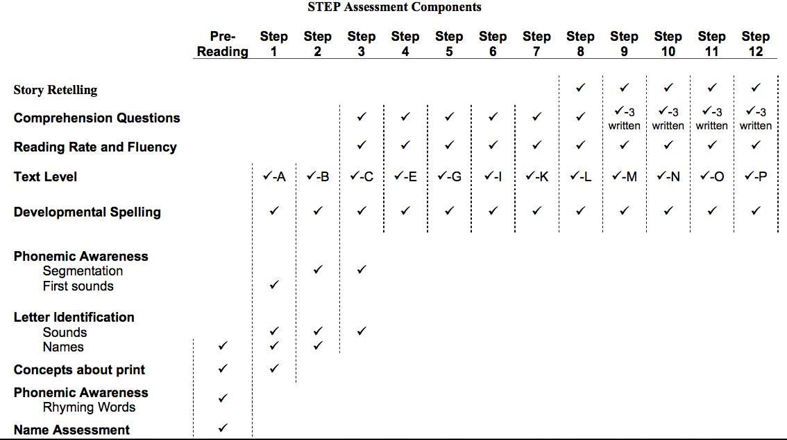
Chart A: Step Assessment Components

Student Name | Aug. | Nov. | March | June | Comments
1. Alyssa | 9 | 12 | Q | R
2.Demetrius | 9 | 9 | 12 | Q
3. Kamron | 9 | 9 | 10 | 10 | Comp
19. Zion | N/A | N/A | 10 | 12
5. Larry | 7 | 8 | 9 | 11 | Fluency
8. Carl | 7 | 7 | 9 | 9
9. Jacobi | 6 | 7 | 9 | 12
7. Dakari | 7 | 7 | 9 | 10 | Comp
4. Kalen | 7 | 8 | 8 | 10 | Comp
6. Courtney | 6 | 8 | 8 | 8
12. Carrington | 6 | 6 | 8 | 8 | spelling
13. Kiara | 5 | 6 | 8 | 8
14. Taylor | 5 | 6 | 8 | 9 | Spelling
15. Chanell | 4 | 6 | 8 | 8 | comprehension
10. Kayla | 6 | 6 | 7 | 8 | Spell/comp
11. Jada | 6 | 6 | 6 | 8 | spell
16. Alexis | 5 | 6 | 6 | 8 | Spelling/Comp
17. DeAndre | 5 | 5 | 6 | 6 | everything
20. Alvin | 3 | 4 | 6 | 7 | spelling
22. Matthew | 1 | 4 | 6 | 7 | spelling
18. Jalen | 5 | 5 | 5 | 7 | Fluency/spell
21. Ramah | 3 | 4 | 4 | 4 | fluency
24. Ahmad | 2 | 2 | 4 | 4 | Vowels! – spell & fluency
25. Jaylon | 1 | 2 | 4 | 5
23. Sylvia | 3 | 3 | 3 | 3
Chart B: Progress of Class in STEP Assessment during 2007-2008 School year

Other Informal Assessments:
The majority of my assessments were informal in nature because I believe that this is the best way to gain a realistic idea of how a student is progressing academically. I also believe it is important to use a variety of informal assessments (Spinelli, 2008) so that the data looks at how a student performs at different tasks. Some students perform well on multiple-choice tests, while others thrive when given the opportunity to perform or exhibit their learning creatively. It is important to give students multiple opportunities to succeed and demonstrate their thinking and learning.
The most common form of informal assessments I would use was classroom observations. I would simply watch how the students performed at a given task. For example, if my students were doing a peer reading exercise, I would watch and listen to their reading. I might either stop them and correct something immediately or make a note to address it at another time. I found notes were necessary for me to keep track of students needs and progress. I would have a file folder and put a post-it for each child inside of it. This way, as the week progressed, I would make sure I was watching each child. If I got to the end of the week and I noticed that there were a few kids’ post-its with no notes, I would make sure to attend to their reading that day. I would then use those notes to organize my instruction for the following week. I would take those dated notes, and put them in the child’s main folder to use for progress monitoring, grading, and parent conferences. Checklists were also a necessity in my classroom to monitor progress. I had a clipboard with the student’s names listed down the side. When I felt that we were working on something that I wanted to remember, I would simply write the title of the exercise at the top and put a check next to the students that mastered it. If they needed work, I would put a circle next to their name. Those students that had a circle would meet with me in a small group the following week and I would readdress that skill.
I find journals an incredible form of assessment for two reasons. First, in one bound book, you can see the progress students have made in their writing over a long period of time. This artifact is a valuable work sample for grading as well as promoting discussion with parents. I also love to point out to the students themselves how much progress they have made over the school year. Oftentimes they don’t notice their progress unless they are made aware. I love to hear, “Can you believe I spelled my name wrong?” or “Look how much more I write now than I did I September!” Second, I use journals as an opportunity to have a written individual discussion with my students. They would write in their reader’s response journals at least once a week telling me about the book that they read. I would respond with deliberate questions to probe for more details and individual thinking. The students loved my personalized letters to them, and it would motivate them to write me back. Therefore, I am able to assess what they are reading, what they are learning from what they read, and how they are able to express that in written form. In their reading journal, they would keep a reading log that I would use to check to make sure they were reading a variety of genres and appropriate books for their reading abilities. In their reading log, they would put next to the book they were reading, what kind of genre it was, and whether they considered it “easy,” “just right,” or “challenging.” This way, I could assess whether or not students understood genres, and whether or not they had learned how to choose appropriate books for themselves.
For example, if I saw that a student was reading all fiction, I would use the journal as an opportunity to tell them to try out a specific book that I think they might enjoy that was non-fiction. Likewise, if I saw a student reading a chapter book that I knew was too difficult, I would suggest a chapter book that they would find easier and more likely to finish.
While writing is extremely important, literature discussion is an essential form of assessment, especially for those students who are not strong writers. I believe students need to be offered the opportunity to discuss their thoughts about literature. Students typically have a larger oral vocabulary than a written one so I can get a more accurate assessment of what they think if they tell me verbally. Watching a student engage with a book and their peers about it’s contents gives me a stronger look at how the student really comprehended what he/she read.
I haven’t met many students that would turn down the opportunity to do a group/individual project or performance to demonstrate their learning. Students love to show what they know in a way other than a test or in written form. My students have loved opportunities to engage in Readers’ Theater. They have performed not only for my class but younger classes. It is an opportunity to evaluate their fluency and let them shine in front of their peers. Honestly, I have taken advantage of using project based assessment minimally and hope to do more in the future because I believe it offers students the opportunity to think outside the box and be unique and creative.

Conclusion:
This look back at what I used to accomplish as a classroom teacher makes me long to be in the classroom again. I recall how much of an impact I was making, and I feel as though I am not making as much of an impact in my current role. Unfortunately, I would not be able to teach the way that I have described in my district. I will continue to be on the hunt for a school that lends itself to best practice. In this respect, I am looking for a school that allows me to practice research driven ideas and strategies that work. I now know how to search for the best practices that have been evaluated and recorded due to research opportunities. I am looking for a school that allows for rigorous, challenging instruction while at the same time, recognizes the need for enjoyment in learning. I am looking for a school that realizes the need to allow more time for silent reading and less on assessment. I am looking for a school where the teachers have the opportunity to collaborate and learn from each other. I refuse to be discouraged. I found it once. I will find it again….I hope.

Bibliography:

Applegate, A. J. & Applegate, M. D. (2010). A Study of Thoughtful Literacy and the Motivation to Read. Reading Teacher, Vol. 64 Issue 4, p226-234.

Bear, D.R., Invernizzi, M., Templeton, S., & Johnston, F. (2008). Words Their Way, Word Study for Phonics, Vocabulary, and Spelling Instruction. Columbus, OH: Pearson Prentice Hall.

Calkins, Lucy. (2005). Launch a Primary Writing Workshop: Getting Started with Units of Study for Primary Writing, Grades K-2. Portsmouth, NH: Heinemann.

Daniels, H. (1994). Literature circles: Voice and choice in the student-
centered classroom. York, ME: Stenhouse.

Dymock, S., & Nicholson, T. (2010). "High 5!" Strategies to Enhance
Comprehension of Expository Text. The Reading Teacher, 64(3), 166-178.

Falk-Ross, F. Helping Literacy Centers Come Alive for Teachers: Tranisitons into Use of Interactive Small Group Reading Stations (2008). College Reading Association Yearbook, Issue 29, p237-247.

Fielding, L.G., & Pearson, P.D. (1994). Reading comprehension: What Works.
Educational Leadership, 62-67.

Fountas I.C., & Pinnell, G.S., (1996). Guided reading: Good first teaching for all children. Portsmouth, NH: Heinemann.

Fountas I.C., & Pinnell, G.S., (2001). Guiding Readers and Writers, Grades 3-6. Portsmouth, NH: Heinemann.

Fountas I.C., & Pinnell, G.S., (2003). Phonics Lessons: Letters, Words, and How They Work. Portsmouth, NH: Heinemann.

Fractor, J.S., Woodruff, M.C. (1993). Let's not miss opportunities to promote voluntary reading: Classroom libraries in the elementary. Reading Teacher, Vol. 46 Issue 6, p476.

Green, J. (1993). The Word Wall: Teaching vocabulary through immersion. Ontario, Canada: Pippin Publishing Limited.

Griffith, L. & Rasinski, T. (2003). Teaching Fluency First: Reader’s Theater, Partner Reading, and Timed “Writer’s Craft: Passages – How one teacher incorporated fluency into her reading curriculum. College Reading Association Yearbook, Issue 25, p86-99.

Harmon, J., Wood, K., Hedrick W., Vintinner, J., Willeford, T. (2009). Interactive Word Walls: More Than Just Reading the Writing on the Walls. Journal of Adolescent & Adult Literacy 52(5)

Kerbow, D. & Bryk, A. STEP Literacy Assessment Technical Report of Validity and Reliability (2004). Retrieved from http://datacenter.spps.org/sites/2259653e-ffb3-45ba-8fd6-04a024ecf7a4/uploads/SOTW_STEP_Technical_Report_2.pdf

Schifferdanoff, V. (2001). Beyond Morning Message. New York: Scholastic.

Martinez, M. & Roser, N. (2008).Writing to Understand Lengthy Text: How First Graders Use Response Journals to Support Their Understanding of a Challenging Chapter Book. Literacy Research & Instruction, Vol. 47 Issue 3, p195-210.

Mechling, Linda C.; Gast, David L.; Krupa, Kristin. (2007). Impact of SMART Board Technology: An Investigation of Sight Word Reading and Observational Learning. Journal of Autism & Developmental Disorders, Vol. 37 Issue 10, p1869-1882.

Reutzel, Ray. Parker C. Fawson. (2002).Your classroom library: new ways to give it more teaching power. NY: Scholastic.

Samuels, S.J. (1976). Automatic decoding and reading comprehension. Language Arts, 53, 323 - 325.

Spinelli, Cathleen G. (2008). Introduction: The benefits, uses, and practical application of informal assessment procedures. Reading & Writing Quarterly, 24: 1–6.

Wiseman, Angela. (2011).Interactive Read Alouds: Teachers and Students Constructing Knowledge and Literacy Together. Early Childhood Education Journal, Vol. 38 Issue 6, p431-438.

Wolfersberger, M.E., Reutzel, D.R., Sudweeks, R., & Fawson, P.C. (2004). Developing and validating the classroom literacy environmental profile (CLEP): A tool for examining the “print richness” of early childhood and elementary classrooms. Journal of Literacy Research, 36(2), 211–272.

Young,C., and Rasinski,T. (2009). Implementing readers theatre as an approach to classroom fluency instruction. The ReadingTeacher,63(1), 4-13.

