7th Grade Student Samples from project on Roanoke, The Lost Colony
Invitation  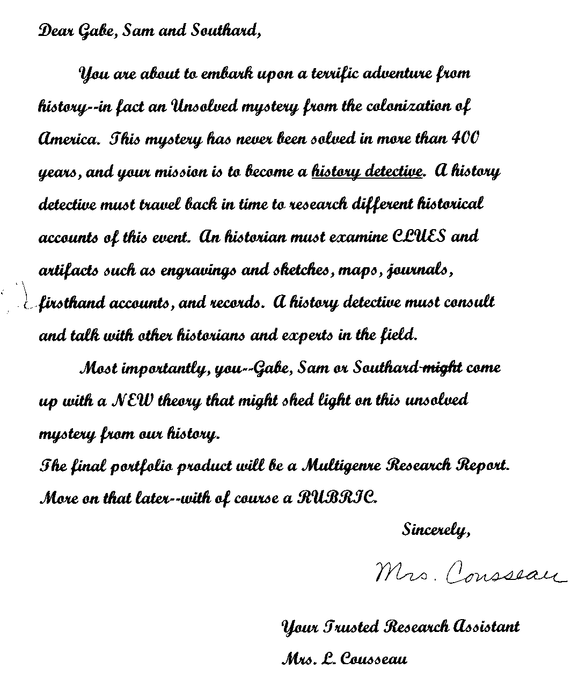 | Final Presentation to 4th grade class studying same topic  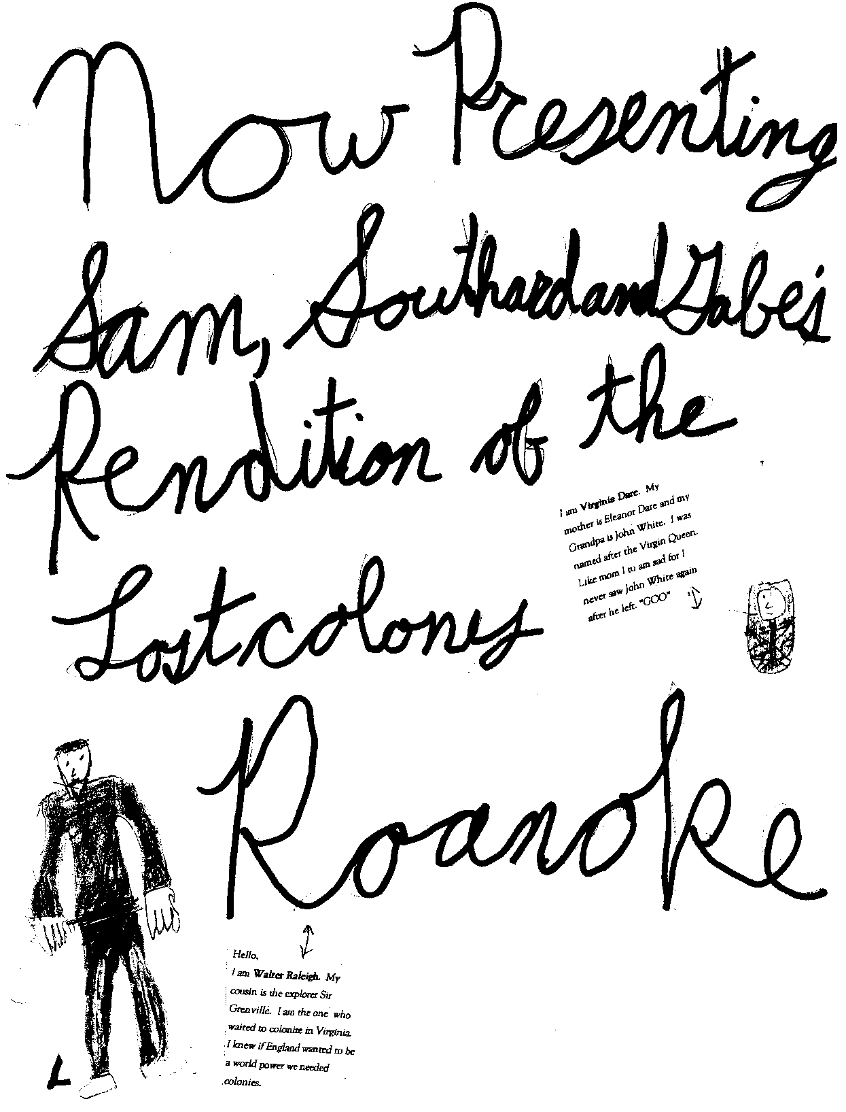
Main Characters of Roanoke (2 formats)  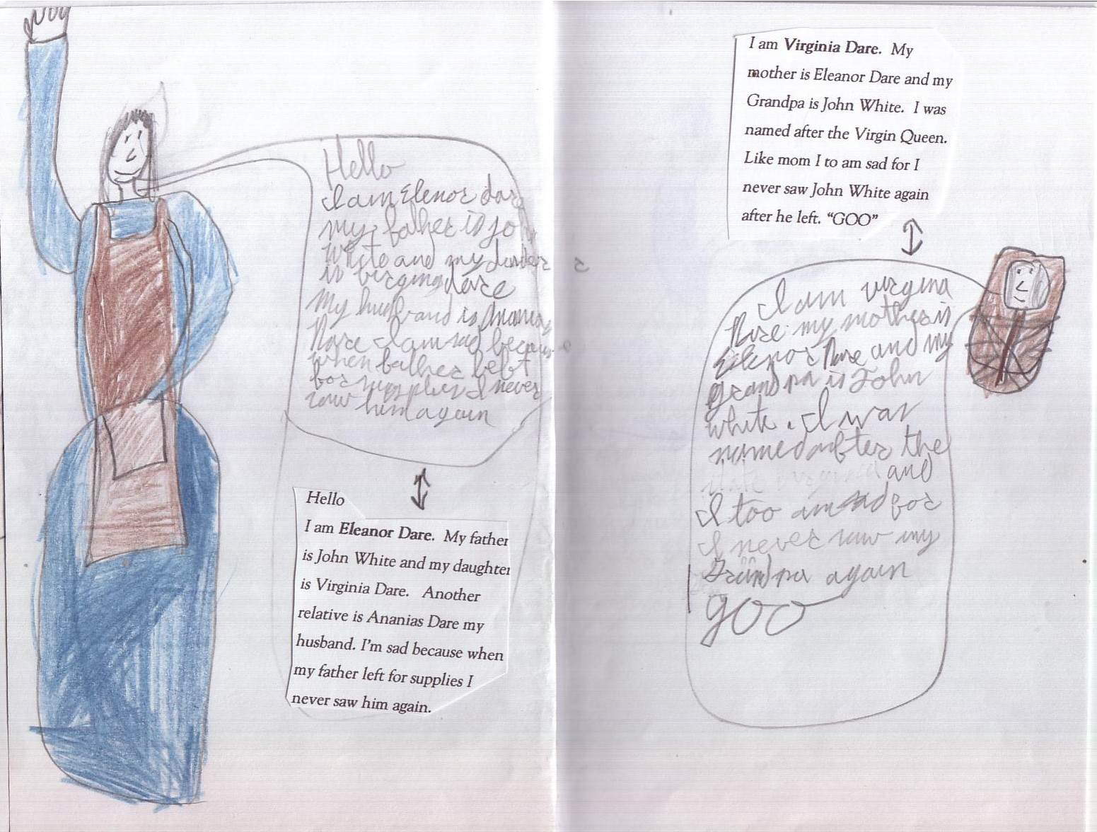 | 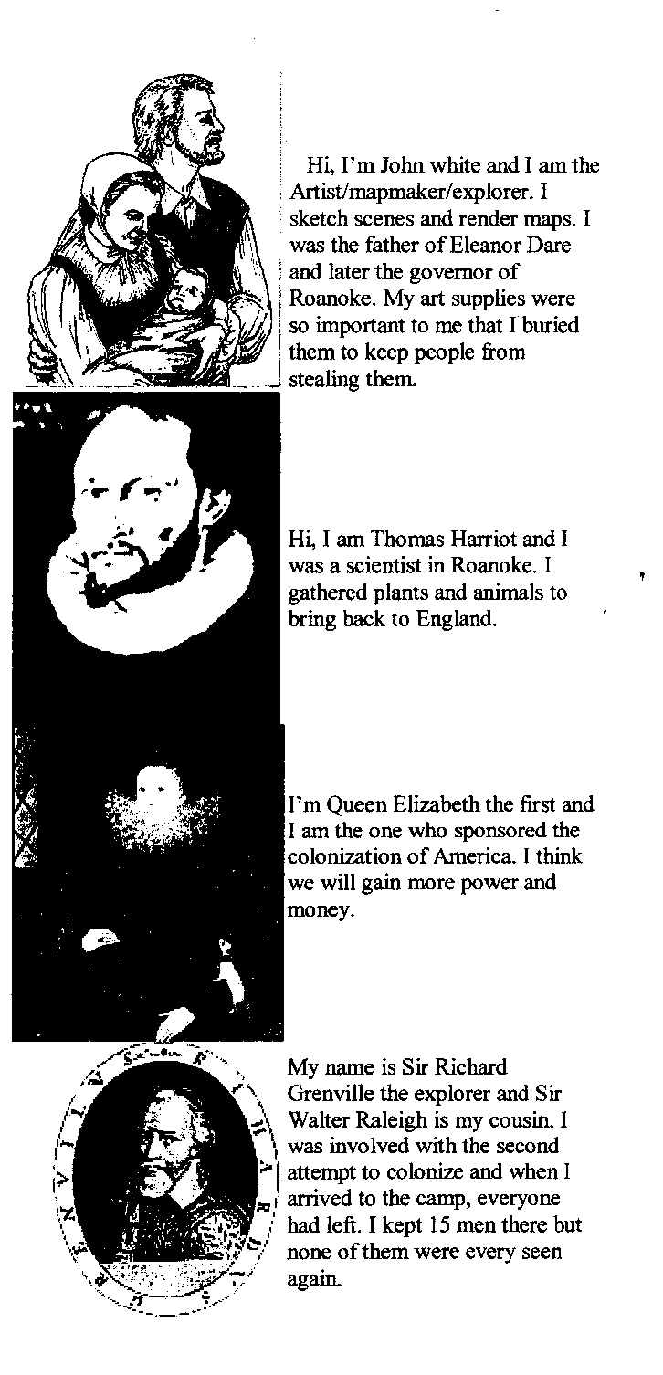
Letters from ‘Key’ player point-of-view made to look authentic  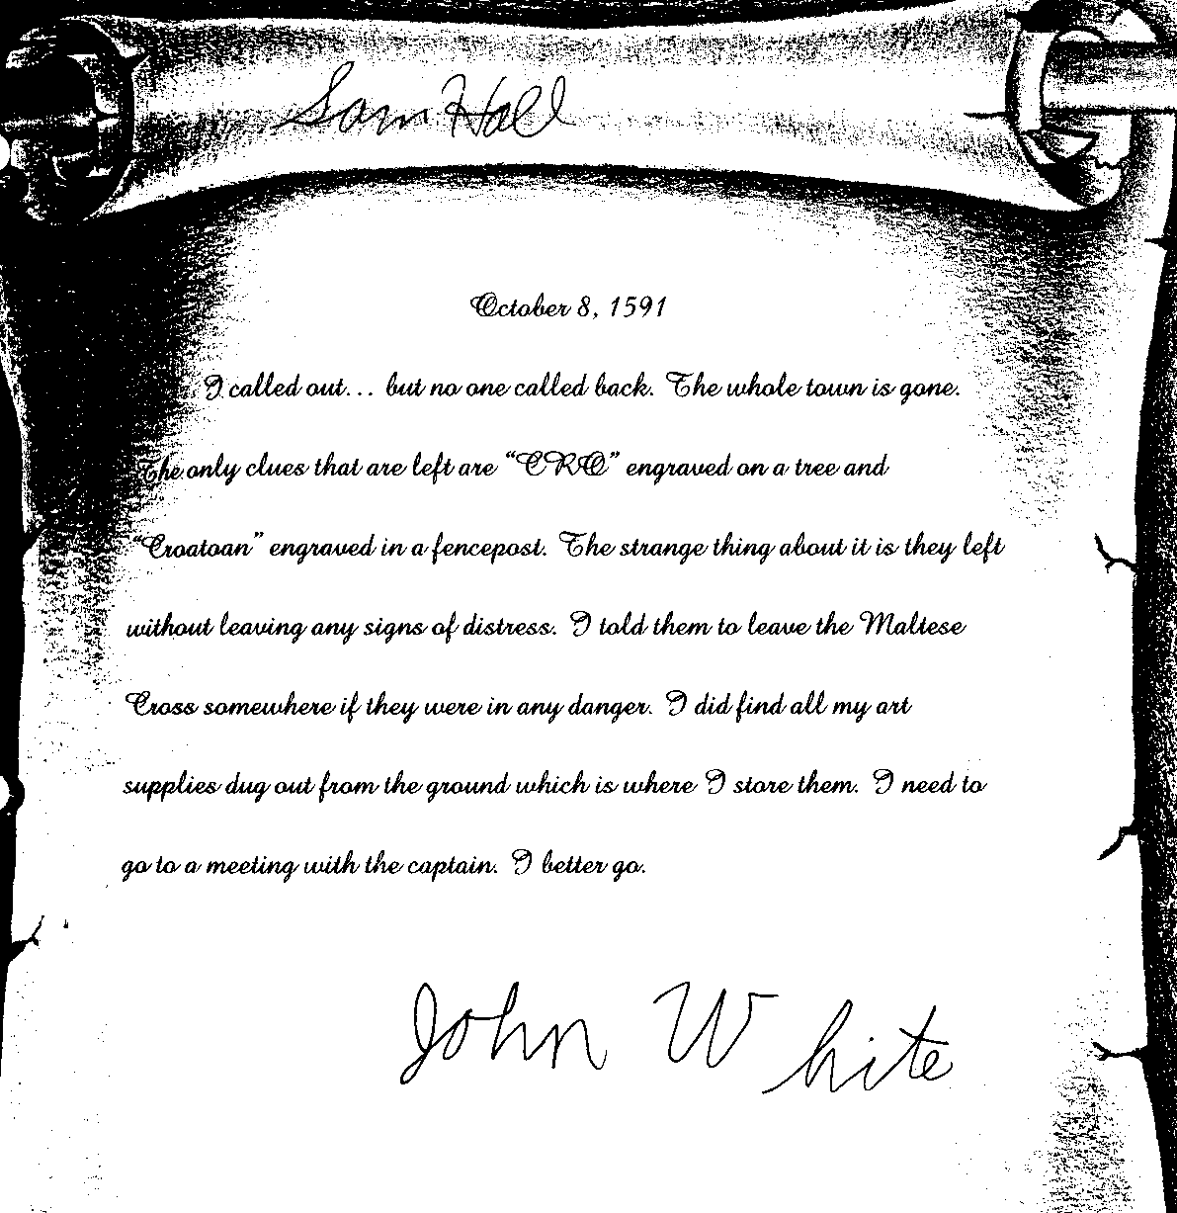 | 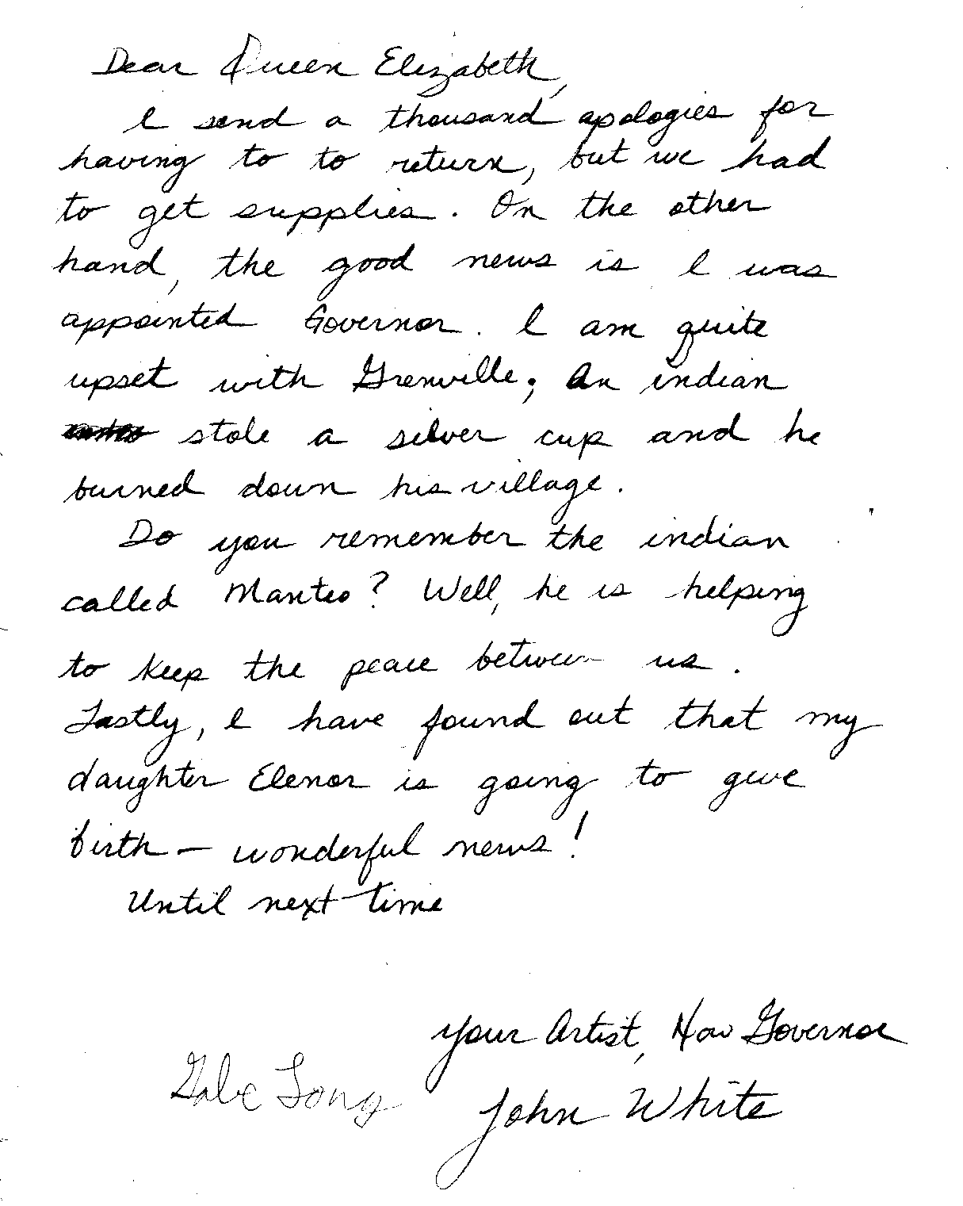
Original Theory  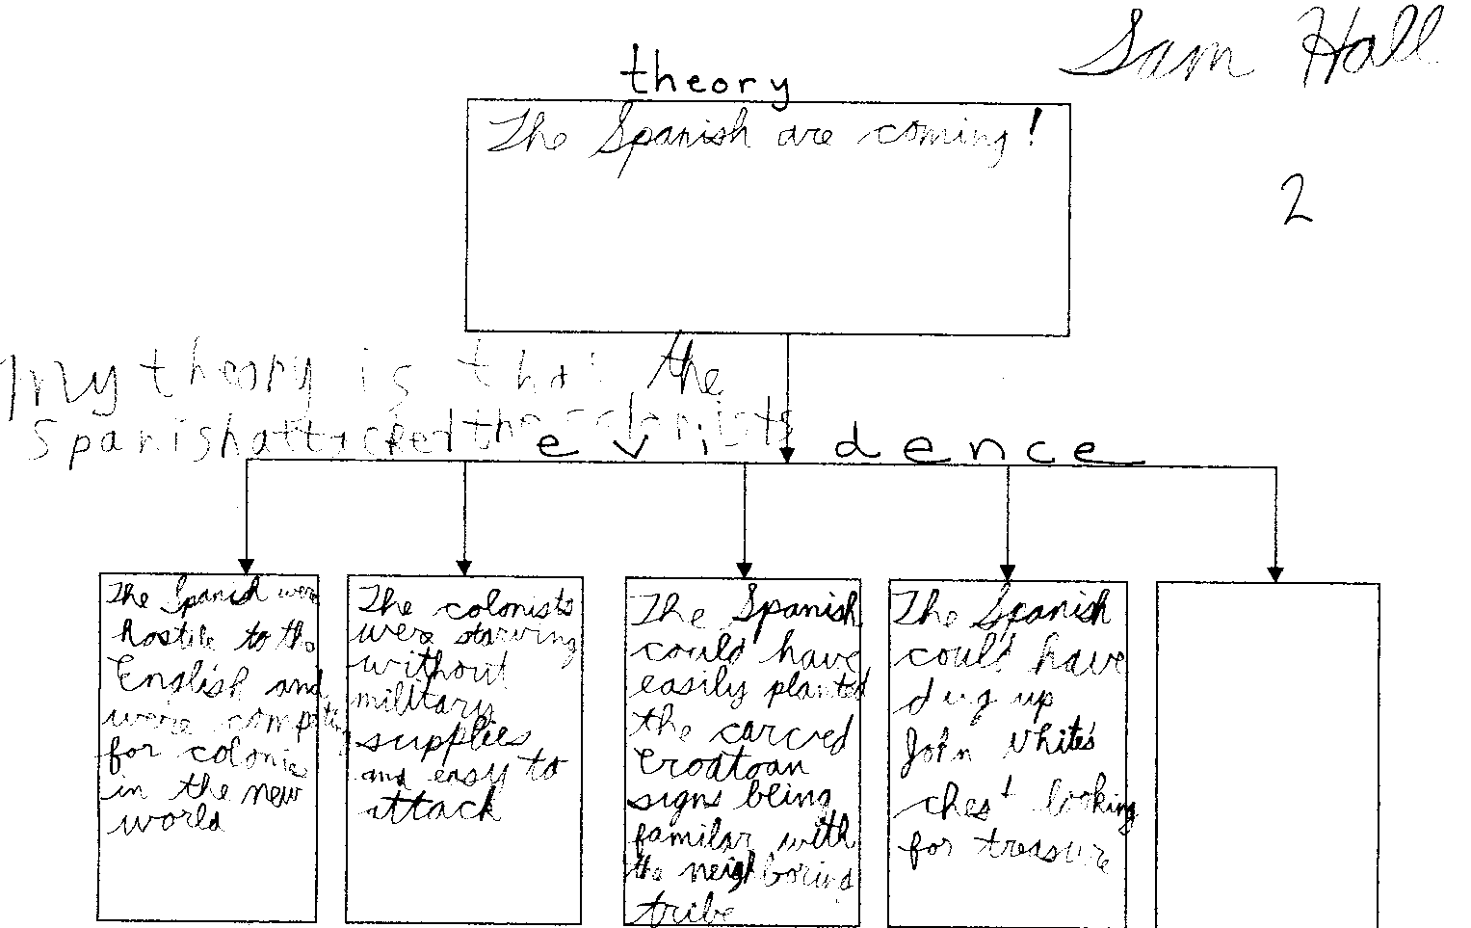 | The students presented their project with props such as authentic maps, quill pens, journal of ‘sketches’ and a log carved with the words CRO.

