Assessment
The unit ends with a five page formalized test that includes a sampling of formats: matching, multiple choice, short answer and short essay. These students are typically overwhelmed and frightened of ‘tests’ often due to past negative experiences and limited preparation and test-taking strategies. Initially, an overview of content is provided and the different formats are modeled. Additionally, students are given a chance to study, discuss and make notes in class. They have been remarkably successful and this gives them a great sense of accomplishment. Rubrics are often used throughout the unit to provide clear expectations and grading. (See Gods/Goddesses report). With the final Literature Circle project, the students design their own rubric for grading to encompass both the project and presentation.

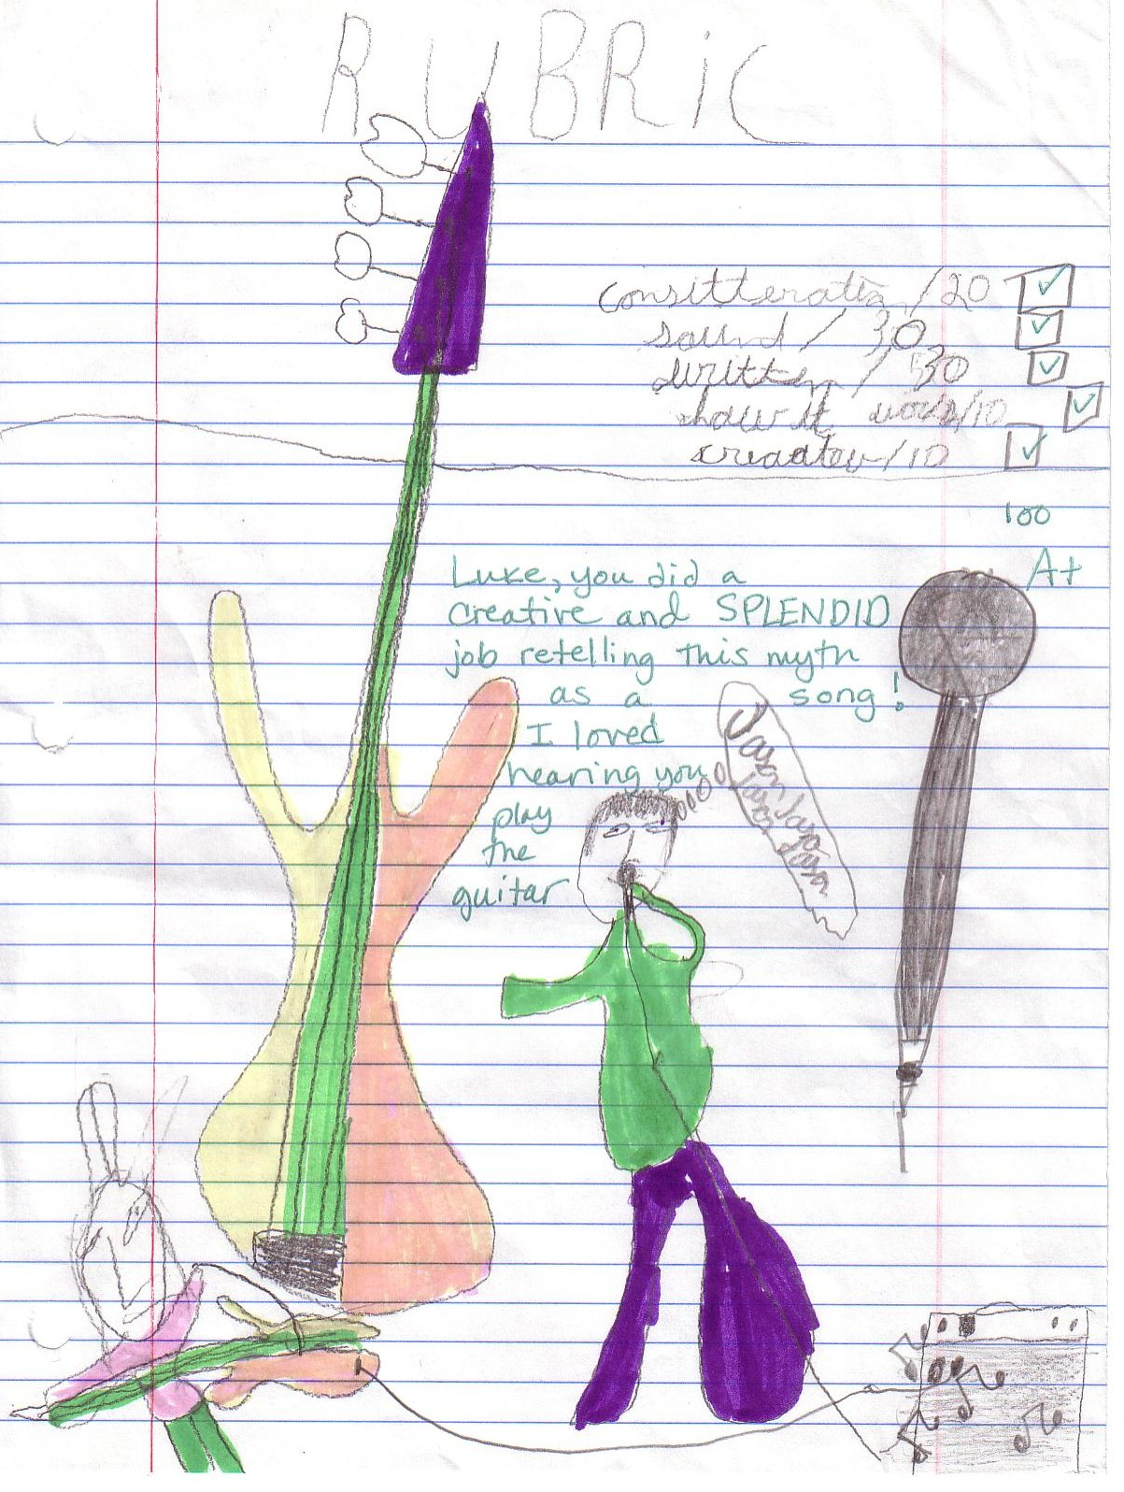

Sample of Student Rubric

