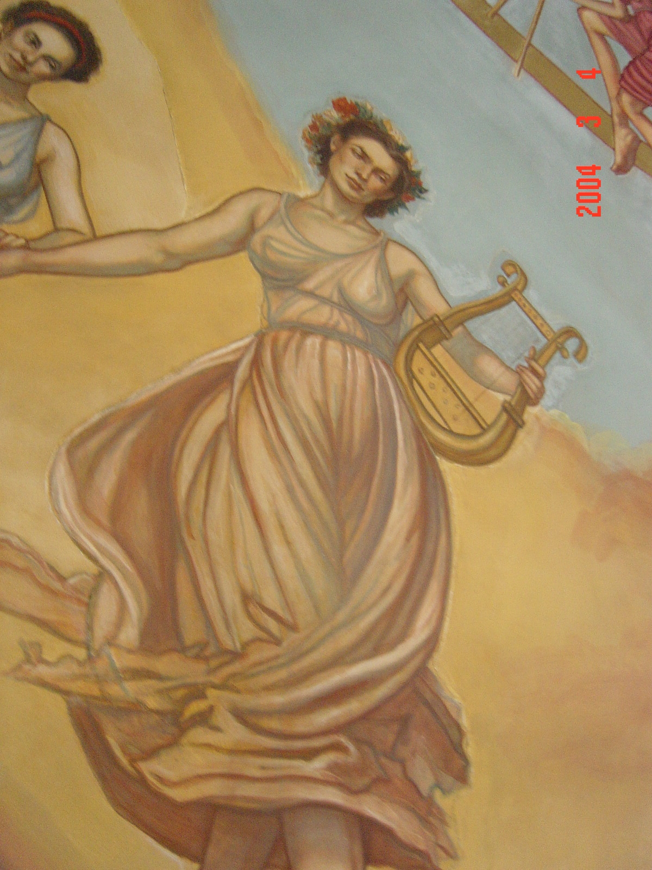

Journal Writing
Up to this point in the year, students have been conducting a private dialogue with the teacher on the pages of their journals. After randomly choosing a God or Goddess from Mount Olympus (out of Athena’s helmet) to correspond with, they start writing and responding to each other. This is a wonderful way for the students to not only take on the persona of their representative God or Goddess (Hermes, Poseidon…), but also to connect the present 21st century with Ancient Greece.

Invitation
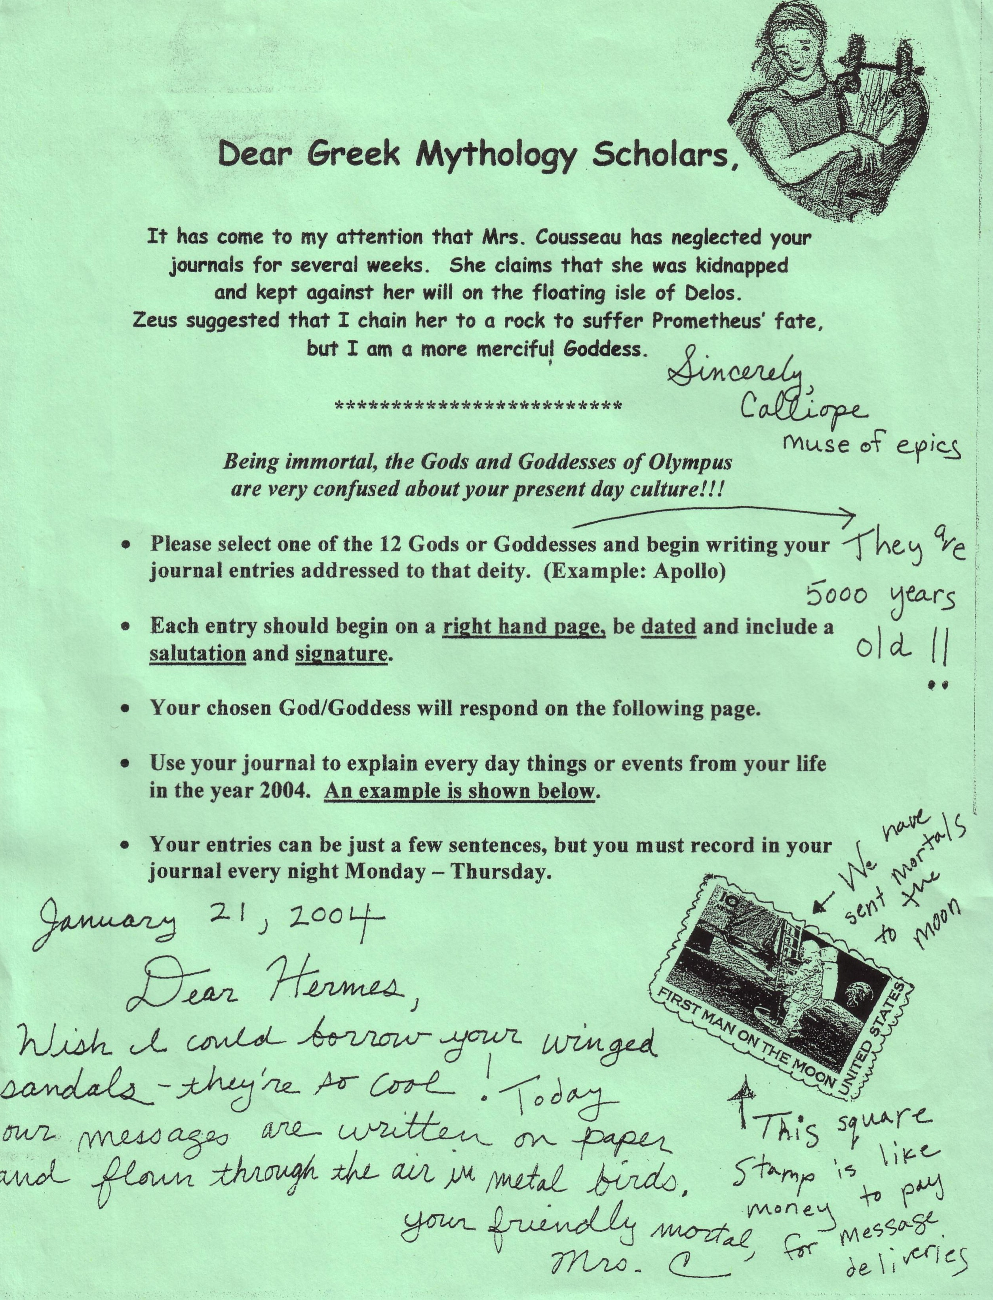

Excerpts from Greek Mythology Journals:

Week of 1/20/04 – 1/23/04

- Dear Hepastus, (Hephaestus),
…. There factoreas that build furnicher. I like your wepon you make….I wish I could be a God because I could be powerful and strong….I want to live in Atlimpus with all the God…a leader like Zeus. I want to see all the storys that happened to the Gods….from, Gio

RESPONSE
Greetings moral Gio,
….I would like to have my own factory instead of working day in and day out. I bet they can’t make fine furnitur like I do…..Being a god isnt just being powerful it’s a lot ov work. You very well could be a leader just not a god….Later mortal. p.s. I hate guns

- Greetings Honorable Hades,
I was wondering when the dead come to you do they stay there or do you tell them were to go? ….Where the heck did you get Cerebrus? Are you p.o’d that you got the short straw and had to rule the underworld? ….see you in about 80 years, Gabe.

RESPONSE
Dear Gabe Long,
…I got Cerebrus off the streets of heaven. If you were a lot older, I would take you to the underworld…..Your god Hades

- Dear Athena
…..It is really gross that you came out of Zues’s head. I almost threw up! There’s not much wisdom in the world theis days. I like to learn about the gods. Do you like to learn about the mortals….I am the one who doesn’t know anything at all. I can’t think of a singal sentans.….Your friend Ambrose

RESPONSE
…..I think mortals are interresting but sometimes they don’t use common sence. You are wizer than most men think and don’t downgrade yourself. ….Your friendly Goddess and friend, Athena

