STORYTELLING

Students presented their favorite myth to several 3rd grade classrooms and interested parents. I had modeled this several times as I presented myths with props (Eg. String that students pass hand from hand as the myth of Theseus and the Minotaur wound its way through their ‘senses’). Although some were initially very hesitant (6th grade boys and oral expressive difficulties), they quickly jumped into the spirit of the event and were inspired by each other. Rather than reading from cards, their well-chosen props guidd the telling.

The third graders were invited to participate and became involved as live props in Perseus and Medusa. They especially loved chopping off the Gorgon’s head. One very shy young man donned a wig as Daphne transformed herself into a laurel tree. Initially facilitating, during the performance, I was able to step back and let they truly STEAL THE SHOW!

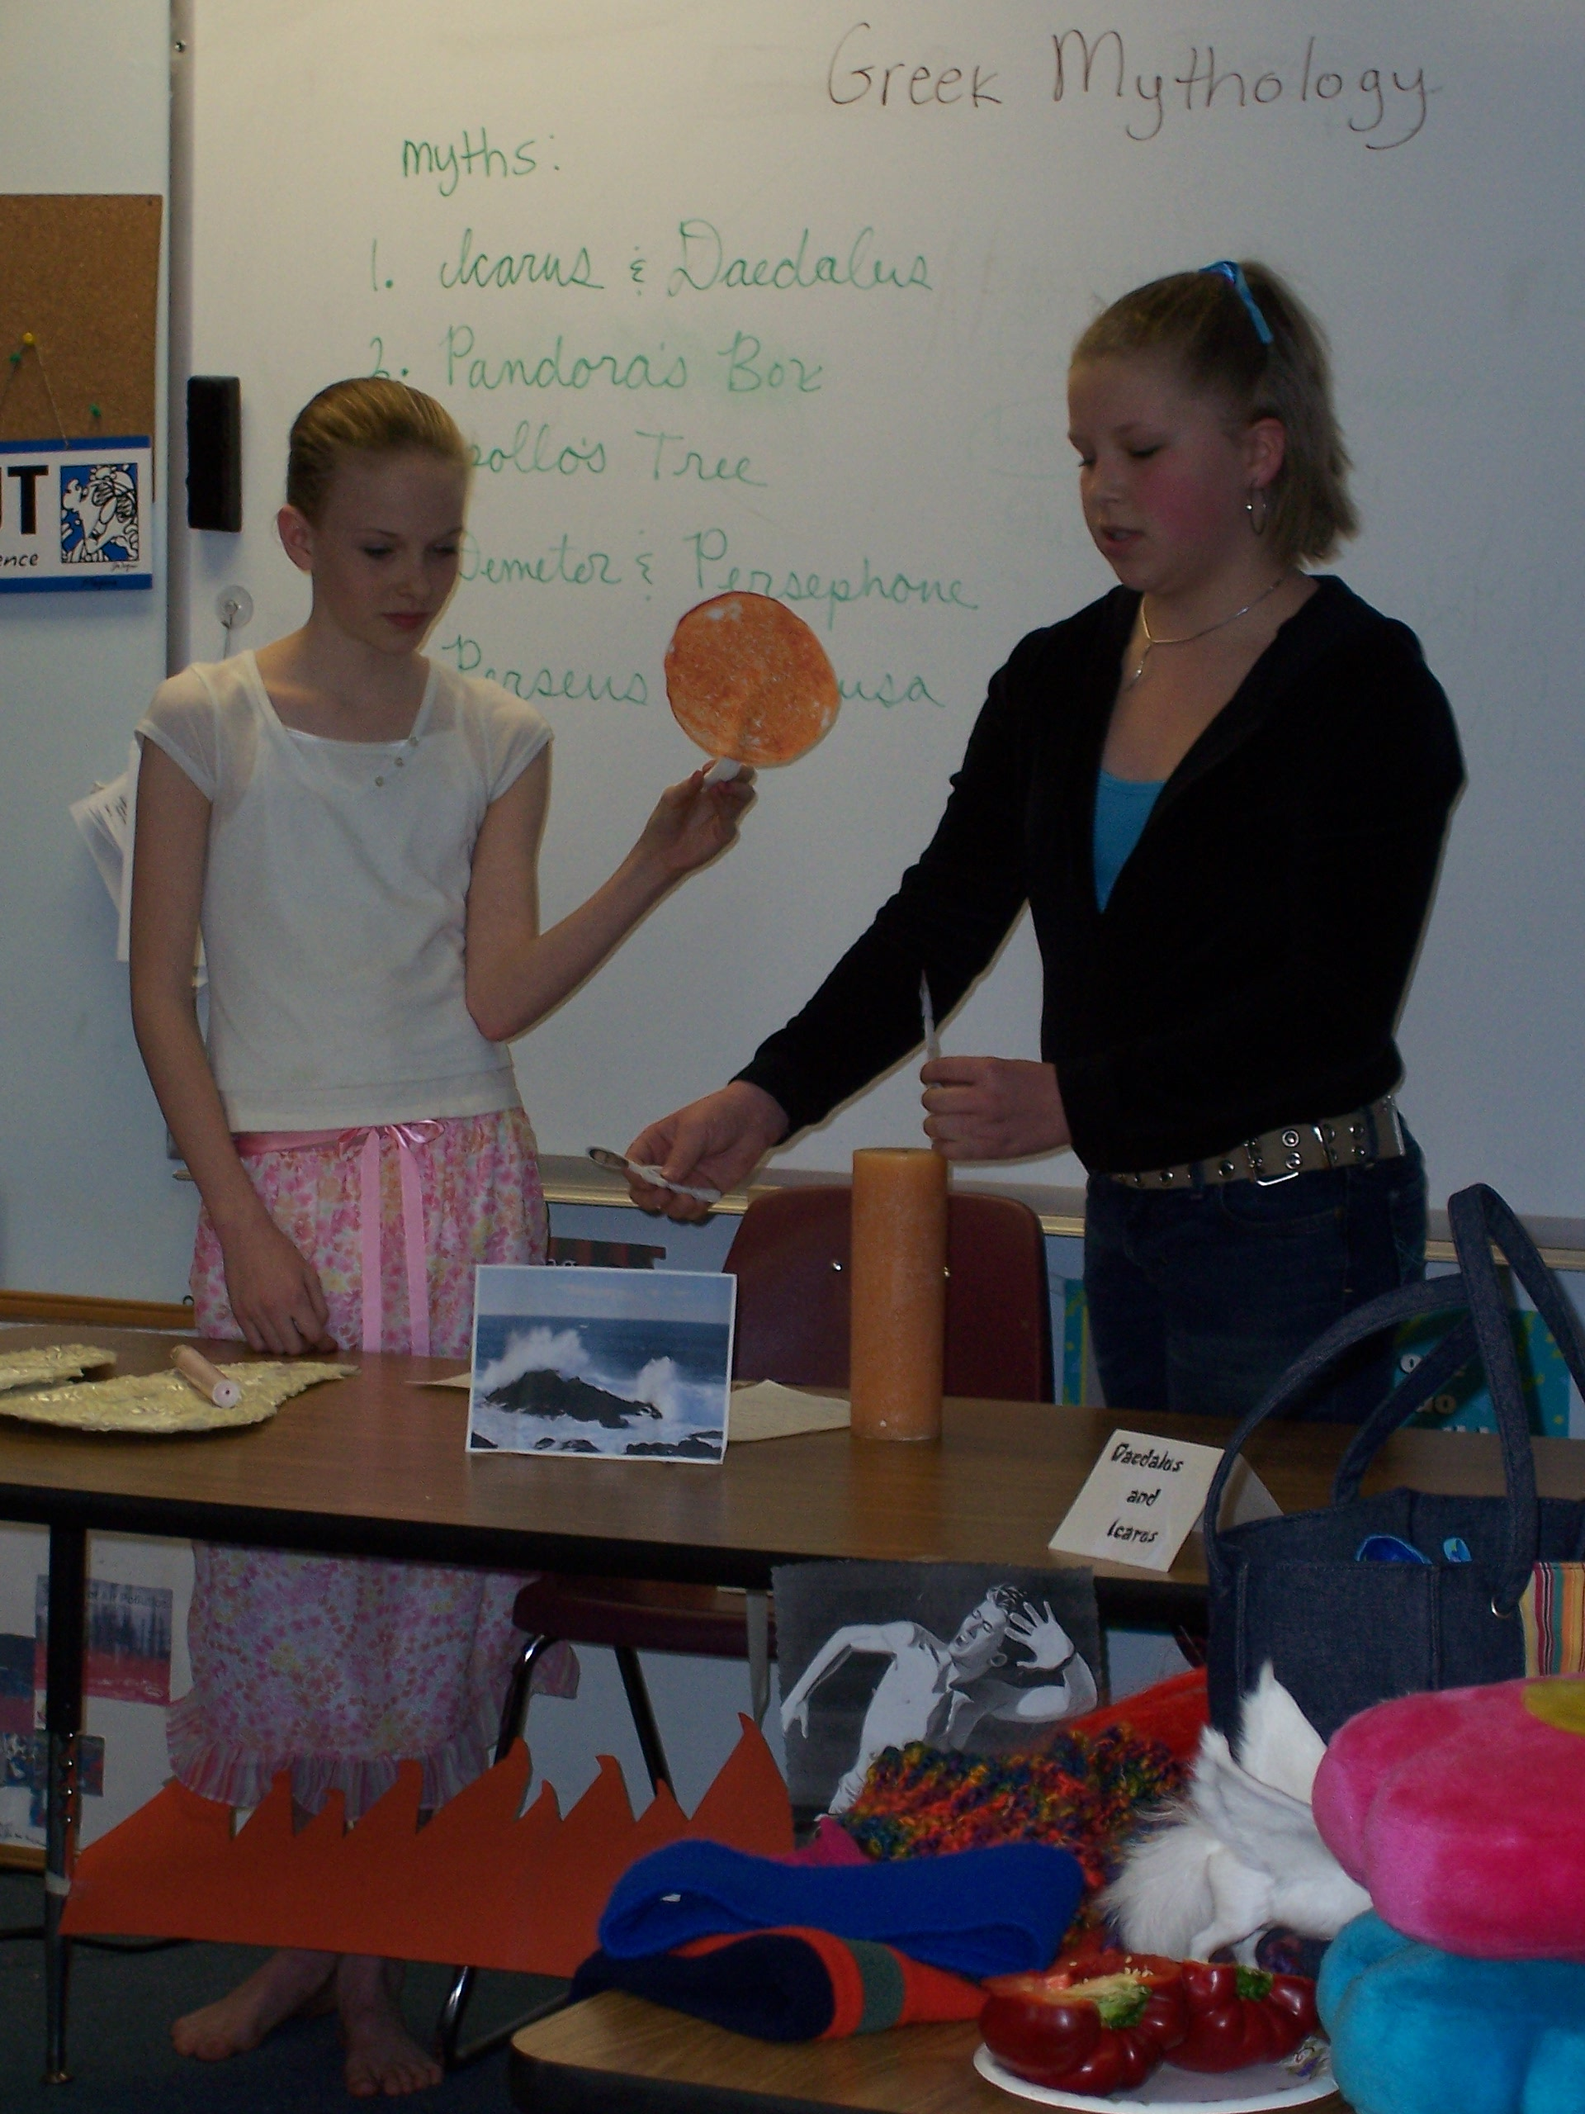  Lily and Meredith present Daedalus and Icarus with wll-chosen props. | 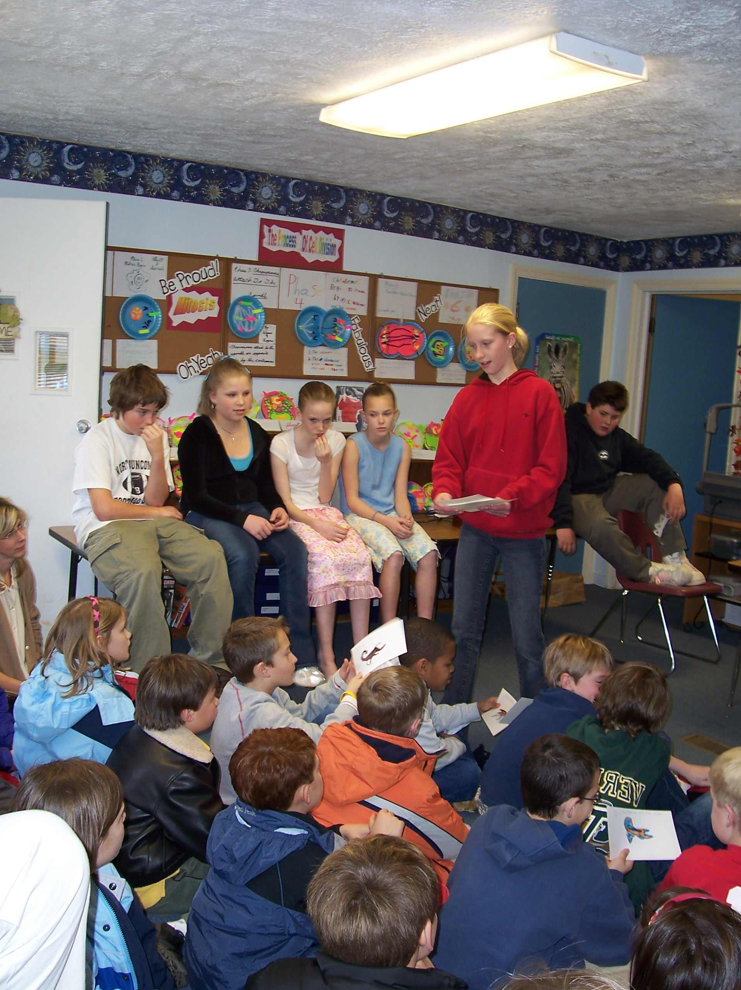  Hannah hands out the miseries from Pandora’s box: (plague, sickness, greed….)
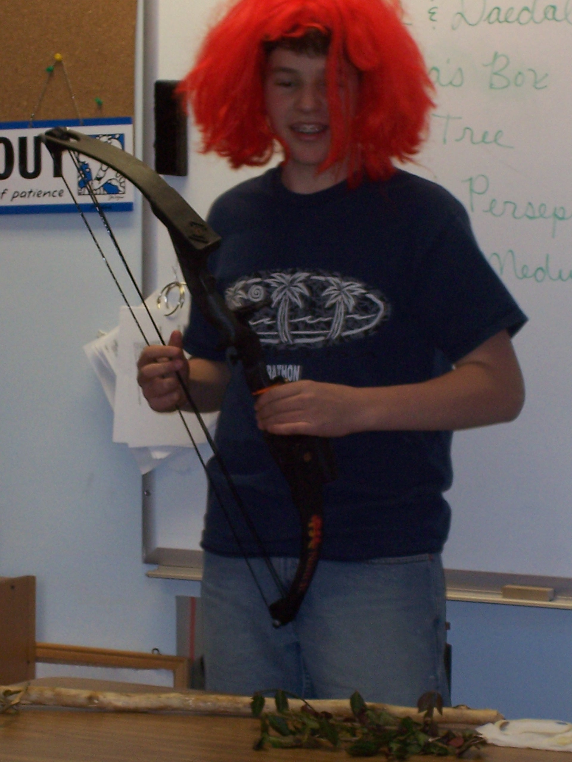  The lovely Daphne….. | 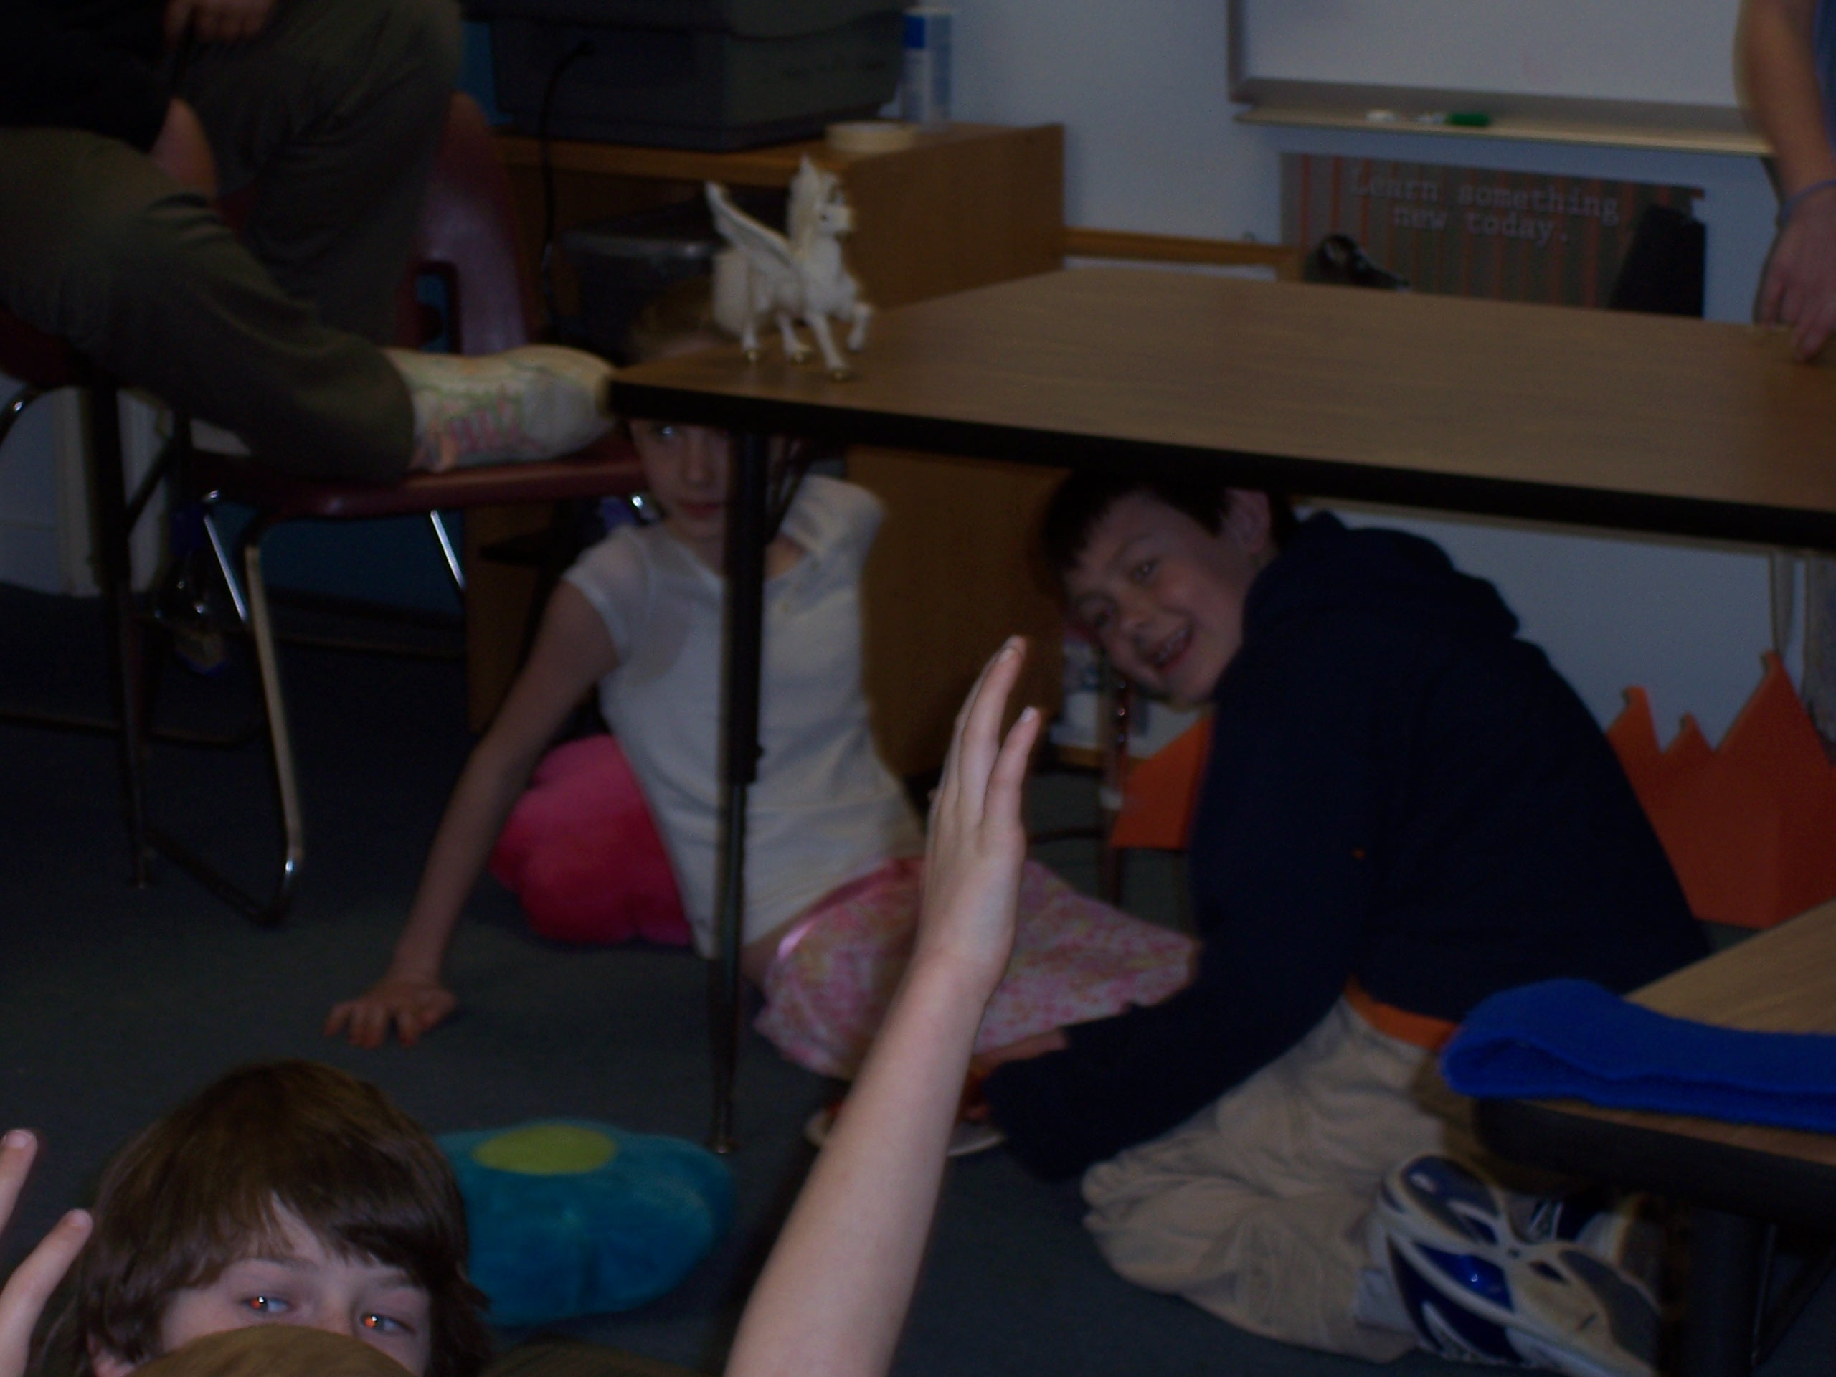  Many hands raise as they are chosen to be props in the myth Perseus and Medusa. In this scene “Danae is imprisoned underground.

