Samples from my personal collection of favorite poems.

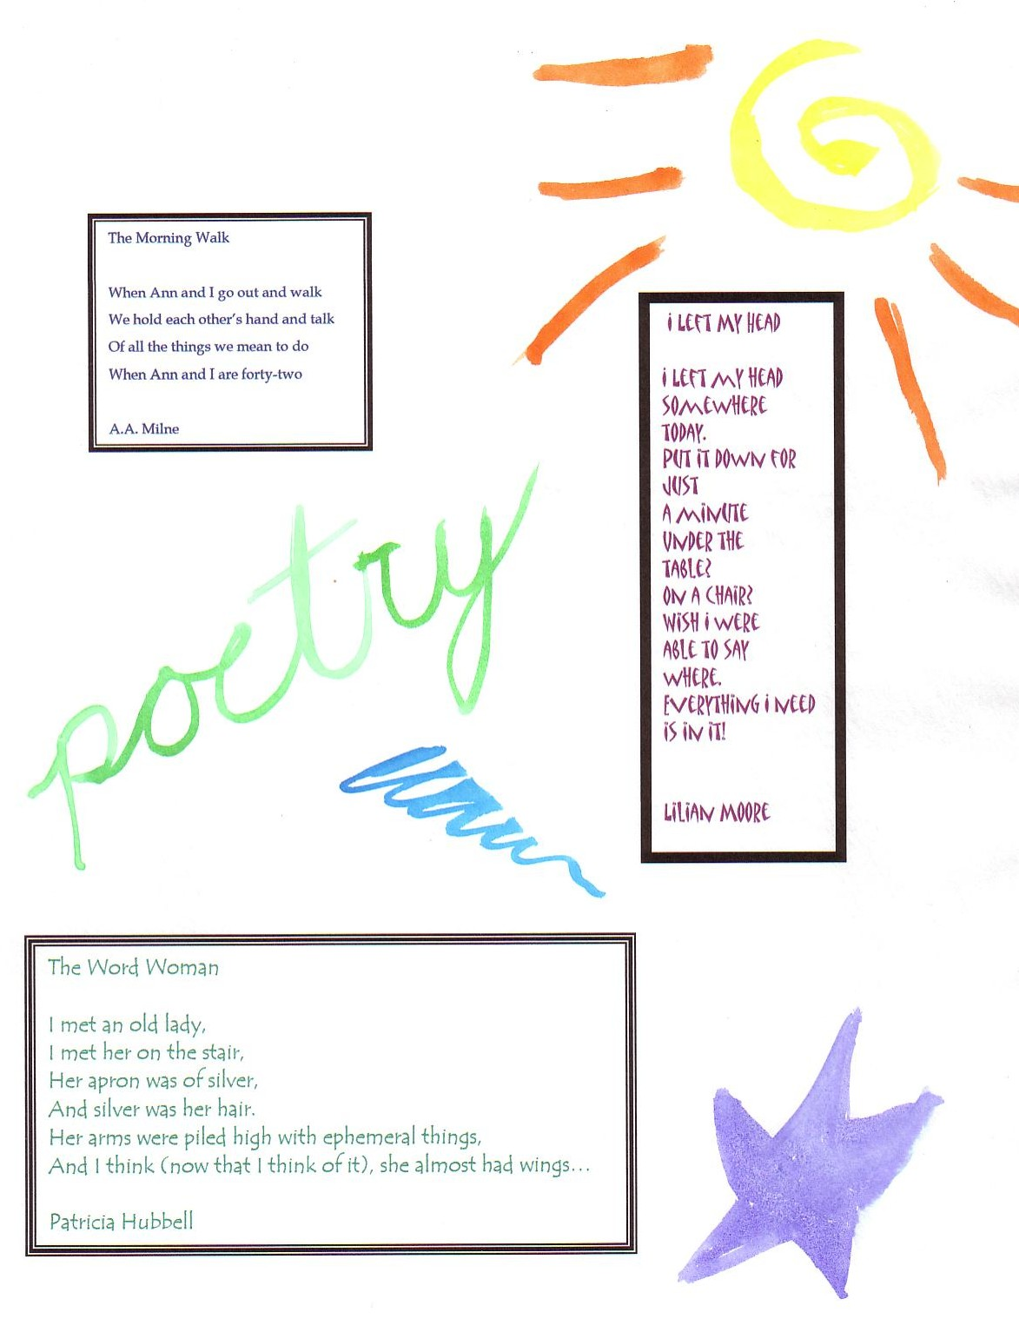 | 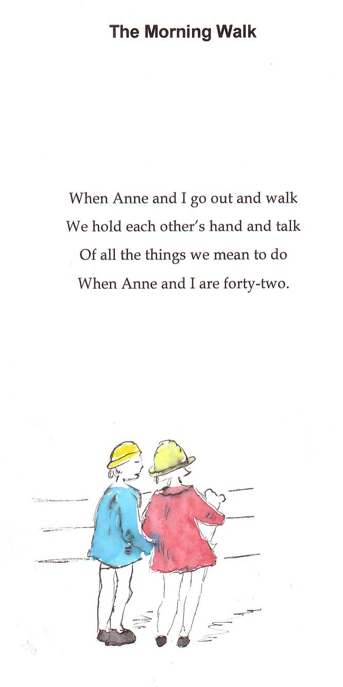  E.E. Milne
Cover: Many of the students also chose to include excerpts from favorite poems on the front.  Each poem was accompanied by an illustration and ‘reflection.’ After much practice, the students produced increasingly thoughtful work. | 