Student Poetry Collections

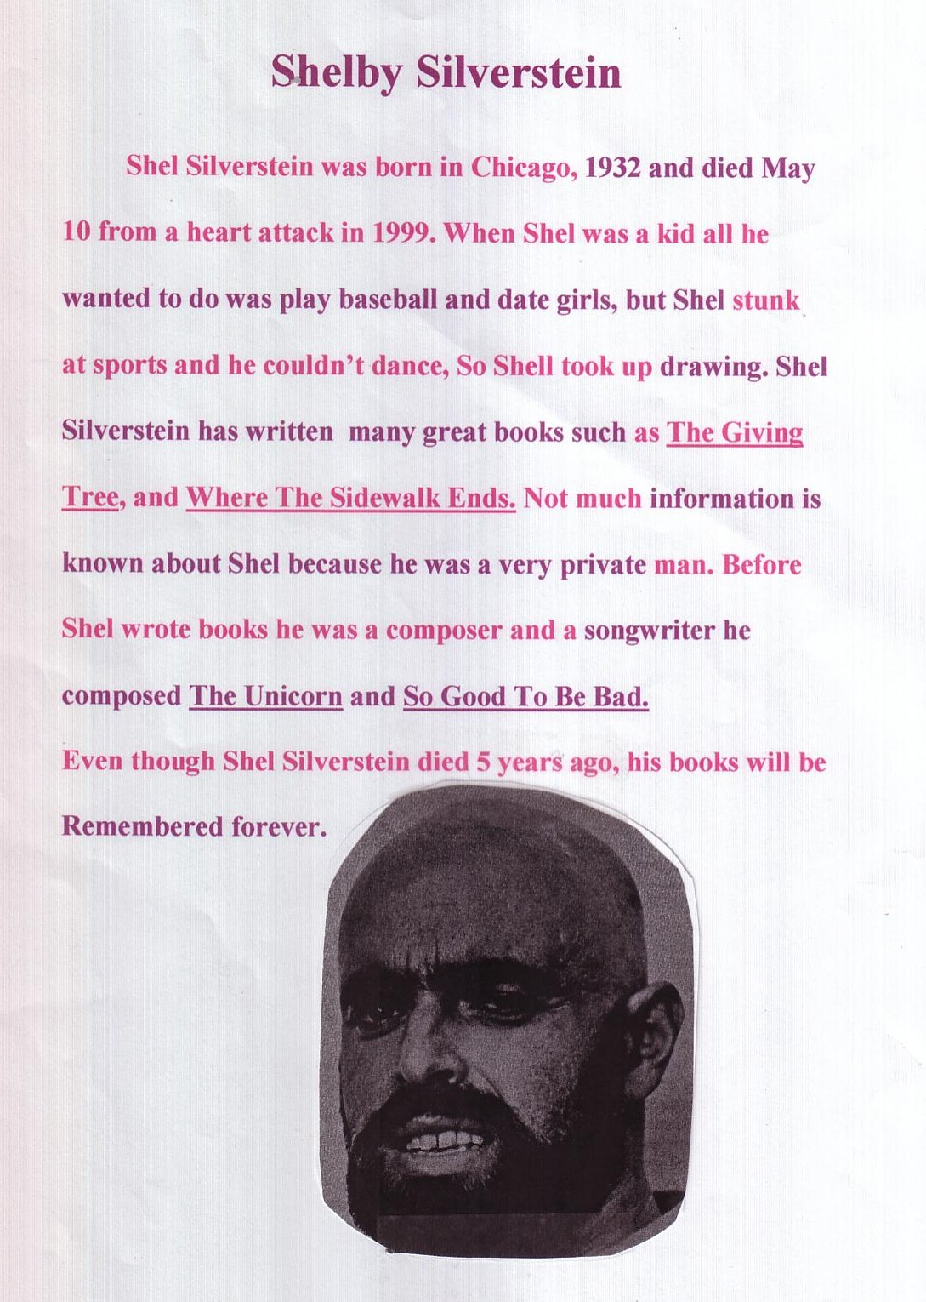  Students had to do some independent research | 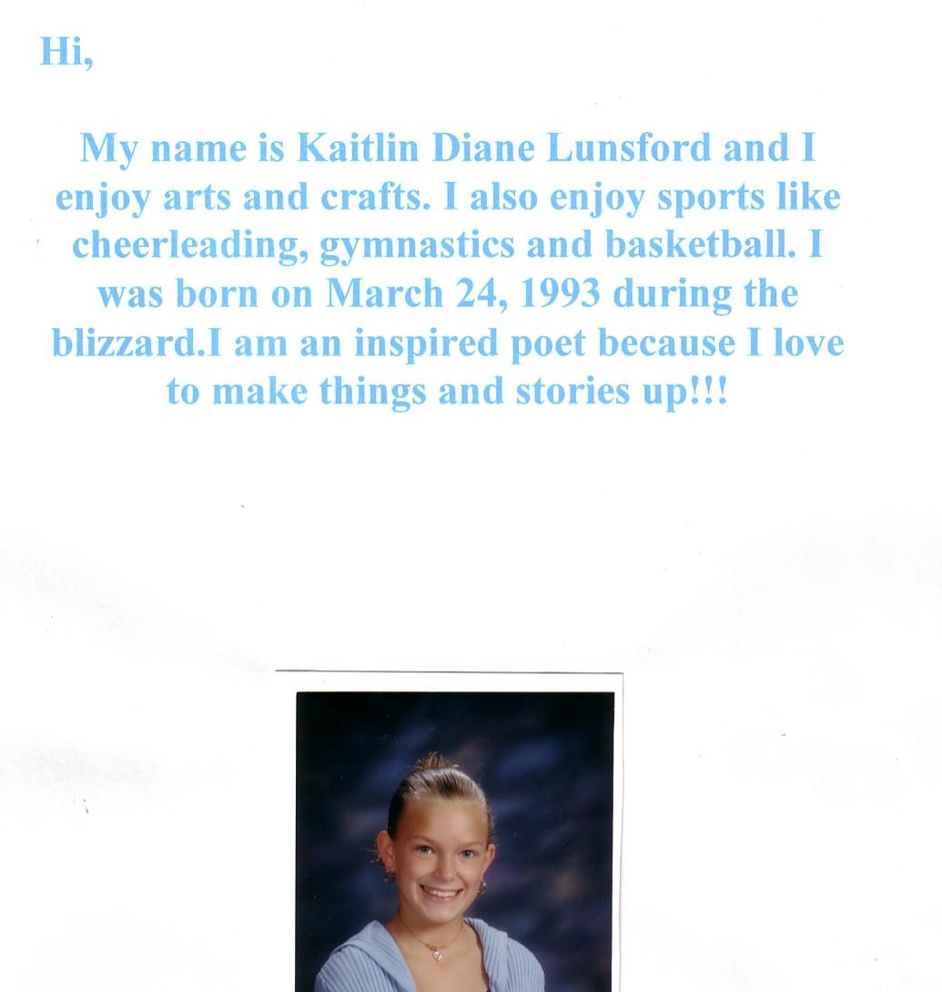  The students truly began to see themselves as poets
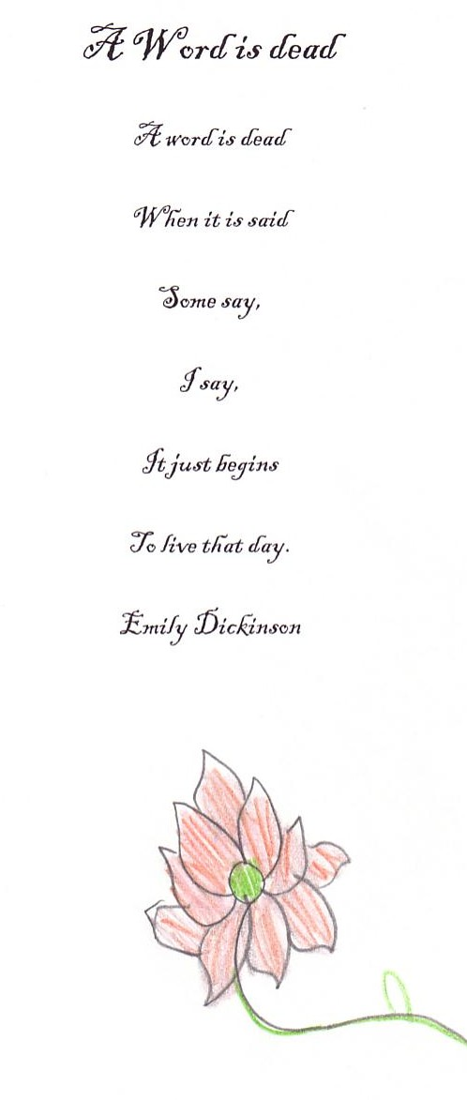  They included ten poems from the poets we studied and  some of their own choice. | 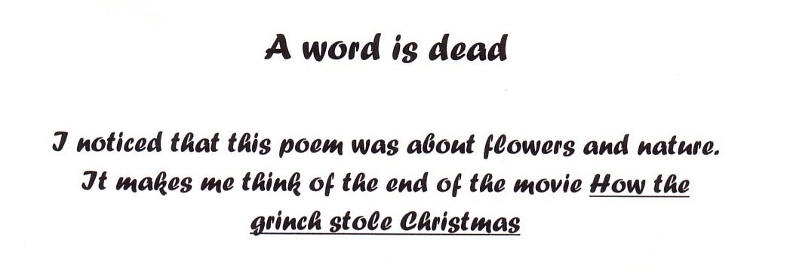  The two questions they were to respond to were:  1: One thing that they noticed about the ‘style?  (this was the most challenging)  AND  2. One thing that the poem made them think of ?
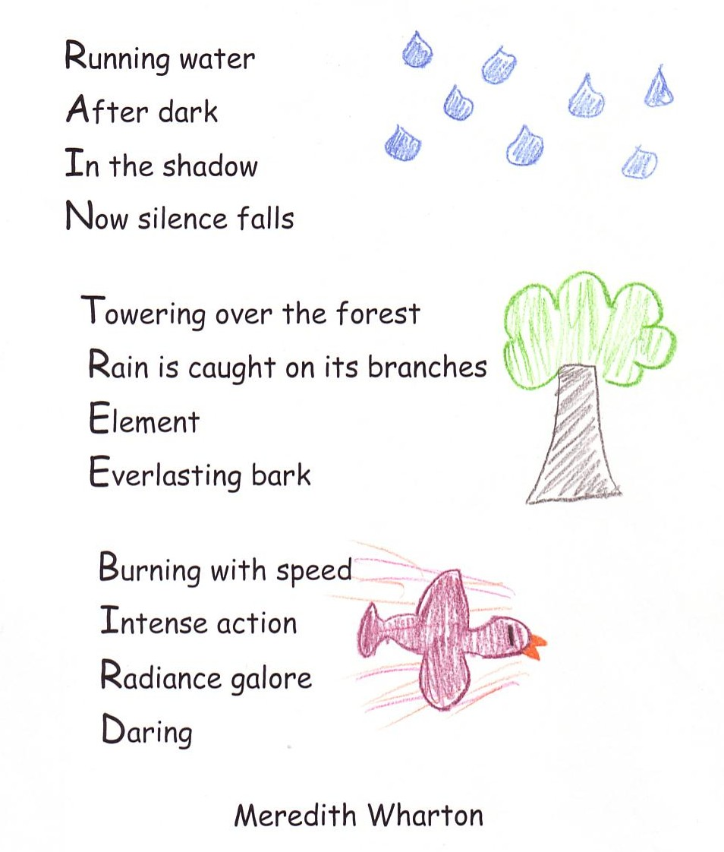  Acrostic Riddle Poems | 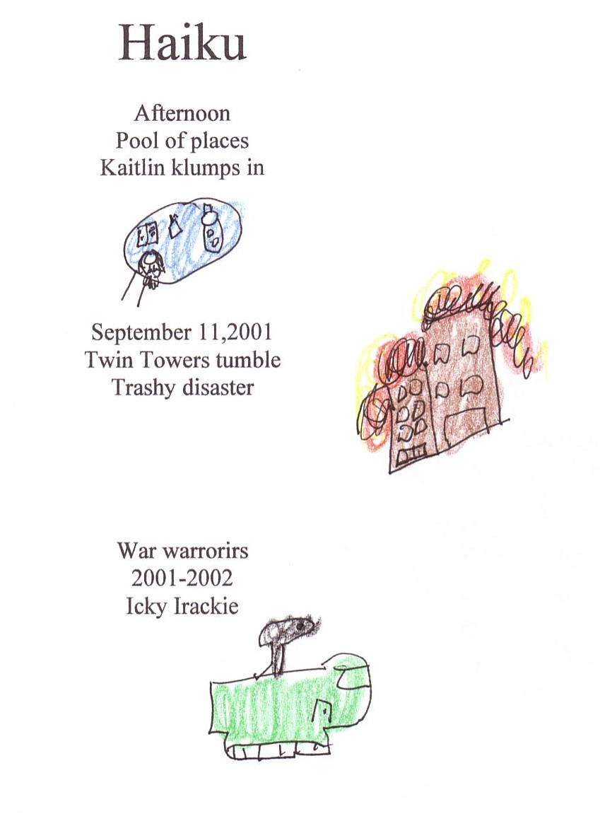  When doing haiku, we also discussed alliteration.
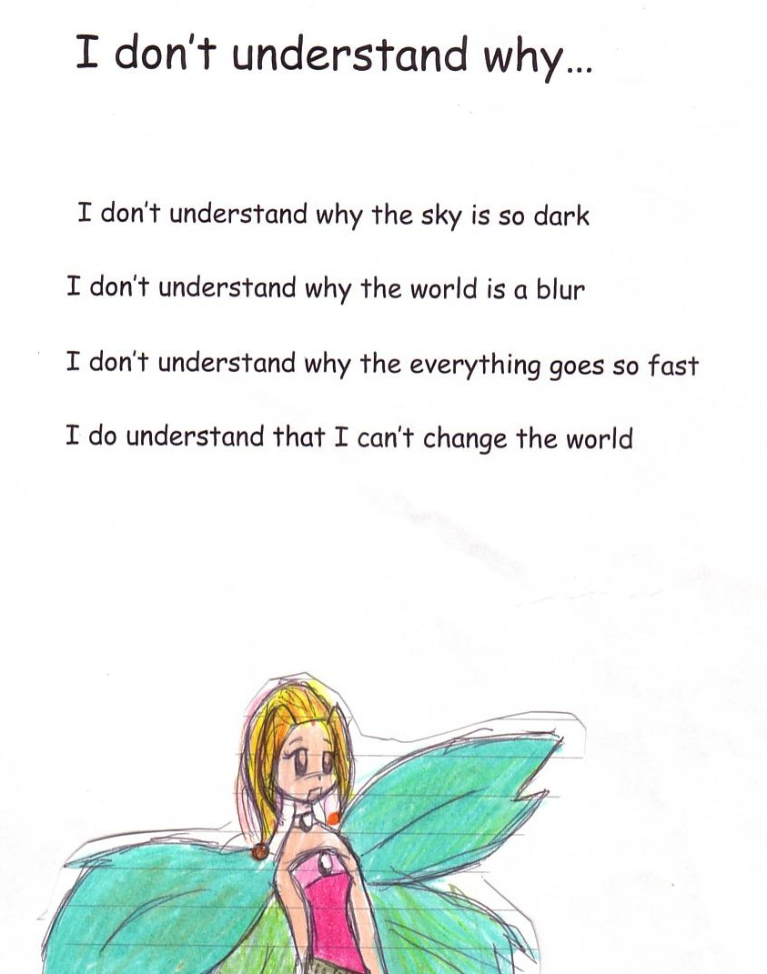  It always helped students to have a model, and for some a template. | 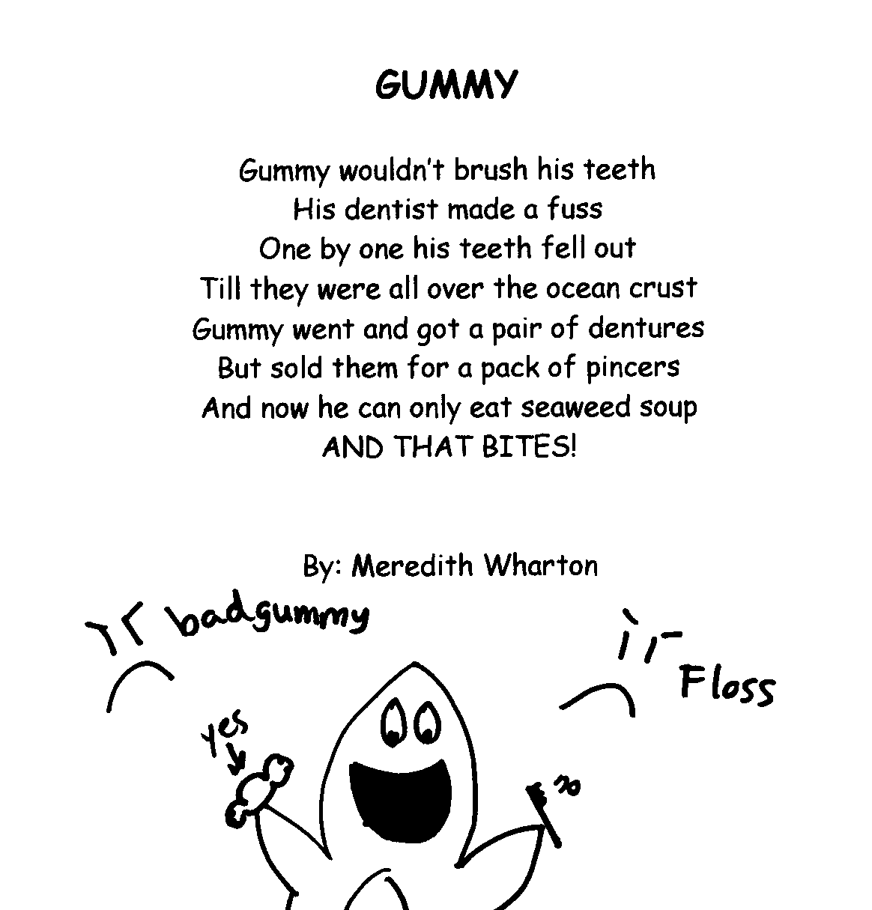  Writing in the style of another poet helped them craft their own style.

