Student Samples from portfolios

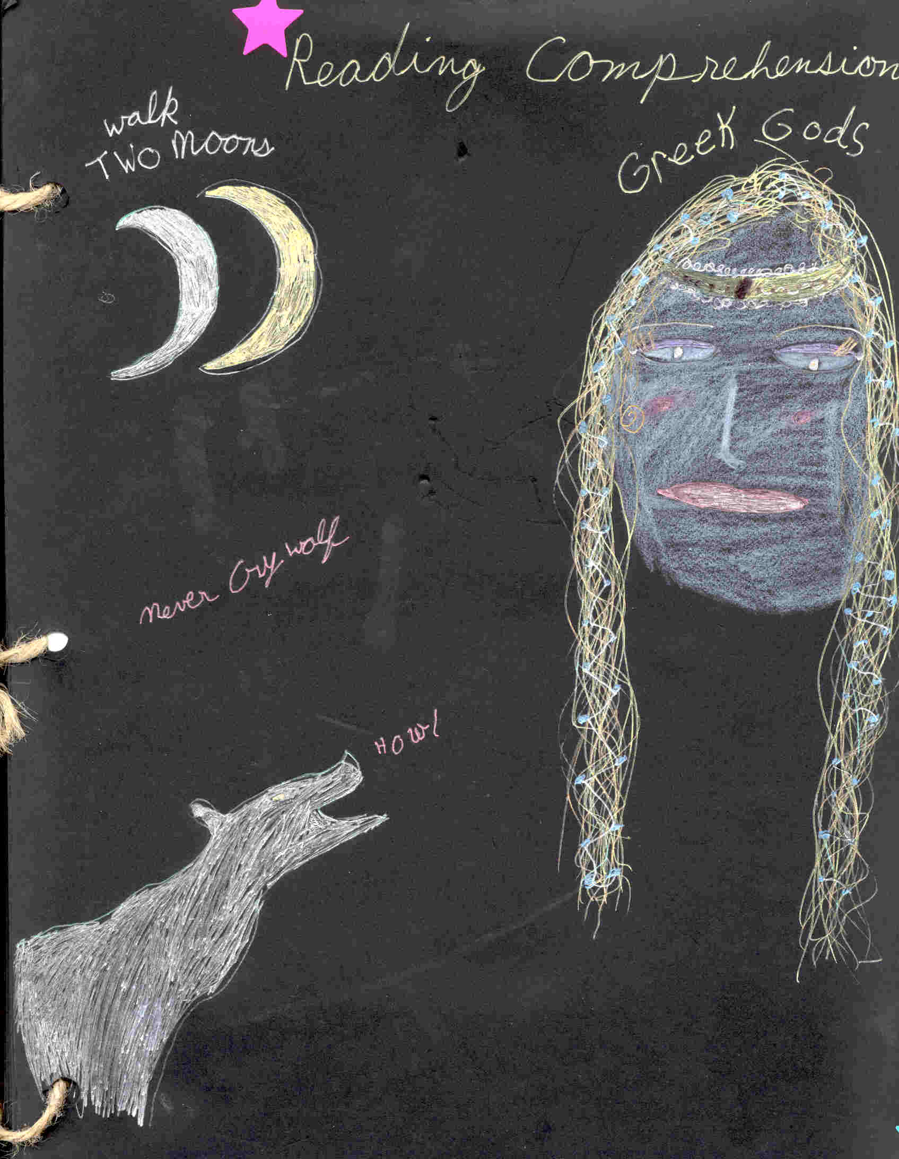 | Cover  Some of the students chose to use black paper and pastels, colored pencils and gel pens.  The 3 units are represented.
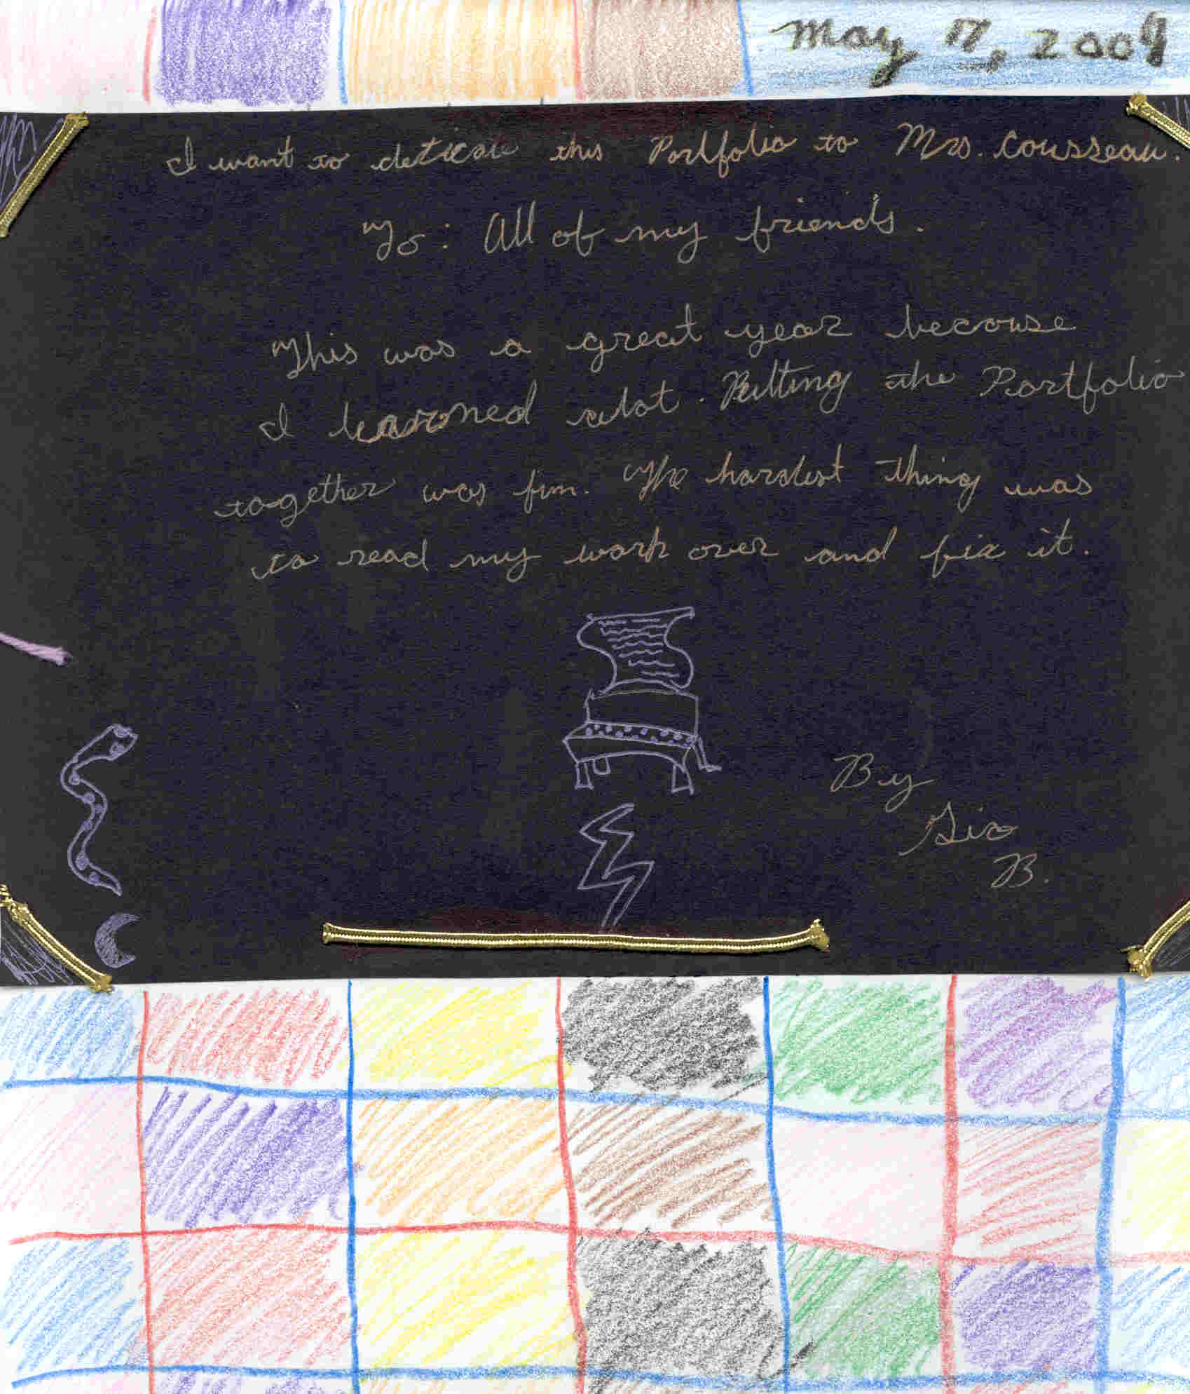 | They each wrote a dedication that reflected what they had learned.
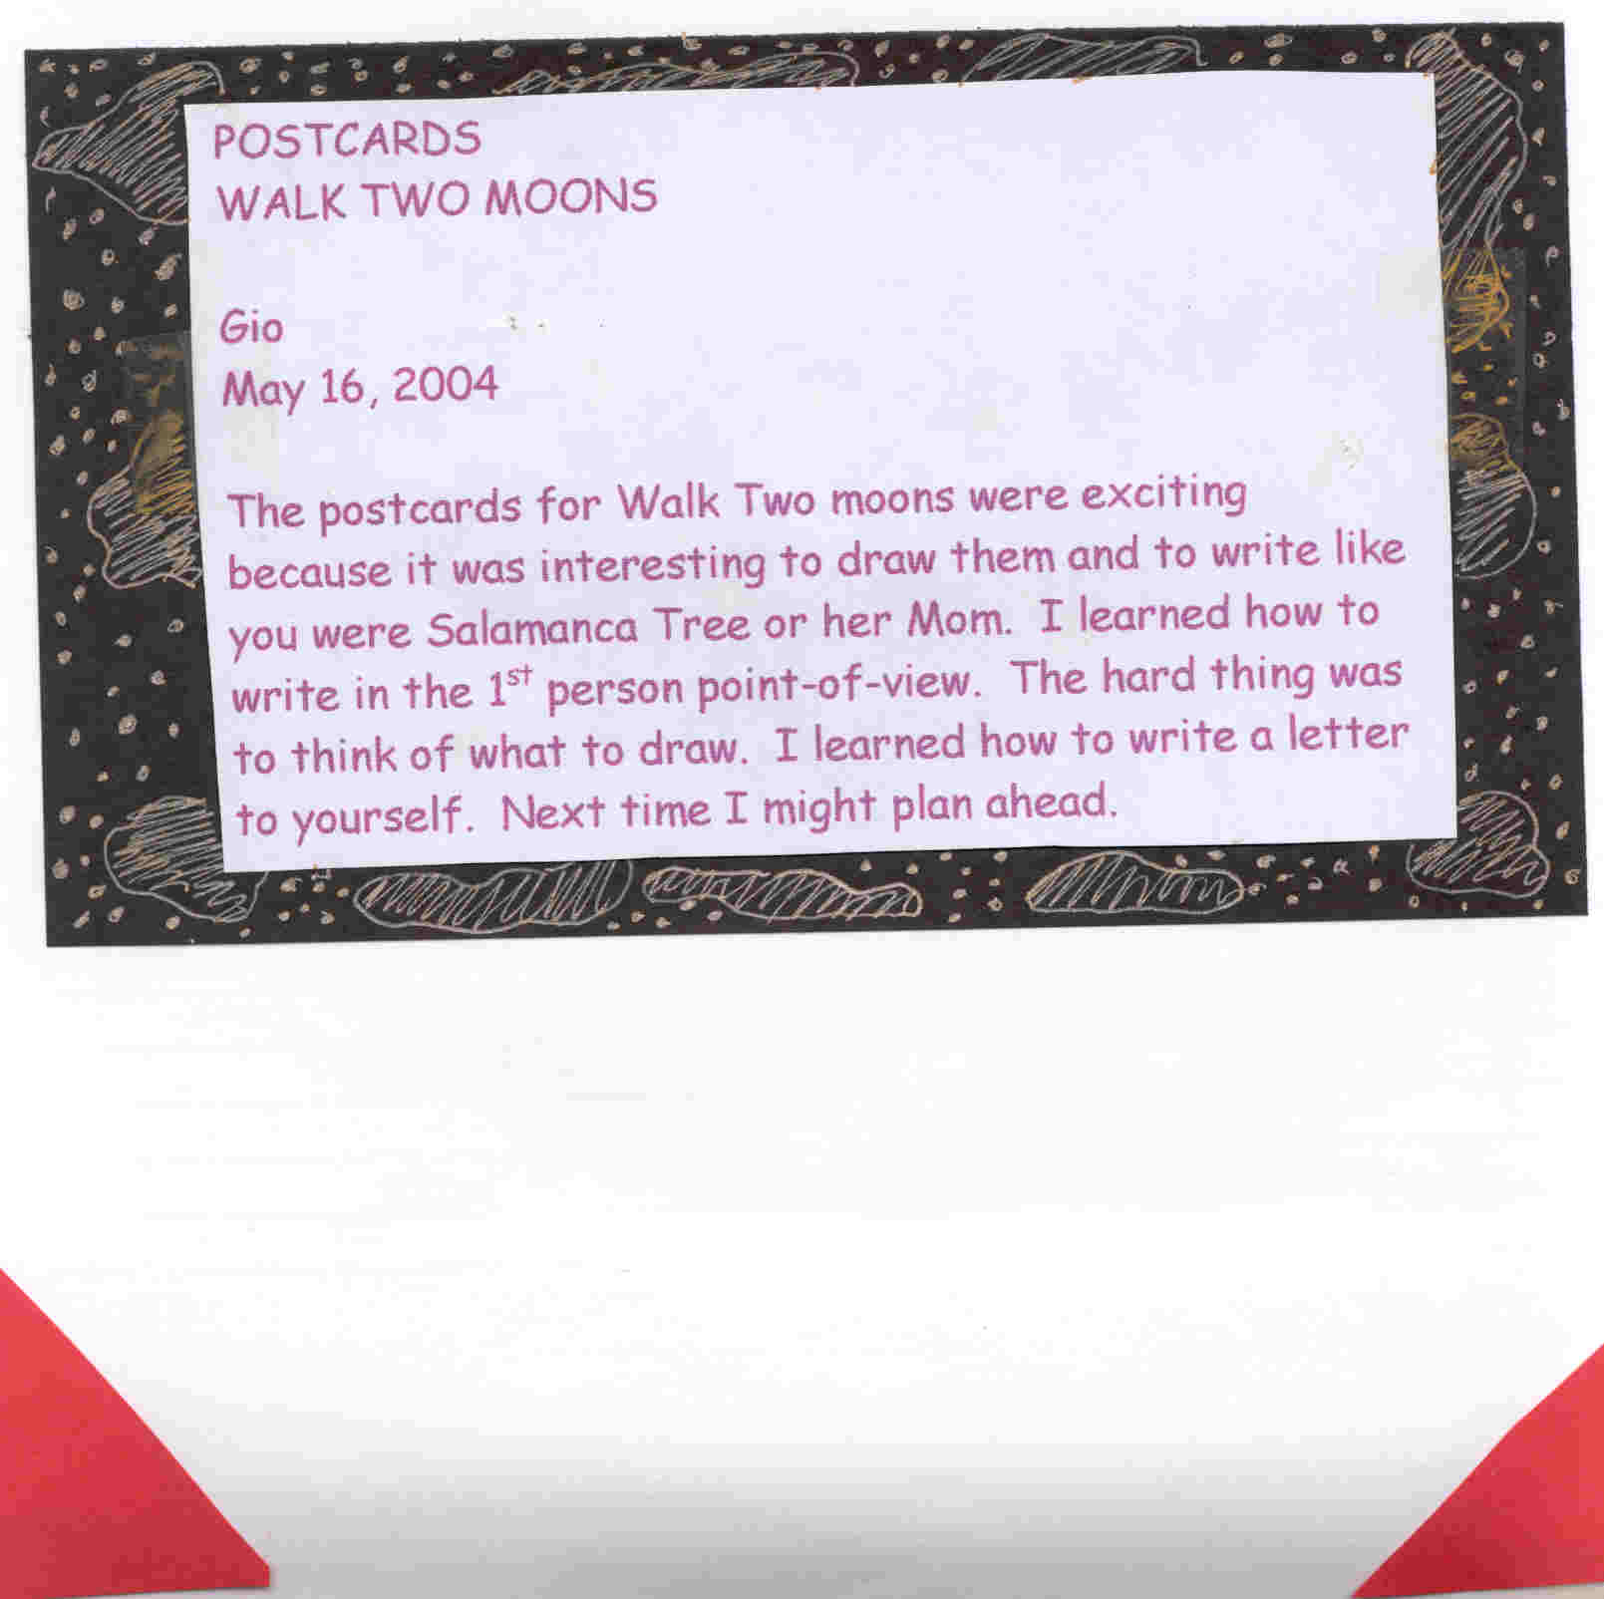 | Students were asked to reflect on each section of a unit.  1  What made this section memorable.  2.  What they learned.  3.  What they might do differently the next time.
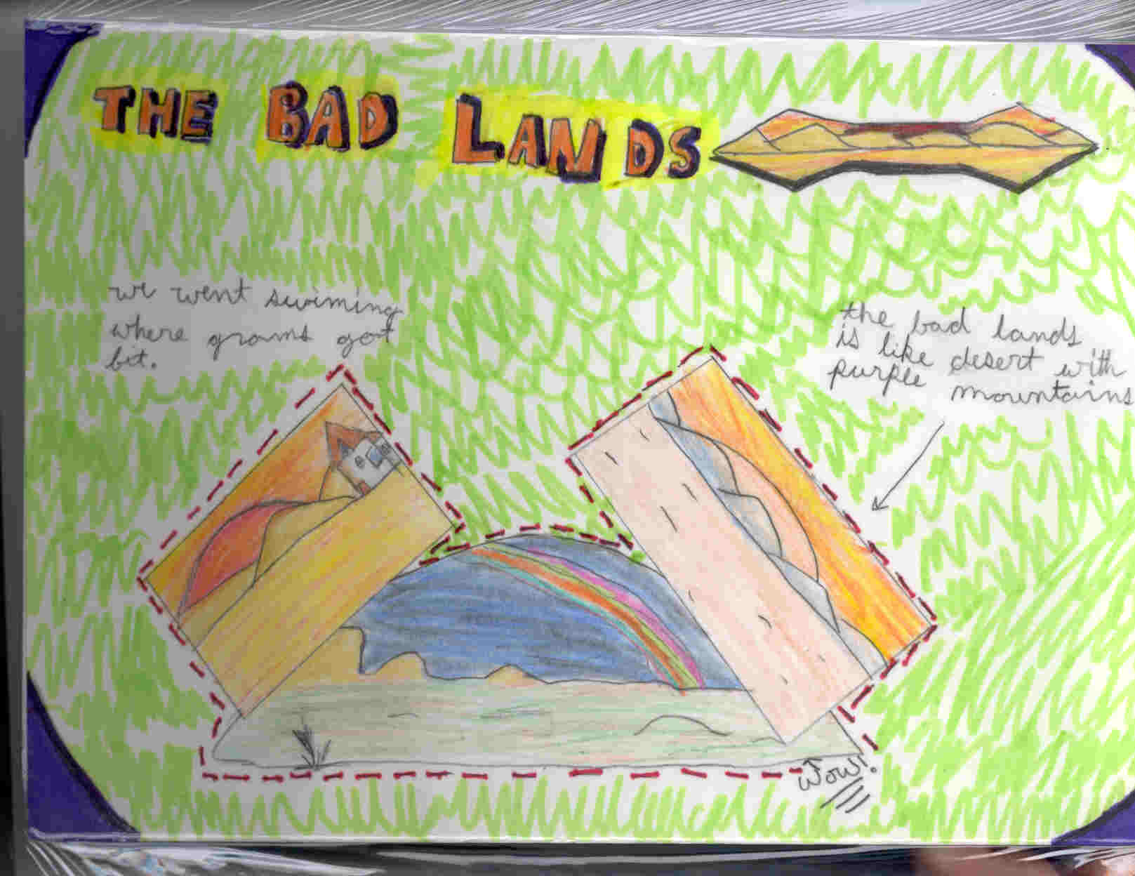 | Sample postcard chosen from Walk Two Moons unit.  So many of these talented students are artists.
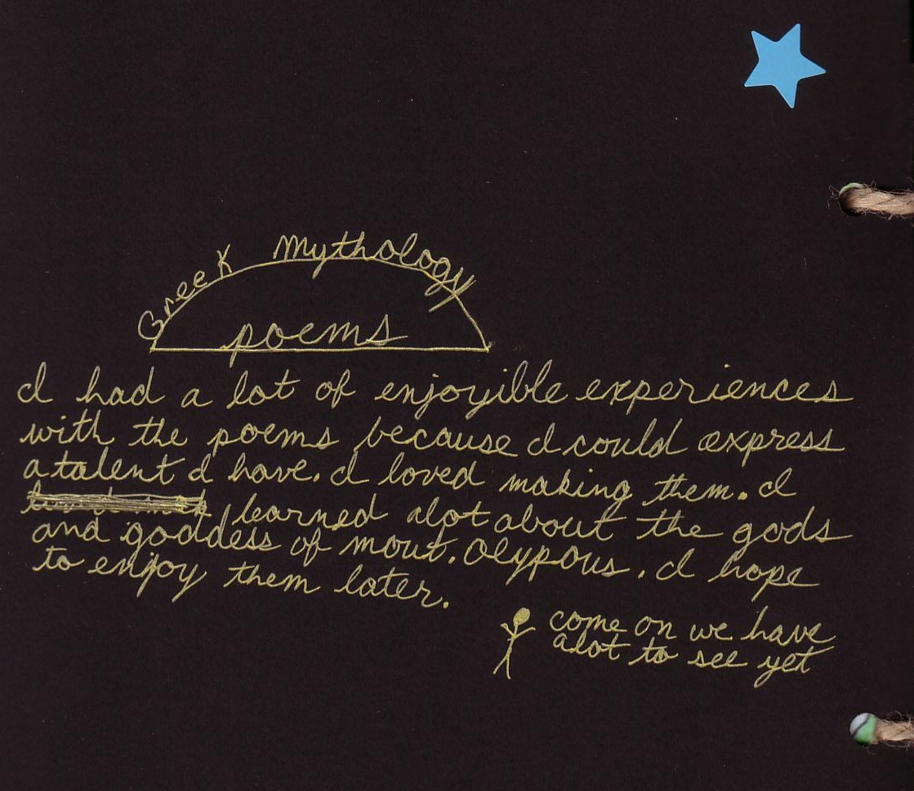 | When compiling their portfolios, one student came up with having a tour guide to escort the reader through the portfolio.  The other students thought this was a wonderful idea and it became the sixth grade trademark for portfolios.  Meet the tour guide shown to the left.
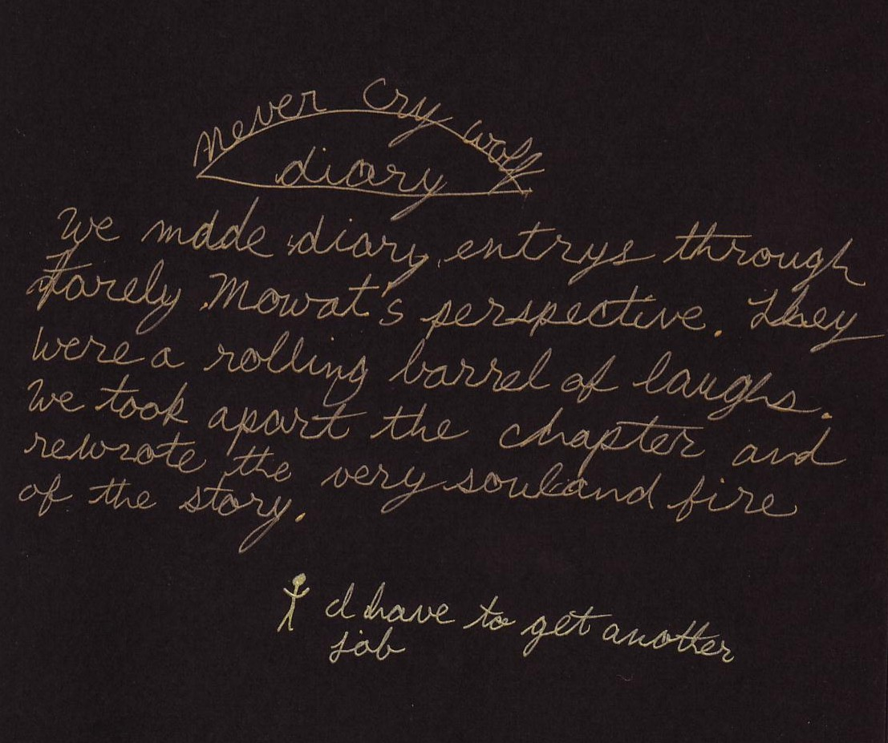 | 