

Name_________________________________________________ Date___________________________

Page 1
Observe and record the names of animals, plants and insects that are found in North Carolina. They may be living or extinct.

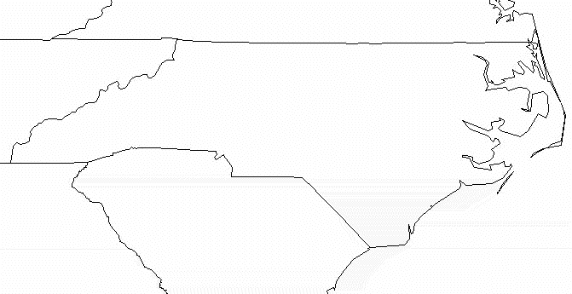

Page 2

Find the specimen room. Find and tell about the items listed below:

- A mammal 2. An invertebrate

- A fish 4. Something that we’ve studied in science

Page 3

Visit the butterfly room. Name 3 examples of living creatures that are in this room.

1.

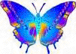
2.

3.

Page 4

Tell about your favorite area of the museum and explain what fascinated you about that section of the museum.

