Copyright 2005 Tina Hanes, Reich College of Education, Appalachian State University
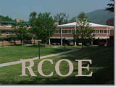

References

The faculty advisor for this telefolio was:

Dr. Woodrow Trathen.
Department of Language, Reading, & Exceptionalities
Appalachian State University
(828) 262-6056
trathenwr@appstate.edu

