Copyright 2005 Isobel Washam, Reich College of Education. Appalachian State University.

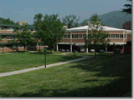

References

The Faculty Advisor for this telefolio was:

Dr. Woodrow Trathen
Department of Language, Reading and Exceptionalities
Appalachian State University
(828) 262-6056
e-mail: trathenwr@appstate.edu

