Litza Bowen
RE 4030

Litza
Compassionate, fun-loving, curious, religious
Relative of Amie, Chelsie, Colene, Louis, and Alan.
Resident of Bethlehem, North Carolina.
Who reads text books, cookbooks, pirate books, scriptures
Who likes CHOCOLATE, traveling, extra butter on my popcorn.
Who loves GOD, my family, CHOCOLATE!
Who fears snakes, icy weather, being alone when my children leave home.
Who wishes there were no fighting or wars going on,
more time in the day to accomplish all tasks on my “TO DO” list,
no more “I wish” lists as the world would be a perfect place.
Who admires GOD, my daughters (Amie, and Chelsie) and my grandma.
Who needs to finish my classes and graduate, make out my grocery list for next week, to change the light bulb in the garage.
Who aspires to become a well respected teacher and to live my life for the glory of GOD.
Bowen

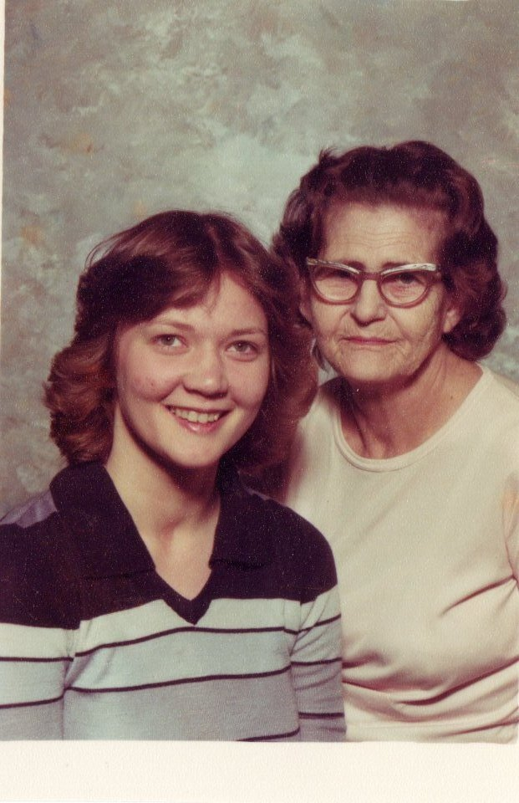





Acrostic Poem

L - Lover of life B - Blessed
I - Intelligent O - Out-going
T - Trusting W - Warm hearted
Z - Zippy personality E - Easy going
A - Accepting N - Nurturer

Portrait Poem

They call her Leigh
Mother of Amie and Chelsie,
Care taker to Cubbie.
Who needs love, nourishments (aka: CHOCOLATE), and fun
Who loves God, family, friends, being outside, and CHOCOLATE.
Who sees the glass as half full instead of half empty.
Who hates prejudices, ignorance, rudeness, and cruelty.
Who fears that I will not make a difference in at least one student.
Who dreams of traveling and owning my own B&B.
Who has found that some poetry inspires people.
Resident of Bethlehem, NC.
Bowen



