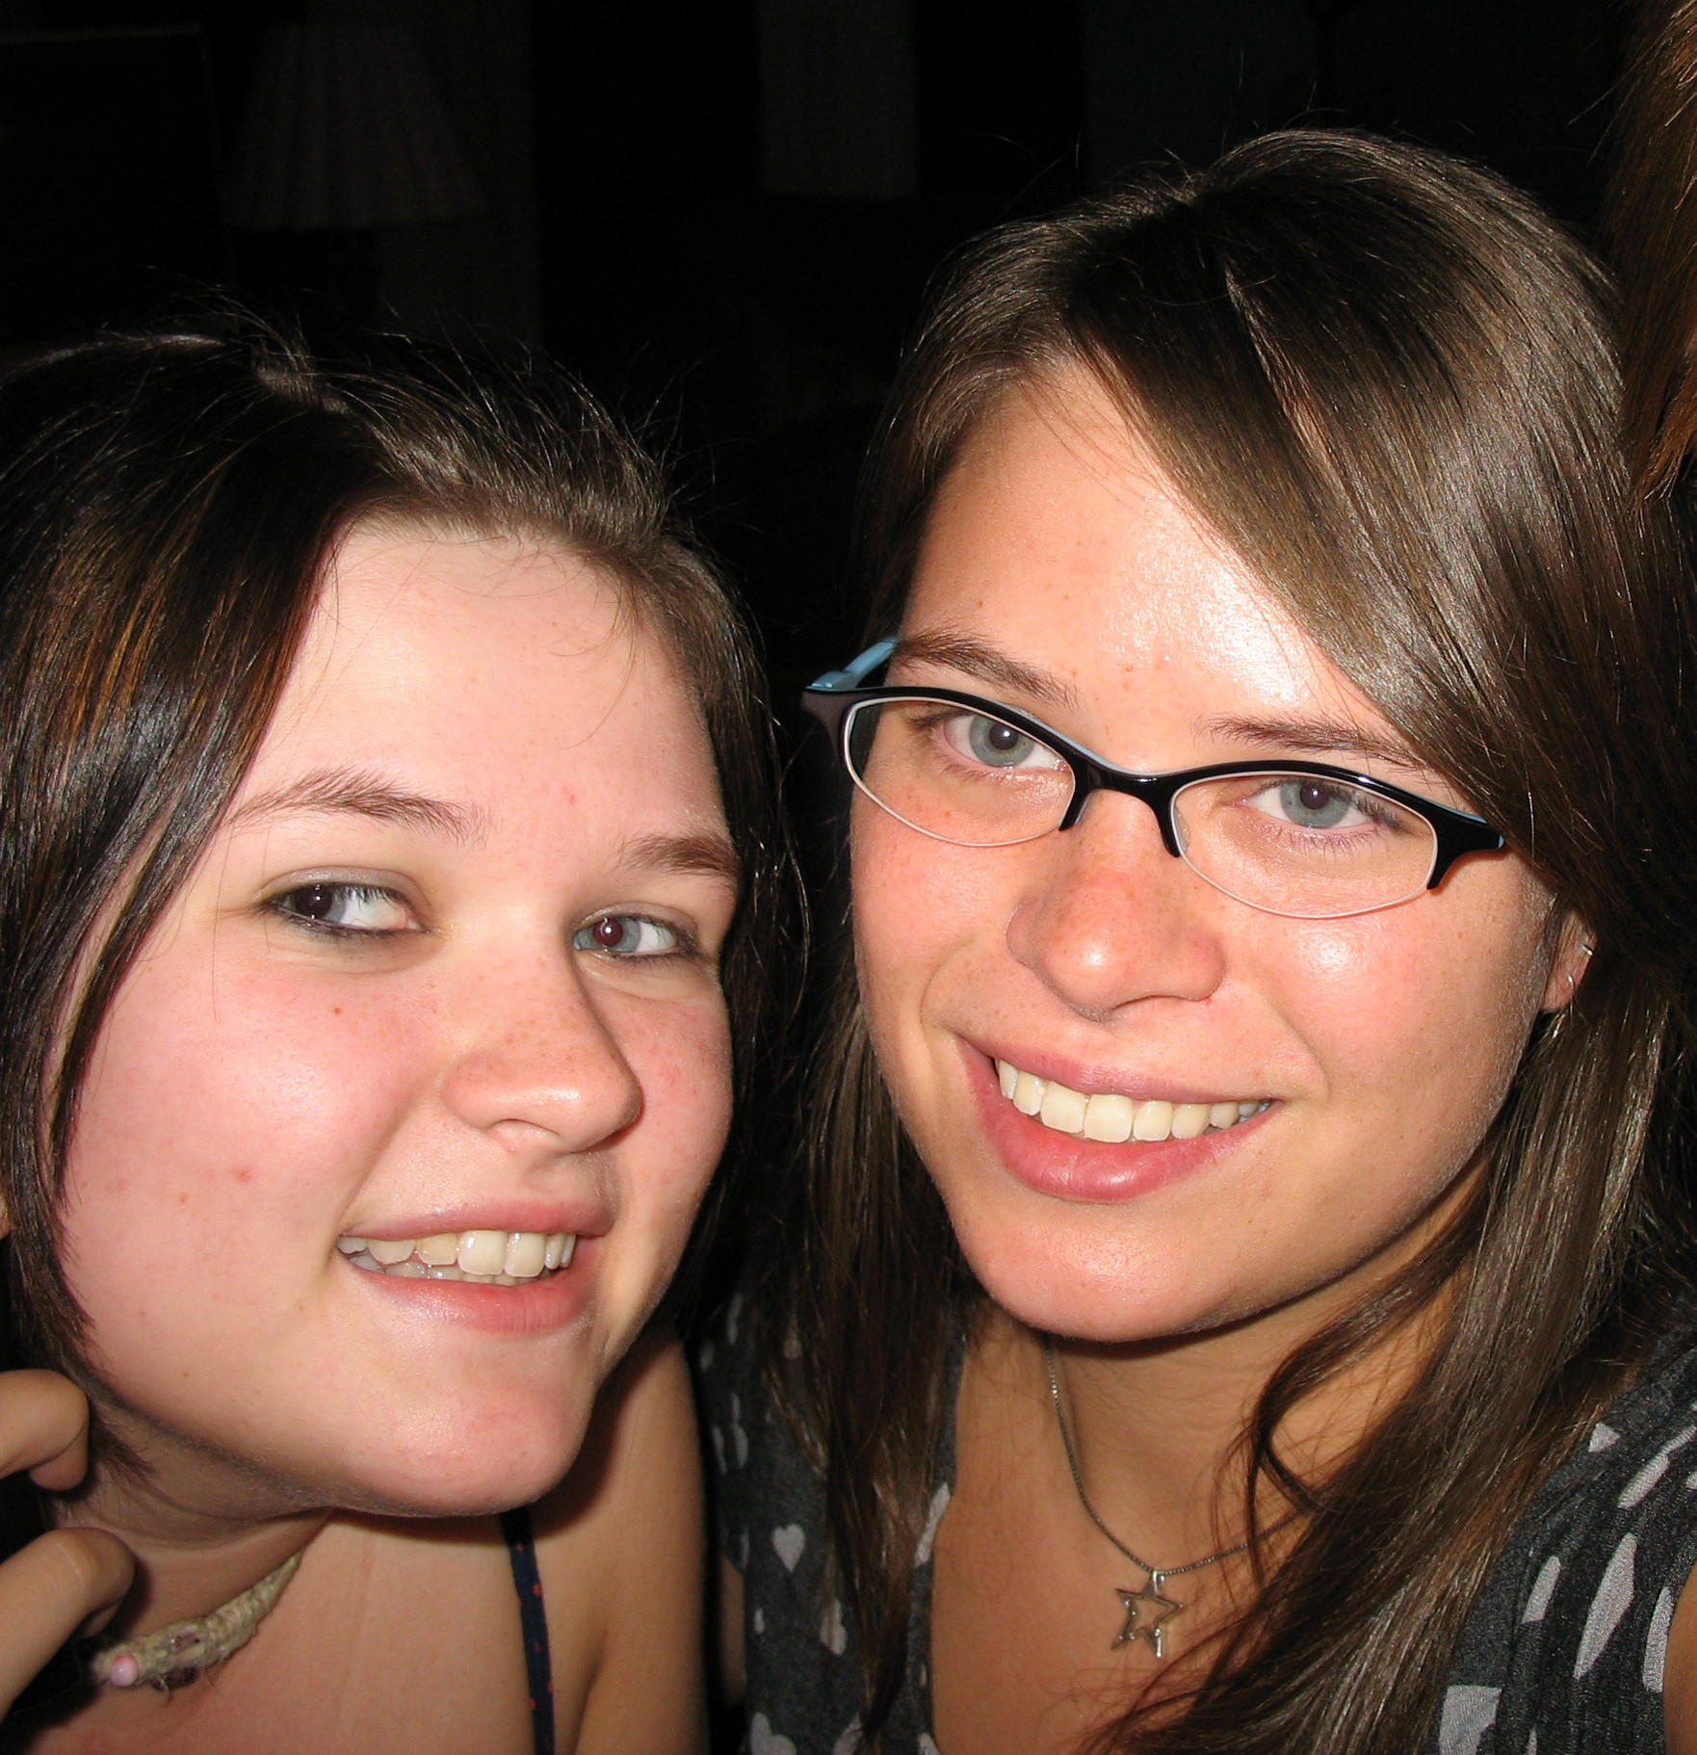

Kellen
Compassionate, sensitive, considerate, perfectionist,
Sister of Karie,
Lover of family, true friends, and pets,
Who feels anxious, stressed out, and like they are always behind,
Who needs love, laughter, music, and food,
Who gives my heart, my mind, and my time to others,
Who fears losing a loved one, the destruction of our planet, and the evils of the world,
Who would like to see world peace, a cure for cancer, and an end to child abuse,
Resident of Wilkes County
Duncan.

Kindhearted
Exciting
Loving
Loyal
Encouraging
Nervous

Daughter
Understanding
Naïve
Clever
Anxiety
Naturalistic

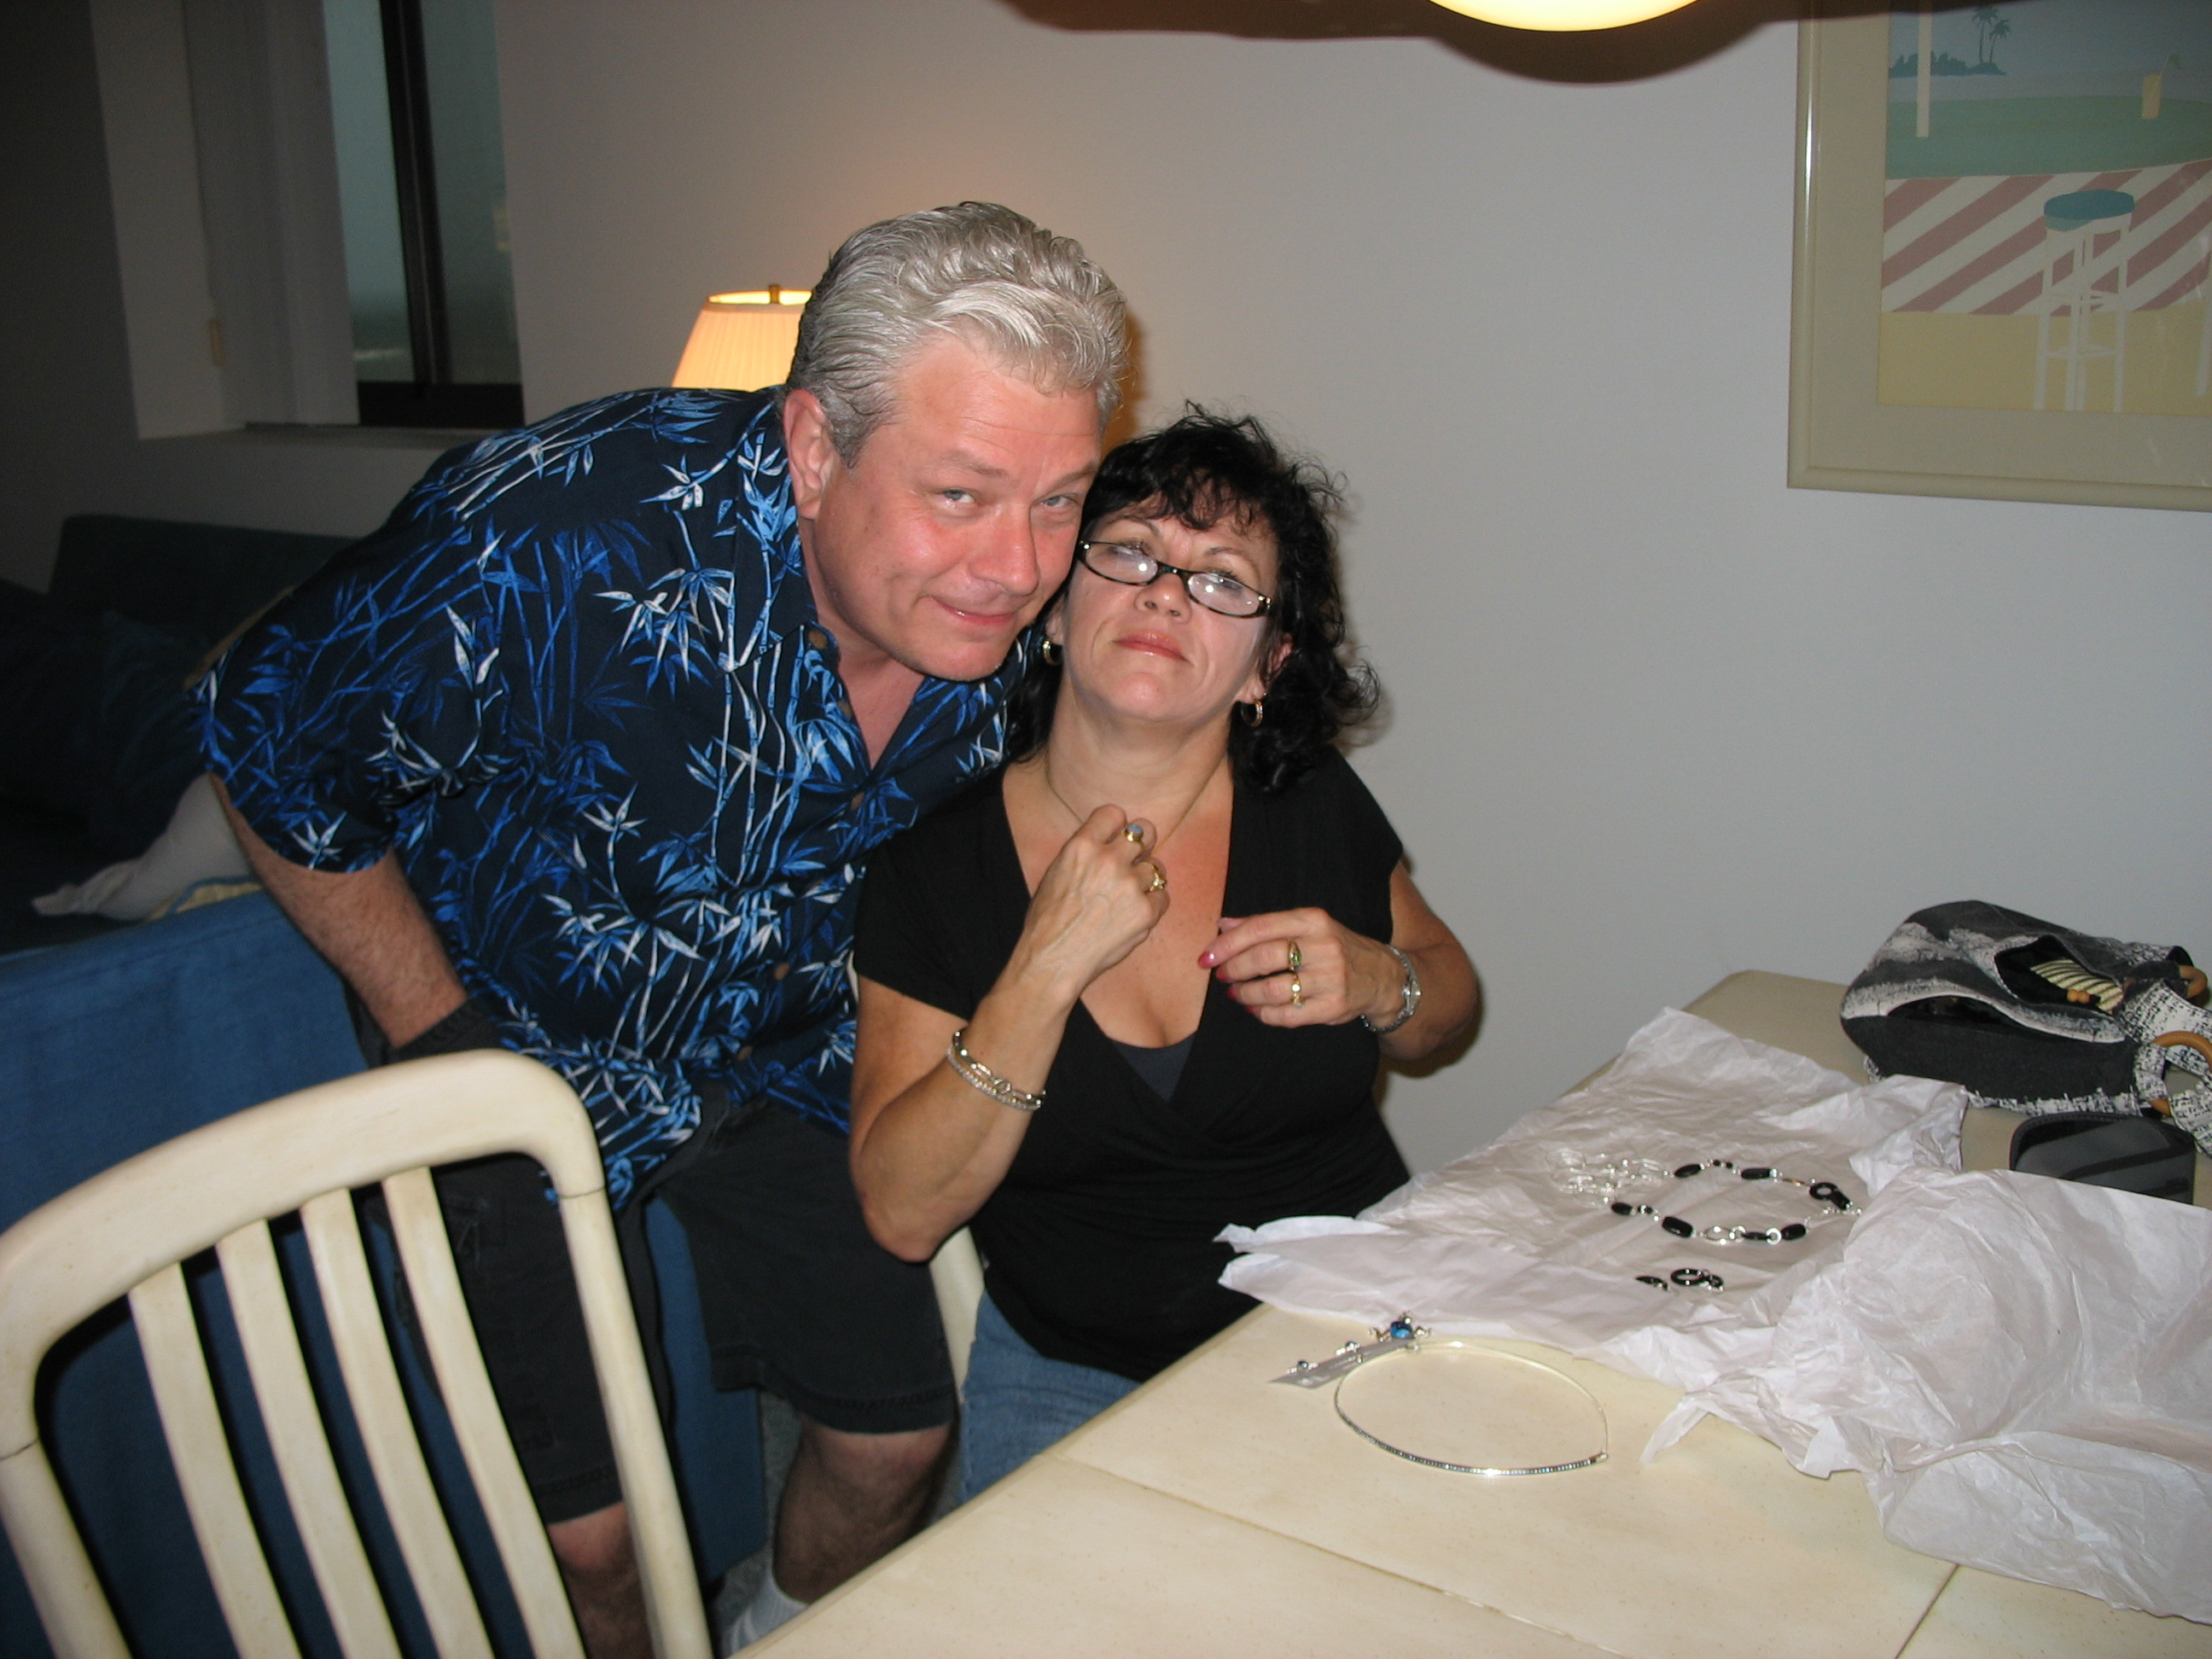 | 