I Am
I am a Christian and a loving husband and father
I wonder what my children will become
I hear time ticking away
I see mostly good in people
I want to help
I am a Christian and a loving husband and father
I pretend that life is fair
I feel that everything happens for a reason
I touch as many people's lives as possible
I worry that my life will not make a difference
I cry when my children hurt
I am a Christian and a loving husband and father
I understand that God has a purpose for me
I say if we seek God's will for our own life we will all get along
I dream about what my children might become
I try to always view the glass half full instead of half empty
I hope I will be able to make a positive impact on those that I meet on life’s journey
I am a Christian and a loving husband and father.
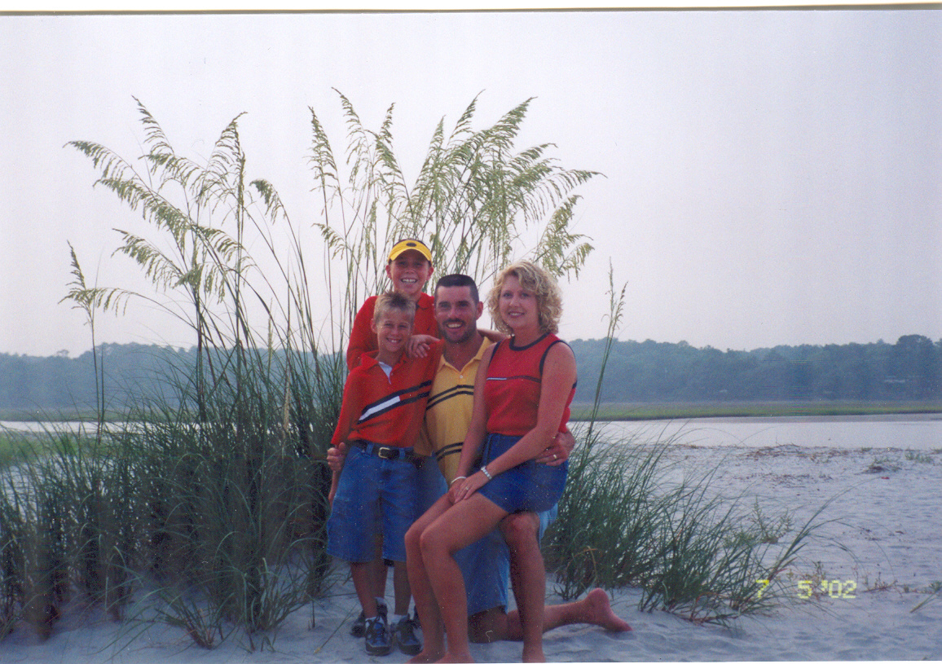
The Fords at the beach
My son Benjamin is to my right and my wife Angie is to my left. My other son Ethan is behind me.

Acrostic

M-Mild mannered
a-able
R-responsible
K-Kind

F-Forgiven
O-original
R-respectable
D-dependable
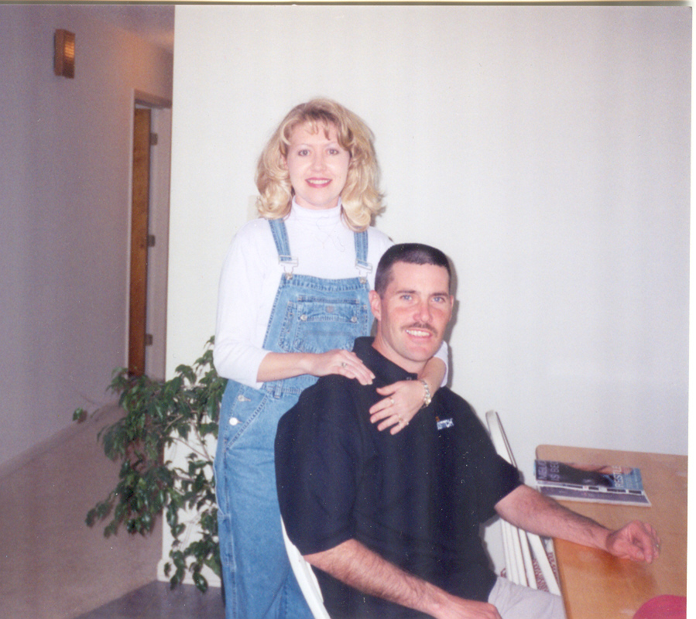
My wife Angie and me

