Andrea Gnisci
CI-3040-435
January 16, 2006

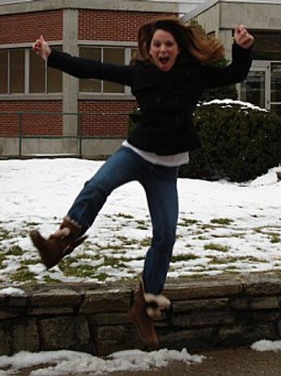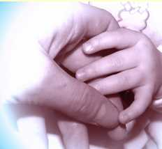

I am Andrea

Daughter of Charlie and Mary

Who needs friends and family for constant support

Who loves sweet foods, romantic comedies, and hammocks

Who sees snowy mountain tops

Who hates goodbyes

Who fears failure, getting hurt, disappointment

Who dreams to inspire others

Who has found poems that make her smile

Resident of North Carolina

Gnisci

