Acrostic Poem
A ffectionate M arried
N ice C rafty
G rateful C onscientious
E asygoing L ucky
L oyal O pen-minded
A musing Y outhful
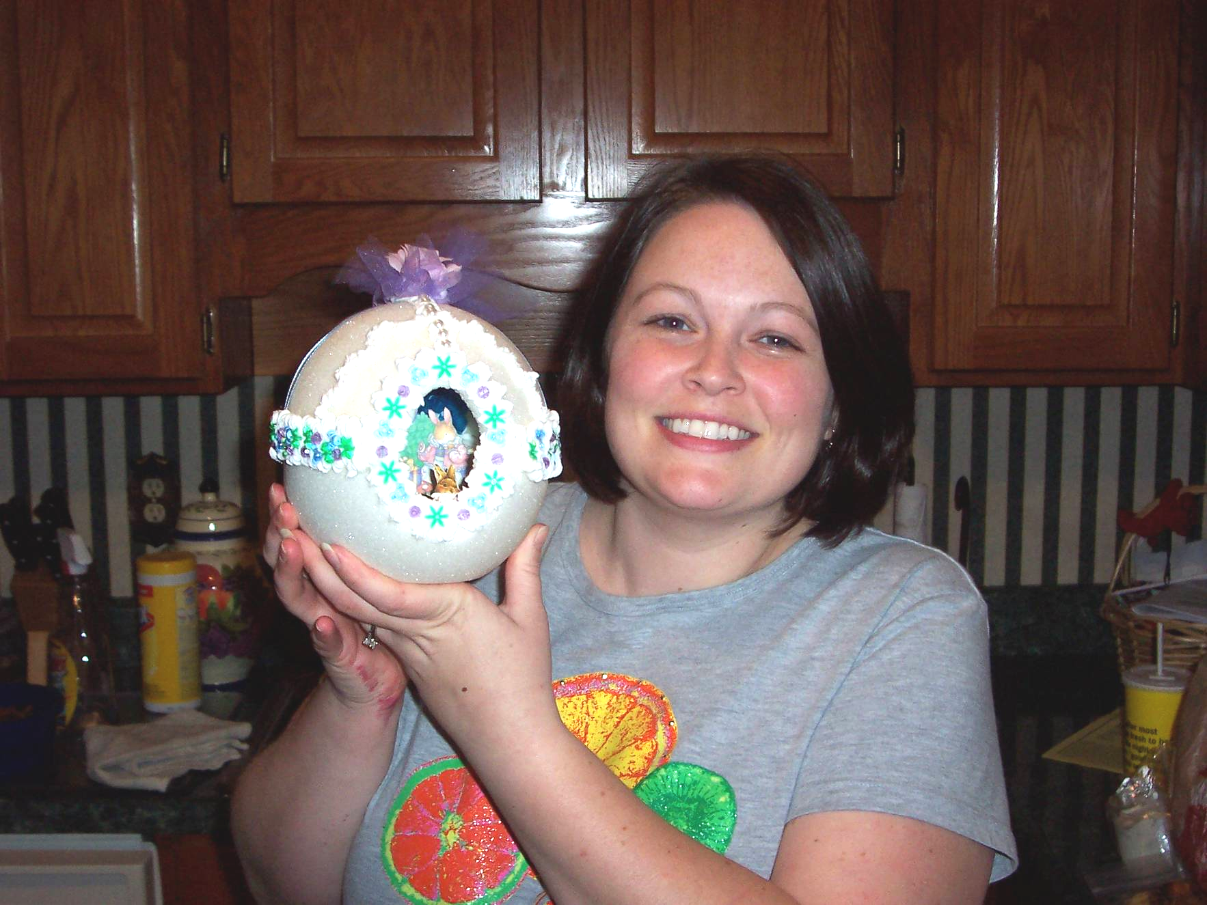
Me showing off my custom made Sugar Easter Egg!

"I Am" Poem
I am compassionate and fun-loving
I wonder if I will ever own a beach house
I hear the sound of one hand clapping
I see a leprechaun sitting at the end of a rainbow
I want to have children after I graduate
I am compassionate and fun-loving

I pretend I am a good singer
I feel the wind in my hair as I ride through the sky on a pale pink unicorn
I touch the blossom of a sugar magnolia
I worry about the world my children will live in
I cry for abused children
I am compassionate and fun-loving

I understand that I am not perfect
I say what does not kill us, makes us stronger
I dream of growing old with my husband
I try to live by spiritual principles
I hope to make a difference in my lifetime
I am compassionate and fun-loving

