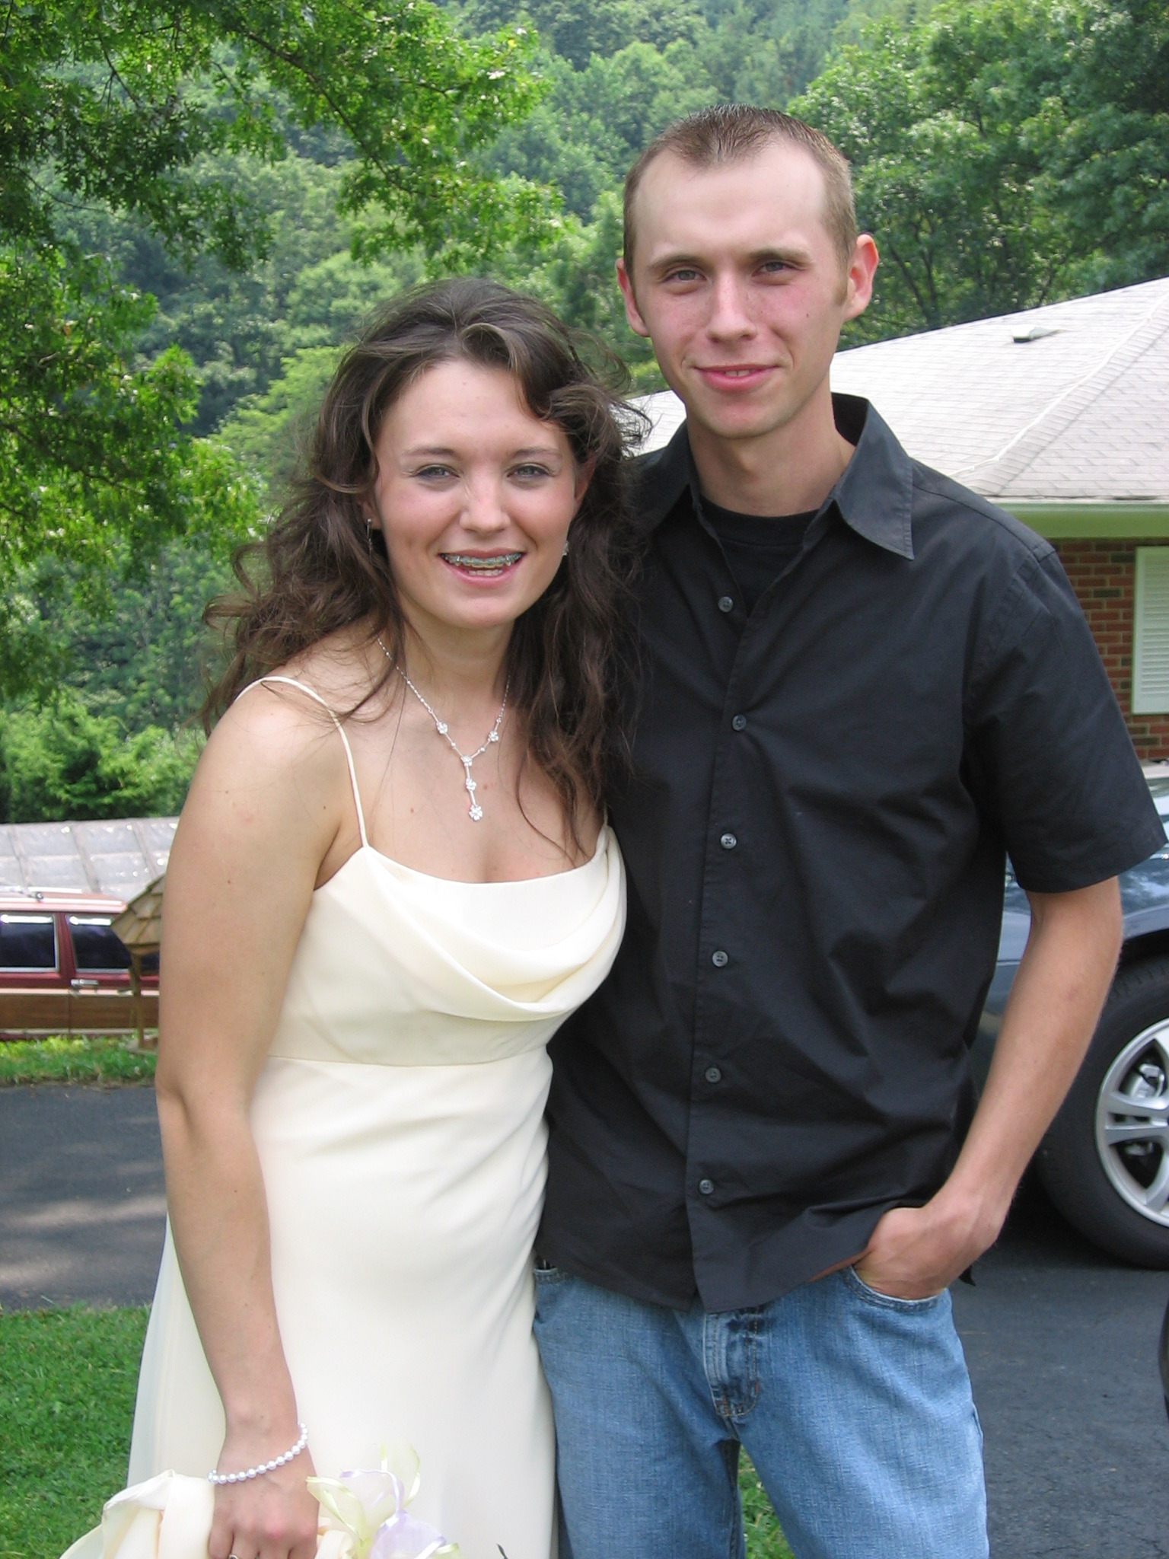
C aring
H onesty
R eligon
I love my family and friends
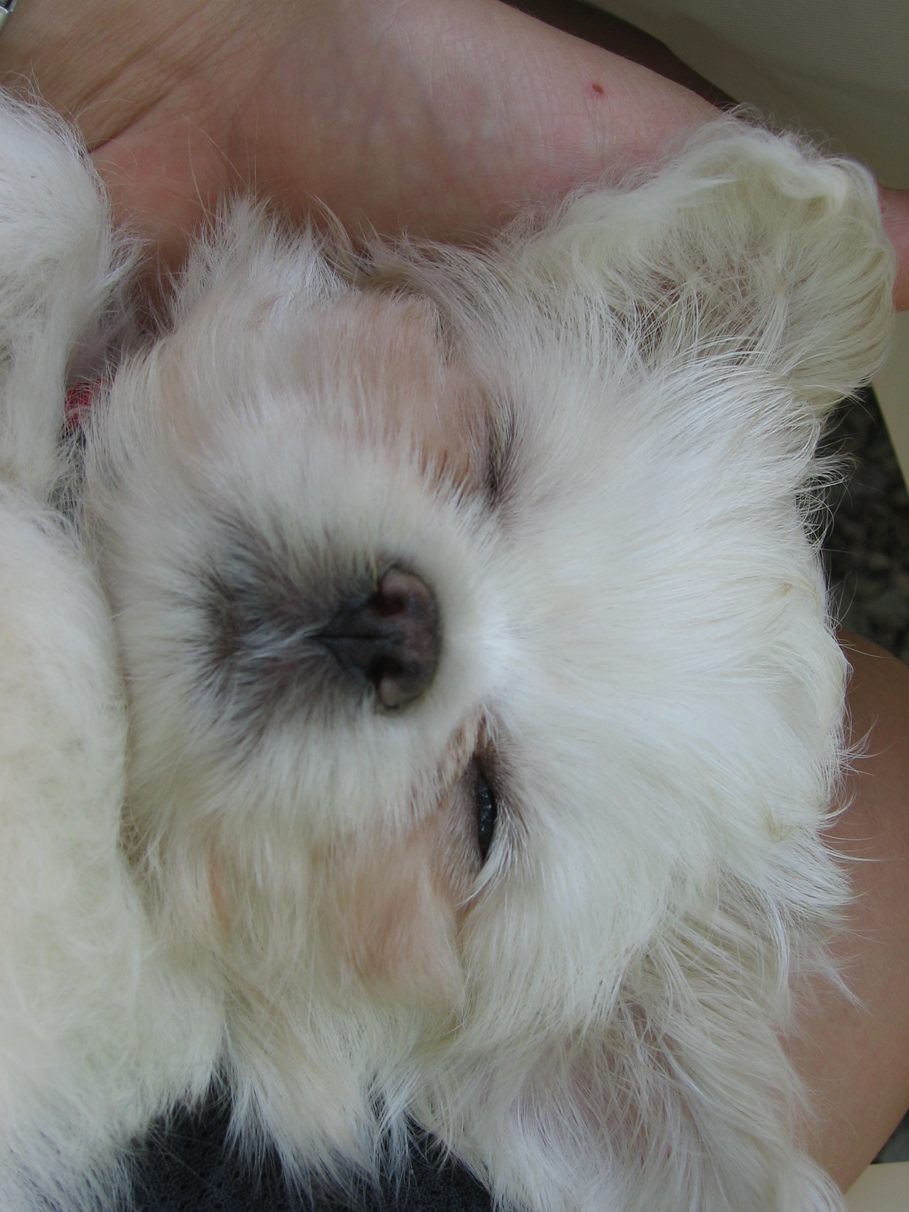
S uccess
T arheels
I nteresting

N ewly engaged

http://www.mrsmcgowan.com/1stgrade/acrosticpoems.htm

