Always thinking

Mischievous
Imagining the possible and even the impossible
Eager to know more
Silly
Nervous
Open minded
Wishing

Jack Scott and Amie
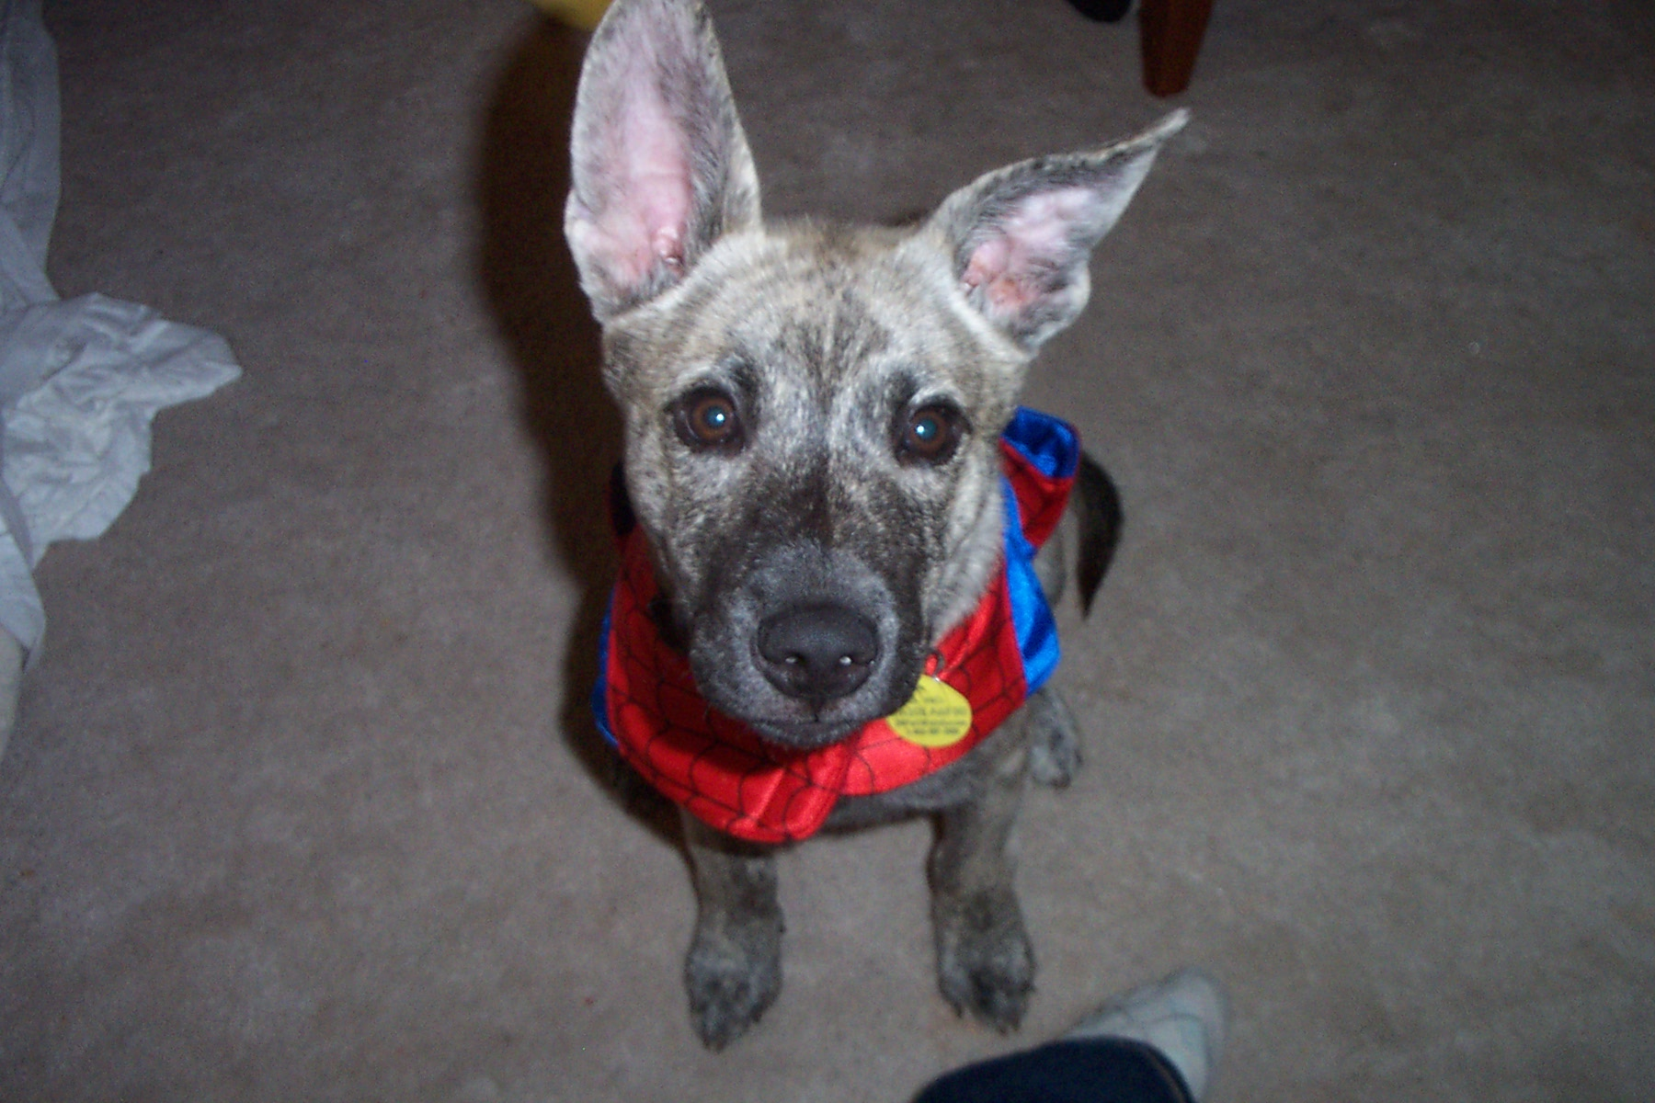
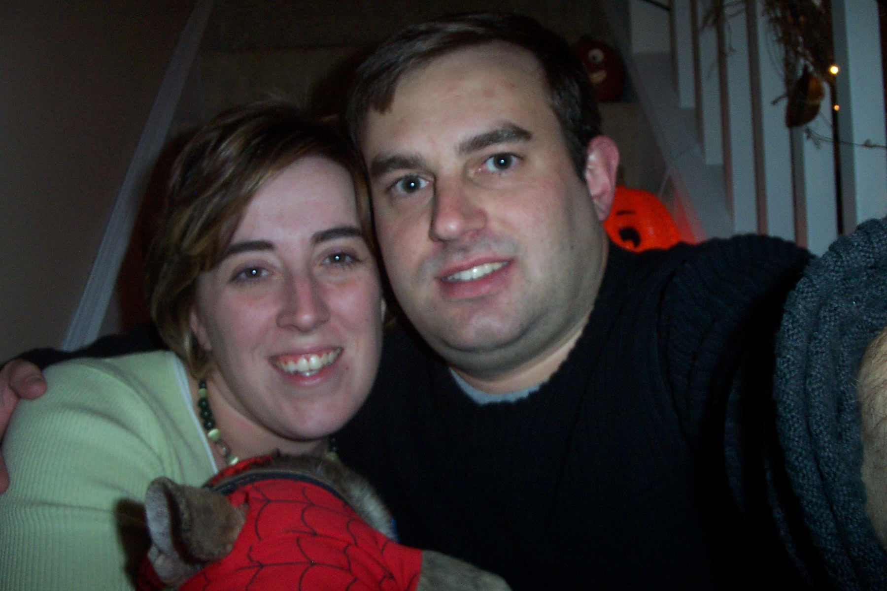

I am Amie

Daughter of Dot and Jim
Who needs laughter, good friends and old stories
Who loves her husband, Scott and her Australian Cattle Dog, Jack
Who sees the potential and hope in all children
Who hates giving up
Who fears losing all she loves and failing at all she hopes for
Who dreams of peace when my brother can come home
Who has found poems of her father’s filled with love for her mother
Resident of Staten Island, New York and King, North Carolina
Snow

