What Am I?

I roam the desert mountains.
I am pugnacious, territorial and I like my space.
Elongated front teeth go over my lip.
I am a vegetarian.
I pull my plants underground.
I am hunted by badgers, coyotes, and snakes.
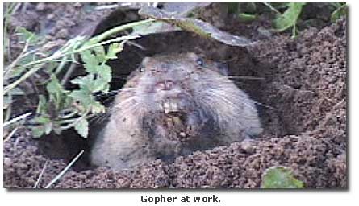
I am Botta’s Pocket Gopher

Picture from www.desertusa.com

