Sensitive
Ambitious
Nana
Determined
Rational
Articulate

Warm
Respectful
Imaginative
Grateful
Happy
Trusting

Sandra
Ambitious, loving, happy, trustworthy
Wife, mother, mother-in-law, nana, daughter, sister
Resident of Granite Falls, NC
Who reads children’s books especially to her grandson
Who likes chocolate, animals, and fellowship with friends
Who loves her family
Who fears snakes, pain and the unknown
Who wishes she could stretch time
Who needs love, acceptance and to be needed
Who aspires to be an instrument used for teaching children
Wright

Nana and Lane
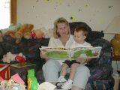 Ashley & Kevin, Christy& Billy,
Sandra& Mike and Lane
