Cherokee Sister
by Debbie Dadey

and

Only the Names Remain: The Cherokees and the Trail of Tears
by Alex W. Bealer

Indian Shoes

These shoes are old and worn
These shoes are old and torn,
These shoes have seen many miles
While tears haunted Indian styles.
These shoes have seen the years
These shoes know the Trail of Tears,
As many wore away
These shoes realized the need to stay.
These shoes are old and pitiful
Their roads were cruel and scornful
These shoes have walked in pain
They endured life with nothing to gain.
These shoes are Indian shoes
And as the end of life nears
These shoes will fade away
They walked the Trail of Tears one day.

by Wazi Nagi

Trail of Tears Unit

Cherokee Sister
by Debbie Dadey

and

Only the Names Remain: The Cherokees and the Trail of Tears
by Alex W. Bealer

Unit by McConnell

Rubric
Activity | Points
Diamonte Poem  - Displays thoughtful connection to the book  - Is in the shape of a diamond  - Contains the correct number of pronouns, adjectives, participles and nouns | 20 points
A Letter from Long Ago  - Is written in legible handwriting  - All blanks are filled in appropriately with examples from book.  - There are at least three additional facts written on the face. | 10 points
Sequoyah  - Problems are converted to numerical value before solving.  - Solutions are correct.  - Solutions are converted back to symbolic form. | 12 points
Missing Poster  - Character information is accurate  - Handwriting and grammar enable easy reading  - Illustration is well done with color and sufficient time input. (not sloppy or done as if in a hurry) | 20 points
Vocabulary Cards  - Each card contains the word, it’s definition, an illustration, and sentence using the word | 16 points
Internet Workshop  - Answers are correct and legible  - Behavior in computer lab is acceptable | 22 points
TOTAL | 100 points

Multi-Text Study: Rationale
Context: I created this multi-text study in RE 4030 under the advisement of Dr. Woodrow Trathen in the fall of 2005 as a Block II requirement. The study is geared toward the fourth grade and was created around the fiction and non-fiction books entitled Cherokee Sister and Only the Names Remain: The Cherokees and the Trail of Tears. In addition an Internet Workshop focusing on the Cherokee Nation was created to promote Internet Browsing skills and different aspects of the Cherokee. This unit is a language arts unit which integrates math, art, and social studies by having students solve problems, draw illustrations, and uncover new information about the Cherokee Indians.
The references for my unit are as follows:
Cherokee Sister by Debbie Dadey. Delacorte Press, 2000. ISBN 0-385-327-03-X
Only the Names Remain: The Cherokees and the Trail of Tears by Alex W. Bealer, illustrated by Kristina Rodanas. Little Brown and Company, 1972/1996. ISBN 0-316-08519-7
Impact: This multi-text study is a great way to integrate both fiction and non-fiction texts through very creative and engaging formats. Through reading Cherokee Sister and Only the Names Remain, students are given the opportunity to think critically about what they read while completing a variety of engaging language arts activities that connect to the multi-texts. I chose to develop this unit because the Cherokee nation has always held my interest and I wanted the students to come away with a similar feeling. I was able to implement the following parts of this unit in Mrs. Glover’s fourth grade class at Valle Crucis Elementary School.
Alignment: This multi-text study unit aligns with the Department of Public Instruction standard 1, indicator 3. In this study, I have included not only a fictional text, but I have also included non-fictional texts which addresses diversity through introducing students to The Trail of Tears. This unit also aligns with the Department of Public Instruction standard 1, indicator 4. This indicator is met through addressing the needs of students by providing a variety of instructional activities in which students are able to exercise their communication skills through a multitude of reading, writing, listening, and speaking activities that cater to a multitude of learning styles. This study aligns with standard 1, indicator 5. Throughout the multi-text study, I ask students questions in order to activate prior knowledge that they have about the books they are reading. Students are provided with individual and small group activities in which they are able to interact with the text in order to increase their reading and comprehension skills. This lesson also meets standard 1, indicator 6. As a teacher, it is my job to encourage the development of literacy in each of my students. It is also my job to cater to the individual needs of the students in my class by providing developmentally appropriate activities that will help and not hinder the development of literacy. Standard 7, indicator 2 is met through integrating language arts, social studies and technology into this unit. Students are reading, writing, learning about the Cherokee Nation, and participating in an internet workshop. Standard 7, indicator 3 is met by activating the prior knowledge of students through having them make predictions about their reading. Standard 7, indicator 5 is met by providing the students with activities that cater to a variety of different learning styles. As a part of this study, students will be artistically representing characters and vocabulary, participating in a math activity, working in partners in a letter activity, writing poems, and even creating a missing poster for one of the characters in Cherokee Sister. Standard 7, indicator 7 is met by assessing students both informally and formally through observations and a written vocabulary assessment at the end of the vocabulary activities section of the multi-text study. Standard 8, indicator 3 is met by encouraging students to use critical thinking skills when reading or writing through the use of positive feedback and guidance. Standard 8, indicator 4 is met through providing students with exciting and interesting literature such as the novel Cherokee Sister and the non-fiction text Only the Names Remain. Standard 8, indicator 5 is met by providing students with a variety of different writing activities such as writing a Diamonte poem, creating a missing poster, writing a letter, and creating vocabulary cards. Students are encouraged to share their products in both small and large group settings. Standard 8, indicator 6 is met by making sure that I, as the teacher, use proper English when working with students so that I will serve as a good model for them as they continue to develop their use of the English language.

NC- North Carolina DPI Elementary Education Specialty Area Standards
Standard : Standard 1: Elementary teachers have a broad knowledge and understanding of the major concepts in English Language Arts and Literacy.
Indicator : Indicator 3: Teachers know and understand a diverse range of historical and contemporary literatures, including various genres of American, British, and World, as well as literatures written by women and authors of colors and works written for children and young adults.

Indicator : Indicator 4: Teachers understand the elementary school child’s social, cultural, linguistic, cognitive, and affective backgrounds as they relate to the ability to develop effective communication processes (listening, speaking, reading, and writing).

Indicator : Indicator 5: Teachers know and understand that reading is taught as a process of constructing meaning through the interaction of the reader’s existing knowledge, the information suggested by the written language, and the context of the reading situation.

Indicator : Indicator 6: Teachers understand the importance of literacy for personal and social growth.

Standard : Standard 7 : Elementary teachers use developmentally appropriate strategies to design and deliver instruction in all areas of the elementary curriculum.
Indicator : Indicator 2: Teachers understand and use an interdisciplinary approach to teaching by connecting and integrating language arts, mathematics, science, social studies, healthful living, and arts concepts and processes, with appropriate technologies to enhance their teaching.

Indicator : Indicator 3: Teachers promote new learning by using students’ prior knowledge, misconceptions, and interests when designing lessons.

Indicator : Indicator 5: Teachers assist students in developing multiple learning strategies to address discipline specific content, critical thinking, and problem solving skills.

Indicator : Indicator 6: Teachers modify instruction and assessments to meet the needs of individual students.

Standard : Standard 8: Teachers design instructional programs and strategies that build on students’ experiences and existing language skills to help students become competent, effective users of language.
Indicator : Indicator 3: Teachers guide and encourage students to think critically about what they write and read.

Indicator : Indicator 4: Teachers encourage students’ enjoyment of reading.

Indicator : Indicator 5: Teachers provide students opportunities to explore the use of different genres of writing and speaking to a variety of audiences.

Indicator : Indicator 6: Teachers model Standard English.

Multi-Text Selection

Through the guidance of a helpful librarian, I choose Cherokee Sister by Debbie Dadey because it tells the story of a young white girl, Allie, who has a Cherokee friend, Leaf, during the time of the Indian Removal Act. This book is written on a 3-5 grade level. Students who read this book can directly relate to the main character’s struggle to be with her one true friend. Allie should abide by her father’s wishes to not see Leaf, but their friendship breaks her self-discipline. I was concerned about the main character being a girl, but when the plot thickens, boys and girls alike will want to keep reading to discover what happens next.
As my accompanying text, I selected Only the Names Remain: The Cherokees and the Trail of Tears by Alex W. Bealer and illustrated by Kristina Rodanas. This book describes the life of the Cherokee Indians in Georgia before and after the U.S. government forcibly removed them from their land. It goes well with Cherokee Sister because it gives concrete information pertaining to the Trail of Tears written in a kid-friendly, 4-5 grade format. Both books correlate directly to the North Carolina Standard Course of Study for the fourth grade under the Social Studies standard of North Carolina History.
Additional Unit Books

- The Path to Snowbird Mountain by Traveller Bird. 1972, Farrar, Straus and Giroux. This book contains sixteen Cherokee stories that children can read to engage them more in this particular culture. These stories will allow children’s imaginations to expand and provide more information of how the Cherokees lived.

- Aunt Mary, Tell Me a Story edited and compiled by Mary Regina Ulmer Galloway, illustrations by Lib Lamber, John Barton Galloway, and Goingback Chiltoskey. 1990, Cherokee Communications. This book contains legends of the Cherokee Indians which provides more stories for students to read and become more absorbed with how they thought about different things.

- How Turtle’s Back was Cracked retold by Gayle Ross, paintings by Murv Jacob. 1995, Dial Books for Young Readers. This is a tale of the infamous Turtle and Possum who are seen repeatedly throughout Cherokee legends. This book would be good for teachers to introduce and teach the moral lesson that being too boastful and bragging too much will lead to trouble. Not to mention how great the drawings are.

- Sequoyah: Cherokee Man who gave his people writing by James Rumford. 2004, Houghton Mifflin Company. This book tells the story of Sequoyah and how he created an alphabet for the Cherokee people. When reading this book, students not only get factual information about the man himself, but they are also able to see the Cherokee language written on every page of the book which may lead to exploration of this particular syllabary.

- Pushing up the Sky by Joseph Bruchac, illustrated by Teresa Flavin. 2000, Dial Books for Young Readers. Within this book is seven Native American plays that children can read and/or perform. While there is only one Cherokee related play, all of them will allow children to learn in a different, more interesting way.

- Itse Selu: Cherokee Harvest Festival by Daniel Pennington, illustrated by Don Stewart. 1994, Charlesbridge. Little Wolf and his family are preparing for the coming harvest festival. This book provides several Cherokee words, along with pronunciation guides and definitions so that children may learn new, authentic words to go along with this particular unit.

- Where It All Began: Cherokee Creation Stories in Art edited by Barbara R. Duncan. 2001, Museum of the Cherokee Indian. There are many different interpretations of how the earth was made and this takes a look at a special art exhibit that portrays several different ways. This book allows art to be integrated into the unit to help widen each child’s perception of how to communicate ideas in more than one way.

- Seven Clans of the Cherokee Society by Marcelina Reed, illustrated by William Taylor. 1993, Book Publishing Company. This informational book will have students learning about the seven different clans including the names in English and Cherokee, power animals for each clan, and the society as a whole. The illustrations are beautiful and there is an additional suggested reading list in the back.

Standard Table
UNIT ACTIVITY | NC LANGUAGE ARTS GRADE 4
Students create a Diamonte Poem centered around a character from Cherokee Sister | 4.07 Compose fiction, nonfiction, poetry, and drama using self-selected and assigned topics and forms (e.g., personal and imaginative narratives, research reports, diaries, journals, logs, rules, instructions).
Students complete Internet Workshop to locate various information about the Cherokee Nation | 4.10 Use technology as a tool to gather, organize, and present information.
Students fill out the Missing Poster form to organize specific character qualities | 3.02 Analyze characters, events, and plots within and between selections and cite supporting evidence.
Students create vocabulary cards | 1.03 Identify key words and discover their meanings and relationships through a variety of strategies.

Student Packet
Outline

Day 1: Before Reading
• Prediction of story based on illustrations and back cover (whole class)

Day 2: Cherokee Sister p.1-21 and Only the Names Remain p. 1-5
• Diamonte Poem (individual)

Day 3: Cherokee Sister p. 22-40
• A Letter from Long Ago (partners)

Day 4: Cherokee Sister p. 41-71 and Only the Names Remain p. 45-49
• Sequoyah - math symbols (individual)

Day 5: Cherokee Sister p. 72-101 and Only the Names Remain p. 36-43
• Missing Poster (small group)

Day 6: Cherokee Sister p. 101-117
• Vocabulary cards (small group)

Day 7: After Reading
• Internet Workshop (individual)

Cherokee Sister
by Debbie Dadey

and

Only the Names Remain: The Cherokees and the Trail of Tears
by Alex W. Bealer

Indian Shoes

These shoes are old and worn
These shoes are old and torn,
These shoes have seen many miles
While tears haunted Indian styles.
These shoes have seen the years
These shoes know the Trail of Tears,
As many wore away
These shoes realized the need to stay.
These shoes are old and pitiful
Their roads were cruel and scornful
These shoes have walked in pain
They endured life with nothing to gain.
These shoes are Indian shoes
And as the end of life nears
These shoes will fade away
They walked the Trail of Tears one day.

by Wazi Nagi

Diamonte Poem

Directions: Complete a Diamonte Poem centered on a character from Cherokee Sister.

First line – one pronoun (a word used in place of a noun)
Second line – two adjectives (a describing word)
Third line – three participles (is a word that functions like an adjective and also shows such features of a verb as tense and voice and the ability to take an object (taken from WordCentral.com). A simpler way to put it might be to say that it is a verb with -ing or -ed added to the end.)
Fourth line – four nouns (person, place, or thing)
Fifth line – three participles
Sixth line – two adjectives
Seventh line – name of person

Example:

She
Pretty, Happy
Teaching, Standing, Listening
School, Adult, Mother, Friend
Walking, Talking, Laughing
Humorous, Creative
Ms. Glover

_________
_________, _________
_________, _________, _________
_________, _________, _________, _________
_________, _________, _________
_________, _________
_________
A Letter from Long Ago
(Global Discovery Activities for the Elementary Grades by Elizabeth Crosby Stull)

Directions: Finish the following letter written about a young Cherokee boy/girl. Be sure to use specific examples from both books we have been reading.

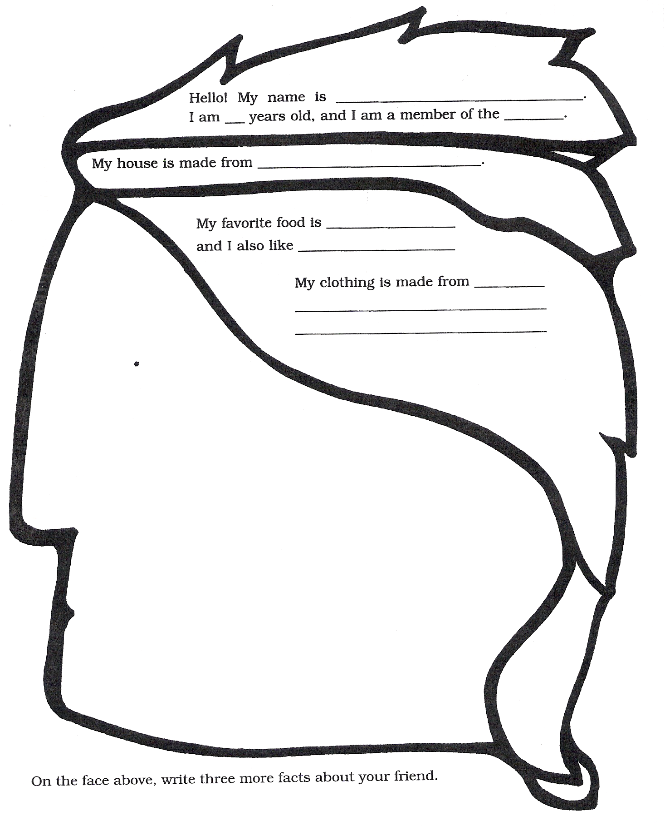
Sequoyah
(Mountains of North Carolina: The Cherokees: an integrated curriculum)

Directions: Pretend you have a system of symbols for numbers, similar to the alphabet Sequoyah created, to solve these math problems. After finding the numerical value, change that number back to symbols. Then make up three more problems for a classmate to solve.

Symbols: 0 = @ 1 = $ 2 = ∆ 3 = ∞ 4 = ◊

5 = ○ 6 = ♀ 7 = ♥ 8 = ► 9 = □

1) ♥$ 2) ♀∞ 3) ►○
+ ∆∆ + $♥ + $@

4) ◊♀ 5) $□ 6) ○○
x ∆ x ◊ x ∞

7) ►□ 8) ♀∆ 9) ♥@
- ∆∞ - ◊$ - ○♀

10) 11) 12)
Missing Poster

Directions: Complete the information below for one of the missing characters in Cherokee Sister. Then draw a picture of the missing person in the box. Be sure to provide details of the person you choose.

Name: _______________________________________________________

Age: ________________ ______

Gender: ___________________

Hair Color: ________________

Eye Color: _________________

Height: ____________________

Weight: ___________________

Acts: ________________________________________________________

_____________________________________________________________

Hobbies/Interests: _____________________________________________

_____________________________________________________________

Likes: ________________________ Dislikes: _______________________

______________________________ ______________________________

Place last seen: ________________________________________________

Please contact ________________________ at ______________________

if you have any information on __________________’s whereabouts.
Tier 2 Vocabulary

Directions: For each word below, write it on one side of an index card with a child-friendly definition, and, on the other side of the card, draw a picture and write a sentence using that word.

scold
hover
emerge
turban
tunic
precious
government
rafter
thrash
measles
swamp
delicate
abandon
grateful
mischief
jealous

Name __________________________
Internet Workshop

Go to the Cherokee Reservation link and click on History and Culture to answer the following questions:

1. Name the seven clans
1.
2.
3.
4.
5.
6.
7.
2. Under the Trail of Tears link, how many Cherokees traveled the trail?
____________________________________________________________

3. How long was the Trail of Tears? ________________________________

Now go to the Kids Corner link on the left side of the web page to answer these questions:

4. Name three things you could do at the Cherokee Fun Park if you were
to visit.
1.
2.
3.

5. What kind of bear might you see at the Cherokee Bear Zoo? ___________
6. Name three other kinds of animals that live at the zoo.
1.
2.
3.

Now click on the Poetry link on the left side to answer this question:

7. Read all seven poems. Which is your favorite and why? ___________
________________________________________________________________________________________________________________________________________________________________________________________________________________________________________

Now click on the Recipes link.

8. What three ingredients are in Fried Hominy?
1.
2.
3.

9. How long would you cook Grape Dumplings? ___________________

10. Extra Credit - Name at least one event someone could do in the month of November in Cherokee, NC.
______________________________________________________________________________________________________________________________________________________________________________

