By: Cornelia Cornelissen

Sadness filled the Cherokee heart
As their clans were torn apart…
The white man thought of only his gain
While the Cherokee suffered in pain.
-Anonymous

By Joseph Bruchac

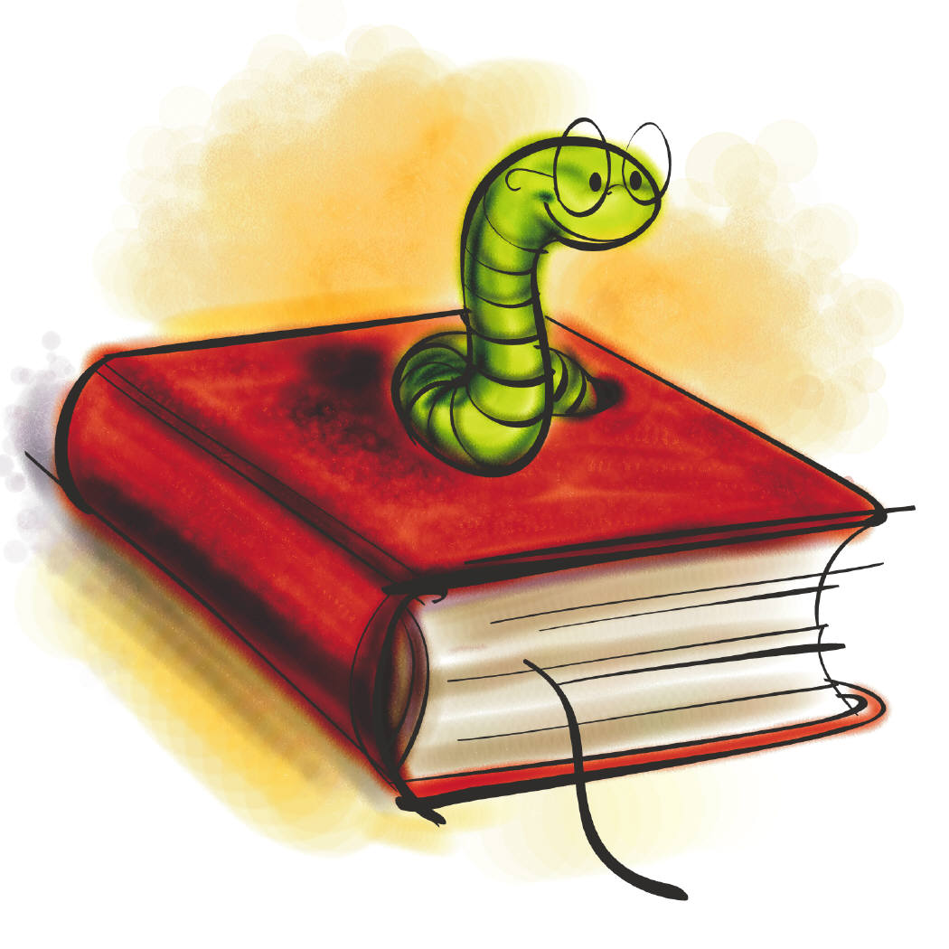Anticipation Guide

Before Reading:
- Read each statement and mark, in the “Me” column, whether you believe it is true or not. (T=true; F=false)

During the reading of the story, think about how the author feels about each of the statements.

After Reading:
- After you have read the story, fill in the author column.

M= My opinion
A= Author’s opinion

M_____ A_____ 1. If someone is different from you, you should be scared of them.

M_____ A_____ 2. Family is important to most people.

M_____ A_____ 3. Being mistreated is just part of life, so it’s okay.

M_____ A_____ 4. Giving up is alright when you cannot win.

M_____ A_____ 5. Grandparents are just old people who don’t know a lot anymore.

M_____ A_____ 6. People of other cultures have weird customs and should not be trusted.

M_____ A_____ 7. It doesn’t matter where you live, as long as you have your family.

M_____ A_____ 8. Young children never understand what is going on in the world around them.
Prediction Poster

- In your groups, explore the book Soft Rain. Look at the front cover, read the back cover, and read each chapter title.
- Discuss what you think this book is about.
- Who are the characters?
- What is going to happen (problems)?
- When and where does this story take place?
- Use the space below to record your ideas then transfer them to a large sheet of white paper.
- Your group’s poster should include the title and author of the book, predictions, and a few illustrations.
- You will share your poster with the class and compare each group’s ideas.

My predictions:

My group’s predictions:
Discussion Director

- Your job is to involve the students in your group by thinking and talking about the section of the book you have just read. You are going to ask questions that really help the students in your group think about the reading. Your questions should require students to discuss their interpretations of the text and connect background experience and knowledge with the text. You want all students involved in the discussion and talking about issues that come up during the reading.

- Your job as the Discussion Director is to come up with 5 thinking questions. Your teacher really wants you to help the students in your group to go back to the book to find their answers if they don’t know them. So, to help this run very smoothly, you need to write down the questions, your answers to your questions, and the page numbers where the students can reference the text to justify their responses to your questions.

When developing your questions, think about Soft Rain’s experiences at her home, with the soldiers, in the stockade, and on the trail.
Character Map

Your assignment is to complete a Character Map of Soft Rain. You need to include an artistic impression of Soft Rain. Under each category, except acts, you need to include at least five descriptions along with the explanations, page, and paragraph numbers. Under the acts category, you will need to list ten. Make sure you are selecting examples throughout the part of the book we’ve read so far (through p. 68), not just a few pages.

You may arrange the Character Map according to the following categories:

Likes Looks

(Artistic Impression of Soft Rain)

Dislikes Acts
(Personality Traits)

What We Should Know About Soft Rain
Vocabulary Words/ Definitions

Here are a few vocabulary words (and definitions) from the book Soft Rain. Find these words in the books and copy the sentences they are from. Then you will be asked to complete some vocabulary activities with these words throughout the week.

Week One Words:
1. stockade p.35- an enclosure in which prisoners are kept
2. peer p.42- to look closely or curiously
3. cautious p.33- using care
4. dainty p.24- delicately pretty
5. hearth p.25- the area in front of a fireplace
6. disgust p.48- a strong feeling of dislike

Sentences:

1. ________________________________________________________________________________________________________________________________________________

2.
________________________________________________________________________________________________________________________________________________

3.
________________________________________________________________________________________________________________________________________________

4.
________________________________________________________________________________________________________________________________________________

5.
________________________________________________________________________________________________________________________________________________

6.
________________________________________________________________________________________________________________________________________________

Vocabulary Activities (week one words)

Word Networks
Write words or phrases around the outside of the oval answering the question and connect them to it by drawing lines.

What people, things, situations, or words come to mind when you think about the word hearth?

Hearth
Word Lines I
Place words or phrases on the line where your answer would be and explain your placement.

How often do you:
- find yourself locked in a stockade?
- Get disgusted with your little brother?
- Peer into a store window?

Very Almost
Often __________________________________________ Never

Have You Ever?
- Describe a time you might use the word cautious.
- Where might you be cautious outside?
- How might you be cautious in a car?
- Why might you be cautious around sharp objects?

Example/ Non-example
Which would be dainty:
-A football player or a ballerina?
-A daisy or an oak tree?
-A butterfly or a cow?

Vocabulary Words/ Definitions

Here are a few vocabulary words (and definitions) from the book Trail of Tears. Find these words in the books and copy the sentences they are from. Then you will be asked to complete some vocabulary activities with these words throughout the week.

Week Two Words:
1. guidance p.6- the process of controlling the course
2. omen p.7- a happening believed to be a sign or warning of some future event
3. opposed p.18- to be against something
4. territory p.17- an assigned area
5. determined p.25- having reached a firm decision
6. plea p.28- to beg

Sentences:

1. ________________________________________________________________________________________________________________________________________________

2.
________________________________________________________________________________________________________________________________________________

3.
________________________________________________________________________________________________________________________________________________

4.
________________________________________________________________________________________________________________________________________________

5.
________________________________________________________________________________________________________________________________________________

6.
________________________________________________________________________________________________________________________________________________

Vocabulary Activities (week two words)

Word Associations
- Which word goes with lines on a map that divides land into sections? Why?
- Which word goes with saying, “Please”? Why?

Sentence Stems/ Idea Completions
- The children were determined to __________________.
- The parents were opposed to _____________________.

Word Networks
-What situations, things or words come to mind when you think of the word omen?

Omen

Have you ever?
- Describe a time when you might use the word guidance?
- When might you offer guidance to a friend?
- How might a teacher give guidance to you?
- What might you use to give guidance to your pet?
Wanted Poster

Use the information in the book Trail of Tears to create a wanted poster for one of the following people:

- John Ross
- Andrew Jackson
- Sequoyah
- Thomas Jefferson
- General John Ellis Wool
- General Winfield Scott

You will complete and artistic representation of the character and then complete the following information for your character:

Wanted:

Character name
Place last seen
Physical Description
Hobbies/Interests
Acts
Likes
Dislikes
Hang Outs
Wanted for

Be sure to make your wanted poster as creative as possible!!!

Learning Log/ Response Journal

After Green Fern dies from the coughing disease Soft Rain has lost her best friend. Then, her mother gets the disease. How do you think Soft Rain feels when she sees her mother sick? Have you ever felt that way? Explain.
Author’s Craft
Cornelia Cornelissen chooses her words very carefully, making use of several interesting literary devices. She appeals to the reader’s senses and sense of humor by using such figurative language. Find two examples of each listed below. Then explain how each passage adds meaning to the story.
 | Page number/  Example/  What does this passage add to the story? | Page number/  Example/  What does this passage add to the story?
Personification : giving human characteristics to something nonhuman.
page 3: A squirrel run up an oak tree, fussing at her for disturbing him.
simile: a comparison that includes the words like or as

page 10: The Little People were such wee folks, as small as children.

Now that you have chosen two examples of similes, please artistically represent one of these comparisons. You may use any artistic medium. The following are options: colored pencils, watercolors, pastels, collage, etc. Enjoy!

Double-Entry Diary

You are invited to complete a Double-Entry Diary for the section of the book. (p.69-112) Remember to write down the quotation or passage and the page number on the left side of your paper. On the right side of your paper, write your response or personal reactions and connections to what was written. You must find four passages within this section to write about.

Quotation/Passage  And page number | Your response, reactions, and connection to the quotation or passage.
Poem for Two Voices

Select two main characters from the book Soft Rain and compose a poem for two voices. Think of something that the characters might have different views about. Then, get them to talk to one another. Remember lines written across from one another are read together. Your poem does not have to rhyme, it is your choice. In addition, you are invited to include an artistic representation that symbolizes a theme in your poem.

You may want to write your poem with a partner. You might also want to write a poem for three or even four voices.

Story Map

Complete a story map for Soft Rain. Illustrate all six parts of the map below.

Setting | Characters
Problem | Important Events
Resolution | Theme(s)

Summary Poster

- In your groups, write a summary of the book Soft Rain in the space provided.
- Then, look at the poster you made the first day of reading, and answer the questions below.

Summary:
__________________________________________________________________________________________________________________
__________________________________________________________________________________________________________________
__________________________________________________________________________________________________________________
__________________________________________________________________________________________________________________
__________________________________________________________________________________________________________________
__________________________________________________________________________________________________________________
__________________________________________________________________________________________________________________

Which of our predictions were correct?
__________________________________________________________________________________________________________________
__________________________________________________________________________________________________________________

Which were incorrect?
__________________________________________________________________________________________________________________
__________________________________________________________________________________________________________________
__________________________________________________________________________________________________________________

Why might we have thought that was going to happen?
__________________________________________________________________________________________________________________
__________________________________________________________________________________________________________________
__________________________________________________________________________________________________________________
__________________________________________________________________________________________________________________
__________________________________________________________________________________________________________________
___________________________________________________________________________________________________________________________________________________________________________

