Who Am I?

I glide across the desert at amazing speeds for my small size.
I snatch other birds directly from midair.
I devour insects and scorpions in one swift motion.
I leave rattlesnakes dangling from my mouth until I feel hungry.
I witness eggs hatching every Spring,
uncovering smaller representations of me.
I avoid the lurking hawks and coyotes.
Who Am I?
I am the ROADRUNNER.

-Ashley Brooks

What Am I?

I appear to have no leaves,
Though I do like to deceive.
My branches are not bare,
My leaves are just real slight.
They look like green scales on a tiny fish.
If you see me the right time of year,
You will witness the flowers of my branches.
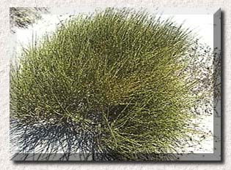
What Am I?
I am the MORMON TEA.

-Ashley Brooks

